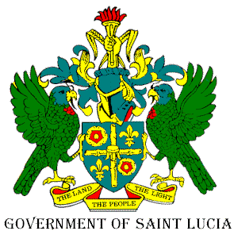

OFFICE OF THE PRIME MINISTER

Greaham Louisy Administrative Building Tel: (758) 468.2111 / 468-2184
Waterfront, Castries Fax: (758) 453.7352 Saint Lucia
Email: opm.communications.slu@gmail.com

12 June 2020
Press Release

Curfew Time Decreased as Cabinet Adjusts COVID-19 Protocols

The Cabinet of Ministers has adjusted the protocols for operations during the State of Emergency which includes lessening of the curfew time and hosting of social activities with the established health protocols in place.

The Amendments to the Emergency Powers (Disasters) (COVID-19) Order will come into effect from Monday June 15th 2020 and are as follows:

- The curfew hours are adjusted from 9:00pm to now start from 12:00am (midnight) to 5:00am each day.

- A person may host or attend social activities (parties, picnics, weddings, receptions, banquets) in keeping with the established physical distancing and other public health protocols. However, mass crowd events, sporting tournaments and contact sporting events remain restricted social activities.

- A person with a valid liquor licence may expose for sale or dispose of intoxicating liquor in accordance with the Liquor Licence Act, Cap. 13.17.

These adjustments are in-keeping with the commitment by the Government of Saint Lucia to review and assess the situation and to make adjustments accordingly in support of the phased re-opening.

END.

