

**Government of Saint Lucia**

**Saint Lucia Human Capital Resilience Project –P170445**

**LABOUR MANAGEMENT PROCEDURES**



***ACRONYMS***

|  |  |
| --- | --- |
| CVQ | Caribbean Vocational Qualification |
| ESF | Environmental and Social Framework |
| ESS | Environmental and Social Standard |
| GBV | Gender-based violence |
| GC | Grievance Redress Committee |
| GRM | Grievance Redress Mechanism |
| LMP | Labour Management Procedures |
| NIC | National Identification Card |
| OHS/OSH | Occupational health and safety |
| SEA | Sexual exploitation and abuse |
| TVET | Technical Vocational Educational Training |

Table of Contents

1. INTRODUCTION 5

2. OVERVIEW OF LABOR USE ON THE PROJECT 5

2.1 Labour Requirements for Component 3: Technical Assistance and Project Management: 6

2.1.1 Direct Workers 6

2.1.2 Non-Direct 7

2.2. Labour requirements for Component 1: Strengthening Technical and Vocational Education and Training (TVET) 7

2.3 Labour Requirements for Component 2: Strengthening the Social Protection System 9

3. ASSESSMENT OF KEY POTENTIAL LABOR RISKS 10

4. BRIEF OVERVIEW OF LABOR LEGISLATION: TERMS AND CONDITIONS 10

5. BRIEF OVERVIEW OF LABOR LEGISLATION: OCCUPATIONAL HEALTH AND SAFETY 11

6. RESPONSIBLE STAFF 12

7. POLICIES AND PROCEDURES 12

8. AGE OF EMPLOYMENT 13

9. TERMS AND CONDITIONS 14

10. GRIEVANCE MECHANISM 15

10.1 GRIEVANCES LEVELS AND PERSONS RESPONSIBLE 15

10.2 GRIEVANCE REPORTING CHANNELS 16

10.3 THE GRIEVANCE REDRESS MECHANISM (GRM) PROCESS FLOW 18

10.4 WORLD BANK GRIEVANCE REDRESS 21

10.5 ADDRESSING GENDER-BASED (GBV) VIOLENCE 22

11. CONSULTANT MANAGEMENT 23

12. COMMUNITY WORKERS 23

13. PRIMARY SUPPLY WORKERS 24

ANNEX: 1 25

MINIMUM REQUIREMENTS FOR THE CODE OF CONDUCT 25

ANNEX 2: 28

Guidance on Reporting of Incidents/accidents by the PIU of the project. 28

ANNEX 3 30

INCIDENT / ACCIDENT REPORTING SHEET 30

ANNEX 3B: INCIDENT CLASSIFICATION GUIDE 33

ANNEX 3C: ELEMENTS OF A CORRECTIVE ACTION PLAN: 34

ANNEX 4 35

Sample Grievance Reporting Form 35

ANNEX 5 37

Grievance Acknowledgement Form (GAF) 37

ANNEX 6 39

Grievances Redress Meeting Notes Form 39

ANNEX 7 41

Grievance Resolution Agreement Form 41

PROPOSED CRITERIA FOR GRIEVANCE CLASSIFICATION 42

ANNEX 8………..………………………………………………………………………………43

Gender Based Violence (GBV) Referral Pathway……………. …………………………43

# INTRODUCTION

The Labour Management Procedures (LMP) was developed in support of the Human Capital Resilience Project. The procedures seek to ensure that measures are in place to manage risks associated with employment under the project. The LMP identifies the main labour requirements for the project and establishes parameters to ensure that hiring is undertaken as per the Labour Laws of Saint Lucia. The LMP sets out the approach for meeting national requirements as well as the objectives of the World Bank’s Environmental and Social Framework, specifically objectives of Environmental and Social Standards 2: Labor and Working Conditions (ESS2). This document highlights all labour management procedures that should be adhered to by project implementers, workers (direct workers or project staff, Consultants, contracted workers and other suppliers, as well as community workers, working to meet the project’s objectives. The GRM also applies to staff of Ministry of Education, Innovation, Gender Relations and Sustainable Development, Ministry of Equity, Social Justice, Empowerment and Local Government, Central Statistical Office, Office of the Prime Minister and the World Bank involved in the project.

Based on the Project’s Social Assessment, risks as it relates to the labour, working conditions and occupational health and safety are minimal. These risks are understood and expected to have limited impact on the project if managed according to the procedures set out in this plan. The Government of Saint Lucia is committed to continuous assessment of the risks and impact throughout the life of the project and ensures that adequate measures and procedures are in place to address any adverse impacts. Nevertheless, the project implementers have the responsibility to communicate the LMP to all stakeholders to facilitate awareness raising and compliance as much as possible.

# OVERVIEW OF LABOR USE ON THE PROJECT

The LMP is applicable to all Project workers, whether full-time, part-time or temporary. The LMP is applicable as per ESS2 to the Project in the following manner[1]:

* People employed or engaged directly by the Ministry of Education or Ministry of Equity including staff of the Project Implementation Unit (PIU), Consultants and Suppliers.
* People employed or engaged by the project’s Consultants to perform work related to the core functions of the project regardless of location.
* People engaged through third parties to perform work related to the core functions of the project regardless of location (for example, rapporteurs, data collectors, drivers and handlers of goods hired by Consultants or Suppliers)

The project will be engaged with direct workers and may hire specialized Consultants for developing different types of studies and curricula.

The project will be implemented by the Department of Education, Innovation and Gender Relations and the Department of Equity, Social Justice, Empowerment and Human Services with the Department of Education being the lead Agency. Support will be provided by the Department of Finance and the Department of Economic, Transport and Civil Aviation.

# 2.1 Labour Requirements for Component 3: Technical Assistance and Project Management:

## 2.1.1 Direct Workers

The Ministry of Education will establish a PIU to oversee the day-to-day operations of the project. The Unit will engage the following personnel throughout the project:

* A Project Manager with overall responsibility for project management as well as technical activities in education;
* A Technical Coordinator with responsibility for the activities in the Ministry of Equity;
* An Administrative Assistant;
* A Finance Officer;
* A Procurement Officer;
* A Monitoring & Evaluation Officer;
* A Social and Environmental Specialist.
* Consultants[2]

## 2.1.2 Non-Direct

Under this project support is to be given to the TVET Council, for staffing of the Council Office. The details of the number of non-direct workers to be engaged, per component, throughout the project, are outlined below. Suppliers (persons delivering goods and services should also be factored in).

## 2.2. Labour requirements for Component 1: Strengthening Technical and Vocational Education and Training (TVET)

| **Component and activities** | **Estimated No. of Persons** | **Timing of Engagement** |
| --- | --- | --- |
| **Component 1: Strengthening Enabling Environment for TVET** | | |
| * Establishing a periodic labor market needs assessment to gauge private, public, and informal sector needs for technical and non-technical (e.g. socio-emotional) skills | 15 interviewers  3 supervisors | January - March 2020 |
| * Supporting the implementation of the TVET Policy and Strategy, including adequate human resourcing of the TVET Council and measures to increase gender inclusivity and inclusion of persons with disabilities; | TVET Council   * 5 Existing staff * 2 New staff * 1 Ancillary staff (8)   TVET Unit  4 New staff | May 2020 |
| * Developing fully operational databases of training institutions, trainees, and credentials (TVET database) and of employers and job seekers | 2 data entry personnel | May 2020 |
| * Developing a resource mobilization strategy to ensure sustainable financing of the sector. | 3 People | February 2020 |
| **Component 1.2: Improved TVET offerings** | | |
| * Rationalization of programs, informed by the labor market needs assessment and skills program diagnostic; | 4 People | May 2020 |
| * Professional development for TVET trainers, including a trainer immersion program in partnership with the private sector, | 2 People | July 2020 |
| * Development of new TVET offerings - including higher-level CVQs | 1 Officer in charge | January 2020 |
| * Provision of financial support for lower-income students to access TVET | 2 people | April 2020 |
| Total | 26 | N/A |

## 2.3 Labour Requirements for Component 2: Strengthening the Social Protection System

| **Component and activities** | **Estimated No. of Persons** | **Timing of Engagement** |
| --- | --- | --- |
| **Subcomponent 2.1: Strengthened social protection policy frame** | | |
| * Review and update the national social protection policy | 1 | Year 1 |
| * Development of a graduation strategy | 1 | Year 2 |
| * Development of Operations Manual for major programmes | 1 | Year 1 |
| * Review of the Draft Social Protection Bill | 1 | Year 1 |
| * Testing and Validation of the updated targeting tool, SL-NET 3.0 | 1 | Year 1 |
| * Planning, implementation and analysis of the 2022 Living Conditions and Household Expenditure Survey | 10 | Year 3 |
| **Subcomponent 2.2: Improved implementation of flagship social programs** | | |
| * Revision of existing social assistance programs | 2 | Year 1 |
| * Design, development and population of a social information system | 5[3] | Year 1-5 |
| * Capacity building activities such as training of management and technical staff | 5[4] | Year 1-5 |
| * Development of a communication strategy | 2 | Year 1 |
| Total | 29 | N/A |

# ASSESSMENT OF KEY POTENTIAL LABOR RISKS

The Labour risks associated with the project are minimal. The majority of activities to be carried out on the project will be focused on consultancies. The key labour risks which may be associated with the project are related to potential breaches in promoting transparency in the terms and conditions of employment, non-discrimination and equal opportunity. In addition, the probability of use of child labour or forced labour[5] is negligible due to the level of skills and qualifications required to execute the activities outlined in the project.

# BRIEF OVERVIEW OF LABOR LEGISLATION: TERMS AND CONDITIONS

There is one main piece of legislation which guide and regulate the terms and conditions of employment in Saint Lucia. This is the:

* Saint Lucia Labour Code no. 37 of 2006

The Saint Lucia Labour Code outlines the conditions of employment with a view to improving the terms and conditions upon which workers are employed. The Labour Code makes it mandatory for employers to provide employees with written details of employment stating, hours of work, leave entitlement, job description, grievance procedures, benefits, health and safety etc. Within this legislation there are provisions relating to:

* Fundamental principles of employment-Part II
* Contracts of employment-Division 1
* Hours of Work-Division 3
* Wages and minimum wages-Division 4&5
* Leave entitlements (annual leave, sick leave, maternity leave, bereavement leave etc.)-Divisions 6, 7 and 2
* Employment of Children and Young persons -Division 9
* Termination of Employment-Division 10
* Duties of Employers, workers and other persons-Part IV Division 4
* Occupational Health and Safety-Part IV
* Equality of opportunity and treatment in employment-Part V Division 1
* Trade Unions and employers’ organizations-Part VII

Part II of the Code under Fundamental Principles of Employment number 7 states that “an employer shall not discriminate against any employee on the grounds of race, colour, sex, religion, national extraction, social origin, ethnic origin, political opinion or affiliation, age, disability, serious family responsibility, pregnancy, marital status or HIV\AIDS, in respect of recruitment, training, work facilities or service, promotion, terms and conditions of employment or benefit arising out of the employment relationship”. The Code also makes provision on how the matter of discrimination can be addressed.

Project workers will be paid on a regular basis as required by national law and labor management procedures. Deductions from payment of wages will only be made as allowed by national law or the labor management procedures, and project workers will be informed of the conditions under which such deductions will be made. Project workers will be provided with adequate periods of rest per week, annual holiday and sick, maternity and family leave, as required by national law and labor management procedures.

# BRIEF OVERVIEW OF LABOR LEGISLATION: OCCUPATIONAL HEALTH AND SAFETY

Part four of the Saint Lucia Labour Code also speaks to occupational health and safety in the workplace. Under Part four, *Divisions 1-4* provides for preventative health measures, protective devices and equipment, medical examinations, notification of employment injuries and diseases, training, etc. This Act obligates the employer to ensure the safety and health of all employees and to mitigate risk of exposure to any hazards in the work environment. *Division 3* of the Code clearly outlines the procedures to be followed in relation to notification of accidents, occupational diseases and other diseases. *Division 4* specifically speaks to the responsibilities of employers, employees and other persons in adhering to health and safety regulations. The Code also clearly outlines the circumstances where employees may refuse to work on health and safety grounds and the procedures for how such matters should be addressed.

# RESPONSIBLE STAFF

The Project Coordinator with support from the Department of Education Human Resource Unit and Department of Public Service Human Resource Unit will be responsible for the:

* Engagement and management of project workers
* Occupational health and safety (OHS)
* Addressing worker grievances
* Training of workers

The Project Coordinator with support from PIU staff and the implementing Ministries will be responsible for the engagement and management of consultants/sub-consultants.

# POLICIES AND PROCEDURES

Given the nature of the project no major risks are foreseen on labor and working conditions. However, Bank provisions of Labor and Working Conditions applies given that the project will be engaged with direct workers, defined as” people employed or engaged directly by the Borrower (including the project proponent and the project implementing agencies) to work specifically in relation to the project” and may hire specialized consultants for developing different types of studies and curricula.” Any identified risk will be addressed in accordance with provisions within the Saint Lucia Labour Code utilizing the various Divisions of the Code as outlined in previous sections, and consistent with the World bank, Environmental and Social Standards. The Department of Education as the lead Agency will ensure that all employees hired as part of the project:

* Ascribe to the principle of not harming people
* That sexual harassment, gender-based violence (GBV), sexual exploitation and abuse (SEA) will not be tolerated.
* That discrimination will not be tolerated in the work place
* The employment of project workers will be based on the principle of equal opportunity

and fair treatment, and there will be no discrimination with respect to any aspects of the employment relationship, such as recruitment and hiring, compensation (including wages and benefits), working conditions and terms of employment.

* Given that there are direct workers under PIU, the PIU will adapt and receive training on Code of Conducts as well as on OHS measures required under ESS2.
* That there is compliance with the laws of the Country at all times.
* Compliance with the Environmental and Social Framework (ESF)of the Bank, including the Environment and Social Standard (ESS2) on Labor and Working Conditions.
* That all health and safety measures are adhered to as laid out under World Bank’s Environmental and Social Standards (ESS) 2 on Labor and Working Conditions and for Community Health and Safety.

It is advised that reference be made to the LMP in all ToRs as well as contracts being signed with workers, consultants and suppliers. The LMP should be made readily available for viewing and be part of staff sensitisation and orientation activities.

# AGE OF EMPLOYMENT

*Division 9* “Employment of children and young persons” of the Labour Code states “…..a person shall not employ or allow to be employed any child who is under the minimum school leaving age[6] as declared by any law in force in Saint Lucia except for employment during school holidays in light work”.

The minimum age of employment for the Project will be 18 years. To ensure compliance, all employees will be required to produce their National Identification Card (NIC) as proof of their identity and age. This NIC serves as the national document required for employment.

A child over the minimum age, and under the age of 18 may be employed or engaged in connection with the project only under the following specific conditions:

(a) an appropriate risk assessment is conducted prior to the work commencing; and

(b) the Borrower conducts regular monitoring of health, working conditions, hours of work and

the other requirement of ESS2 of the World Bank: Labor and Working condition.

A child over the minimum age and under the age of 18 will not be employed or engaged in connection with the project in a manner that is likely to be hazardous[7] or interfere with the child’s education or be harmful to the child’s health or physical, mental, spiritual, moral or social development.

Any consultant found hiring persons under the age of 18 will have their contract immediately terminated and will be reported to the authorities. Under *Division 9* 127- “Any employer who contravenes sections 122, 123 or 124 commits an offence and is liable on summary conviction to a fine not exceeding ***ten thousand dollars*** or to imprisonment for a term of two years or both.

# TERMS AND CONDITIONS

The Saint Lucia Labour Code guides and regulates the terms and conditions of employment. *Division 1* “Contracts of Employment” applies to all persons engaged under contracts of employment. The Act mandates that “Within fourteen days from the date on which employment commences, an employer may prepare a written contract correctly describing the terms and conditions of employment that have been agreed upon by the employer and employee”. The Code also states that “where a contract of employment is not written the employer shall explain to the employee the contents of the contact of employment….”. The Code further states that “upon written request to the employer, an employee who is not employed under a written contract shall be given, within one month of the request, a written contract.

The Labour code, para. 27.— (1) states that subject to subsections (2) and (3), an employer shall not require any employee to work for more than forty hours during any week, excluding overtime. In para. 265. — (1) It also states, that an employer shall not — (a) dismiss or threaten to dismiss an employee; (b) discipline or suspend or threaten to discipline or suspend an employee, (c) impose any penalty upon an employee; (d) intimidate or coerce an employee; or (e) discriminate against an employee in any way.

The code states, that a person discriminates against another person if the first-mentioned person makes, on any of the grounds specified in subsection (2), any distinction, exclusion or preference, the intent or effect of which is to nullify or impair equality of opportunity or treatment in occupation or employment. (2) The grounds referred to in subsection (1) are — (a) race, sex, religion, colour, ethnic origin, social origin, political opinion or affiliation, disability, serious family responsibility, pregnancy, marital status, HIV/AIDS, trade union affiliation or activity, or age except for purposes of retirement and restrictions on work and employment of minors or for the protection of children and young persons.

Para 285. (1) states that, without prejudice to the provisions under this Division, an employer shall not refuse to employ a person, demote or dismiss a female employee, alter the terms and conditions of her contract of employment, refuse her promotion or training or in other way discriminate against her because she is or was pregnant or for any reason connected with pregnancy.

Under this Project all consultants will be provided with a written contract, in accordance with the Labour Code, outlining terms and conditions for executing the particular work that they have been contracted for. The terms and conditions of employment will make adequate provisions for periods of rest per week, annual holiday, sick, maternity and vacation and bereavement leave as stipulated in the Labour Code.

# GRIEVANCE MECHANISM

In any working environment it is essential for both employers and employees to be fully conversant with all aspects of disciplinary processes, the grievance handling procedures and the legal requirements and rights involved. In implementing an effective dispute management system consideration must be given to the disputes resulting from the following:

* Disciplinary action
* Individual grievances
* Collective grievances and negotiation of collective grievances
* Gender-based violence, sexual exploitation and workplace sexual harassment

As mentioned previously, the Saint Lucia Labour Code, 2006[8] will be utilized to address any issues of breaches in procedures or fulfillment of Contract requirements. Prior to the implementation of any contracts, Consultants, Contractors or Suppliers will be briefed on the laws of the land, on acceptable and unacceptable conduct and the avenues available for redress.

## GRIEVANCES LEVELS AND PERSONS RESPONSIBLE

Complaints or grievances for this project will be classified as Level 1 (Low Risk), Level 2 (Substantial Risk) and Level 3 (High Risk). While all complaints or grievances are considered important and critical, Levels 2 and 3 are classified as high priority, with Level 3 being the highest priority. Levels 2 and 3 requires immediate intervention of the PIU Manager or Grievance Committee.

|  |  |  |
| --- | --- | --- |
| Grievance Level | Examples | Persons Responsible |
| Level 1- Low Risk | Wage dispute; hours of work; transportation, etc. | PIU Manager |
| Level 2- Medium Risk | Work related injuries- minor; health risks, sick leave, etc. | PS Education |
| Level 3- High Risk | Work related injuries- major GBV, fraud accusations, etc. | GC |

NB- All matters involving the project manager should be reported directly to the PS, and can involve the SESS.

## 10.2 GRIEVANCE REPORTING CHANNELS

Channels of Reporting or Filing a Complaint/Grievance

The HCRP PIU will communicate this procedure to its internal and external stakeholders to raise awareness and offer transparency of how stakeholders can voice their grievances. Various channels for internal external stakeholders to vocalize their grievances formally include:

* ***Email:*** A complainant can email the HCRP PIU to complain. Complainant will receive email acknowledging complaint and be advised to complete a grievance form and sign (electronic or by reporting to nearest office). (Email: Attention Social and Environmental Specialist- [sesslhcrp@gmail.com](mailto:sesslhcrp@gmail.com) and [secslhcrp2021@gmail.com](mailto:secslhcrp2021@gmail.com))
* ***WhatsApp:*** A complainant can send a voice note, typed message or an image of a completed grievance form or other documents related to complaint filed to the SESS- Social and Environmental Specialist. Mobile no: 1758.285.3753
* ***Mail:*** Write a letter to the HCRP PIU to complain (respond to letters via telephone or email, inviting complainant to complete an official grievance form/transfer information from letter to grievance form; record complaint in log)

**Pierre Building**

**2nd Floor, Trinity Church Road**

**Castries, Saint Lucia**

* ***Telephone:*** Complainants can call the HCRP PIU at:

1. Social and Environmental Specialist 1758.285.3753
2. Technical Coordinator 1758. 722. 6630
3. Administrative Secretary 1758. 717. 8636

* ***In Person:*** Complainants can report to the PIU office or other agreed upon locations, to complete and submit a grievance form, (HCRP Project Implementation Unit (PIU) at:

**Pierre Building**

**2nd Floor, Trinity Church Road**

**Castries, Saint Lucia**

They can also register their complaint directly to: Social and Environmental Specialist via the mediums list above

**All complaints or grievances received by the PIU will be registered in the Grievance log book, PIU staff will be trained to assist persons with completing grievance form. The log and completed forms will be handed over to the Social and Environmental** **Safeguards Specialist for further action.**

1. **Modes of Communication and Publishing of Grievance Redress Mechanism**

The PIU will facilitate knowledge of the GRM reporting and redress mechanism by undertaking training at offices and at all stakeholder engagement activities. Adverts on the GRM will be published in print media, social media, other electronic media (Government websites).

## 10.3 THE GRIEVANCE REDRESS MECHANISM (GRM) PROCESS FLOW

**Figure 1: Grievance Mechanism Process Flow Chart**



**Follow up and Close Out**



**Act**



**Investigate**



**Acknowledge**



**Screen**



**Record Grievance**



**Receive Grievance**

**STEP 1: Receive Grievance**

SESS or Project manager will receive complaint or advise on procedure for filing complaint if someone voices a grievance. **Complaint Form, Annex 2)**.

The Social and Environmental Safeguards Specialist (ESSS) receives all grievances that may involve the Project Manager if the Aggrieved cannot reach the Permanent Secretary. **(Complaint Form, Annex 2)**.

**STEP 2: Record**

Administrative, the PM and the SESS to ensure system is I place within th PIU for recording ad filing of grievances. (**Grievance Register (Annex 1)**

Social and Environmental Safeguards Specialist will complete the **Grievance Register (Annex 1)** for all grievances that are delivered via telephone, email or letter.

The Project Manager/Social and Environmental Safeguards Specialist will review the Grievance Register and prepare and either:

1. follow-up with the party who received the complaint (telephone or via log book) to clarify details of grievance recorded;
2. follow- up with complainant and execute a redress;
3. make referrals to the PS for prompting Grievance Committee meeting, seeking redress for complaints. **Grievance Report using Annex 3 template**.

**STEP 3: Screen**

The PM/Social and Environmental Specialist will do the initial assessment of whether the grievance is a level 1, 2 or 3. Level 1 will be addressed by ESS. Level 2 also by SESS but following consultation with PIU Manager and PS Education and Equity. Grievance Redress Committee meeting to be convened once deemed necessary by the PS. **See Step 5 below**.

**STEP 4: Acknowledge**

A grievance will be acknowledged in writing or email, by the PS/ Social and Environmental Safeguards Specialist/***within five (5)*** working days of a grievance being submitted. Communication will be made either verbally or in written form to the complainant. The acknowledgement of a grievance will include a letter from PIU **(See Annex 5).**

**STEP 5: Investigate**

The PM/Social and Environmental Specialist is responsible for investigating the grievance within ***10-15 working days***. High level cases, ***15-30 working days***. The investigation may require the safeguards specialists to make site visits and contact the complainant. Investigations to be supported by key technical specialists of the Ministry of Education or Equity, where necessary. All meetings and discussions must be documented during the investigation. Information gathered during the investigation will be analyzed and will assist in determining how the grievance is handled and what steps need to be taken in order to resolve the grievance. (Investigations will be commissioned by the PS Education or Equity) and may take place before or after convening meetings with the Grievance Committee.

**STEP 6: Actions and Commitments**

Following the requisite investigations, the GC will use the findings to create an action plan outlining steps to be taken in order to resolve the grievance. The PM/SESS will be assigned responsibility for assigning actions, monitoring actions undertaken and making sure deadlines are adhered to. Grievances identified as level 1, are capable of being addressed by the Project Manager/Social and Environmental Safeguards Specialist. **(See Annex 3/ 4- Grievance Report)**

Level 2 grievances will be dealt with by the PS. For grievances identified as level 3, proposed action plans will be reviewed by GC, to advise on next steps. This may be action required to resolve the complaint or request further investigation is required (**Refer to Section 2.5)**.

Once all actions have been completed and the grievance has been resolved, SESS will then formally advise the complainant. Communication of proposed resolution will include a letter and a copy of the **Grievance Report (Annex 6)** prepared by the HCRP PIU. If required, HCRP PIU will request additional information or to clarify any issues.

**STEP 7: Follow up and Close Out**

The PM/Social and Environmental Safeguards Specialist will document the outcome of the redress, ensuring that the grievance has been resolved and also gather any feedback on the grievance process. The Safeguards Specialist may need to follow up with the complainant on numerous occasions to confirm all parties are satisfied. **(See** **Annex 7).**

**STEP 8: Reporting**

The PIU Manager will receive monthly report/updates on all complainant grievances. Information outlining the number of grievances, time taken to arrive at resolution and outcomes of grievances will be communicated. The report will be prepared by the PM/Social and Environmental Social Safeguards Specialist and be available for submission to the Bank, upon request or as per reporting schedule.

**If a complaint is unresolved for several months or considered a serious complaint or high risk to project then the PIU should inform the World Bank project team.**

**STEP 9: Records**

All records, including grievance register and reports, investigation notes, interviews and minutes of meetings will be securely filed in a password protected, project grievance filing system and the HCRP’s intranet/internal filing system to ensure privacy and confidentiality is maintained for all parties involved.

All names or contact details of complainants will be held confidential and will not be released to an external party without the complainant’s permission. **(See** **Annex 6).**

## 10.4 WORLD BANK GRIEVANCE REDRESS

Communities and individuals who believe that they are adversely affected by a World Bank (WB) supported project may submit complaints to existing project-level grievance redress mechanisms or the WB’s Grievance Redress Service (GRS). For information on how to submit complaints to the World Bank’s Corporate Grievance Redress Service (GRS), please visit <http://www.worldbank.org/en/projects-operations/products-and-services/grievance-redress-service>

For information on how to submit complaints to the World Bank Inspection Panel, please visit [www.inspectionpanel.org](http://www.inspectionpanel.org)

Grievances whether by project staff, consultants, contracted workers or community workers will be addressed through the following steps:

1. A Grievance complaint can be submitted in writing to the PIU Project Manager or SESS, using the following address:

**Pierre Building**

**2nd Floor, Trinity Church Road**

**Castries,**

**Saint Lucia**

If the complainant wishes to remain anonymous, this must be confirmed and adhered to. A Complainant can also go directly to the PS if the complaint involves the PM. The PS will convene a GC (Grievance Redress Committee) meeting if necessary. The Grievance Committee is composed of representatives from the Ministry of Education, and from the Ministry of Equity, and the PIU. The Ministry of Education Chairs of the committee.

1. Investigation: A full investigation will be carried out by the Committee, supported by the SESS and all relevant evidence gathered. The findings will be sent to the aggrieved party in advance of the meeting.
2. The grievance matter will be addressed within a minimum of one (1) to fifteen (15) days depending on the nature of the matter reported.
3. Grievance Meeting: A grievance meeting (of the GC members) will be arranged and the aggrieved party will be invited to present his/her case. The aggrieved party will be reminded of their statutory right to be accompanied[9].
4. Decision: The aggrieved party will be informed in writing of the decision reached.
5. If the issue cannot be resolved by the Committee, then the matter will be referred to the Department of Labour for their action and ruling.
6. Appeal: The aggrieved party will be notified of their right to appeal against the outcome of the grievance procedure. If either party is not satisfied with the ruling by either the Committee or the Department of Labour the party may seek redress in the courts of the Country.

Documentation/records will be kept on all grievance matters including the outcomes and at every stage of the grievance process. This information should also be communicated to the WB by the Social and Environmental and Safeguards Specialist.

This Grievance Mechanism is provided for all direct workers and contracted workers (and, where relevant, their organizations) to raise workplace concerns. All workers will be informed of the grievance mechanism at the time of recruitment and the measures put in place to protect them against any reprisal for its use. The grievance mechanism will be easily accessible to all workers and does not impede access to other judicial or administrative remedies that might be available under the laws of Saint Lucia or through existing arbitration procedures, or substitute for grievance mechanisms provided through collective agreements.

## 10.5 ADDRESSING GENDER-BASED (GBV) VIOLENCE

Should any incidence of gender-based violence be reported through the GRM, the PIU will immediately seek out the assistance of the Department of Gender Relations for appropriate guidance and action. The Department of Gender Relations is the nationally recognized institution for the coordination of GBV incidences as well as training of individuals in handling GBV incidence. The Department of Gender Relations have developed a Gender Based Violence (GBV) Referral Pathway (Annex 8) to guide institutions and affected person on the process for reporting and address issues as well as linking survivors to resources.

In the event that a GBV matter is registered with PIU or through the GRM, the SES will refer the survivor in accordance with the GBV Referral Pathway to connect the survivor with GBV services, resources and support immediately after receiving the complaint. It must be noted that while the GBV Pathway exists all actions must be done with accordance and consent from the survivor.

All GBV-related incidences reported through the GRM, will be handled appropriately ensuring that the survivor’s information is kept confidential. Specifically, the GRM will only record the following information related to the GBV complaint:

* The nature of the complaint (what the complainant says in her/his own words without direct questioning);
* If, to the best of their knowledge, the perpetrator was associated with the project; and,
* If possible, the age and sex of the survivor.

Any cases of GBV brought through the GRM will be documented but remain closed/sealed to maintain the confidentiality of the survivor. Here, the GRM will primarily serve to:

* Refer complainants to the GBV Services Provider; and
* Record the resolution of the complaint

# CONSULTANT MANAGEMENT

Consultants will be managed according to the terms and conditions stipulated in their signed contract. The Project Coordinator will be responsible for providing general oversight over the execution of the contacts. The relevant technical staff within the PIU will be responsible for overseeing the day-to-day execution of the contracts and for ensuring that the consultants are implementing the project activities according to their agreed upon Terms of Reference which will form part of the contract document. A copy of the Grievance Redress Mechanism and any other approved documents guiding workers in the Public Sector will be made available to all workers hired as part of the project.

# COMMUNITY WORKERS

Community workers may be engaged to facilitate mobilization of stakeholders under different project components. The project staff are obliged to clearly communicate all terms of engagement clearly. All expectations of remuneration should be addressed and clarified. Hours involved and resources to be used, etc., should be clarified and expectations managed. At no time should the project endanger the health and safety of community workers engaged.

# PRIMARY SUPPLY WORKERS

The project does not intend to be engaged with primary supply workers. However, if such situation appears, the contractor who subcontracts the supply of materials and equipment will be responsible to include the same conditions and specifications on ESHS aspects to its subcontracting arrangements, including and to prevent the use of child labor, forced labour and serious safety issues which may arise in relation to primary suppliers.

# ANNEX: 1

## MINIMUM REQUIREMENTS FOR THE CODE OF CONDUCT

The Code of Conduct should be written in plain language and signed by each worker to indicate that they have:

* Received a copy of the code;
* Had the code explained to them;
* Acknowledged that adherence to this Code of Conduct is a condition of employment; and,
* It shall be understood that violations of the Code can result in serious consequences, up to and including dismissal, or referral to legal authorities.
* Reporting of Events – All Near Events and/or Incidents[10] must be reported within 24 Hours of their occurrence to the Project Manager or his/her designate. Serious safety incidents that occur must be reported immediately to the PIU and through the PIU to the Bank.
* Sexual Harassment (SH)/GBV/SEA requirements – The project manager shall have in place a referral system for victims of Gender Based Violence/Sexual Exploitation and Abuse of employees and any individual that may be associated with Project. Where such incident would have occurred, the Consultant should immediately report same to the Project Manager or his/her designate and ensure that the victim is referred to a service provider trained to handle GBV cases.
* Consent/permit conditions - The consultant shall put proper systems in place to ensure that no work is undertaken that is contrary to the laws of Saint Lucia.
* Required standards including – The Consultant shall ensure that there is equal opportunity for all persons to be employed and work on the site and shall ensure that there is strict adherence to labour laws in protecting the welfare of all employees.
* Grievance redress mechanisms – The consultant and his employees shall utilize a Grievance Redress Mechanism which will afford for effective remedies to affected parties. Matters of differences should be reported to the Project Manager or his/her designate, where this is not properly addressing the matter may be reported to the Project Manager’s Superior or in the case of the Project Manager’s Designate, the matter should be reported to the Project Manager. If both the Designate and the Project Manager fails to address the difference, the concern may be raised to the Superior of the Project Manager, and if same is not properly addressed the Contractors and/or the employee may raise same to the investor (The contact details and route of the grievance redress mechanism will be produced to the contractor upon the award of the Bid.)
* This does not take away the Contractor’s right to utilize the provisions of this contract to utilize Arbitration.

Additional obligations may be added to respond to particular concerns of the region, the location and the project sector or to specific project requirements. The code of conduct shall contain a statement that the term “child” / “children” means any person(s) under the age of 18 years.

The issues to be addressed include:

1. Compliance with applicable laws, rules, and regulations
2. Compliance with applicable health and safety requirements to protect the local community (including vulnerable and disadvantaged groups), the Employer’s and Project Manager’s personnel, and the Contractor’s personnel, including sub-contractors and day workers, (including wearing prescribed personal protective equipment, preventing avoidable accidents and a duty to report conditions or practices that pose a safety hazard or threaten the environment)
3. The use of illegal substances
4. Non-Discrimination in dealing with the local community (including vulnerable and disadvantaged groups), the Employer’s and Project Manager’s personnel, and the Contractor’s personnel, including sub-contractors and day workers (for example on the basis of family status, ethnicity, race, gender, religion, language, marital status, age, disability (physical and mental), sexual orientation, gender identity, political conviction or social, civic, or health status)
5. Interactions with the local community(ies), members of the local community (ies), and any affected person(s) (for example to convey an attitude of respect, including to their culture and traditions)
6. Sexual harassment (for example to prohibit use of language or behavior, in particular towards women and/or children, that is inappropriate, harassing, abusive, sexually provocative, demeaning or culturally inappropriate)
7. Violence including sexual and/or gender-based violence (for example acts that inflict physical, mental or sexual harm or suffering, threats of such acts, coercion, and deprivation of liberty
8. Exploitation including sexual exploitation and abuse (for example the prohibition of the exchange of money, employment, goods, or services for sex, including sexual favors or other forms of humiliating, degrading behavior, exploitative behavior or abuse of power)
9. Protection of children (including prohibitions against sexual activity or abuse, or otherwise unacceptable behavior towards children, limiting interactions with children, and ensuring their safety in project areas)
10. Sanitation requirements (for example, to ensure workers use specified sanitary facilities provided by their employer and not open areas)
11. Avoidance of conflicts of interest (such that benefits, contracts, or employment, or any sort of preferential treatment or favors, are not provided to any person with whom there is a financial, family, or personal connection)
12. Respecting reasonable work instructions (including regarding environmental and social norms)
13. Protection and proper use of property (for example, to prohibit theft, carelessness or waste)
14. Duty to report violations of this Code
15. Non-retaliation against workers who report violations of the Code, if that report is made in good faith.

# ANNEX 2:

## Guidance on Reporting of Incidents/accidents by the PIU of the project.

In case of incidents and accidents, the Project Implementation Unit (PIU) will notify the Bank within 24 hours after learning of the incident or accident. The submission of the subsequent report would be provided to the Bank in a timeframe acceptable to the Bank and or as requested. The IPU will provide sufficient details about the incident or accident, indicating the immediate measures taken to address it, including information provided by any contractor and supervisory entity, as appropriate. Subsequently, at the Bank's request, the PIU will prepare more detailed report (s) on the incident or accident, where it will propose measures to prevent it from happening again. See annex A, format for reporting incident and accident.

These subsequent reports, among others, can be:

1. Root Cause Analysis (RCA). The main objective of the RCA is Prevention and it will be carried out by whoever is managing the site where the incident / accident occurred, for example grant, contractor, subcontractor, etc. The RCA[11] will address the following:
   1. Determine what happened by identifying and describing the incident / accident. Include photos.
      1. What happened? Who was affected?
      2. Where and when it happened.
      3. What is the source of the information? How did you find out about the incident / accident?
      4. Are the basic facts of the incident / accident clear and indisputable, or are there contradictory versions?
      5. What were the conditions or circumstances under which the incident / accident occurred?
      6. Is the incident ongoing or contained?
      7. Is it a loss of life / s or serious damage?
      8. How serious was the incident?
   2. Determine the root cause (RCA) of the incident / accident
      1. Understand and document the root cause (s) of the incident, which may be due to the following factors:
         1. Labor Procedures
         2. Equipment and technology
         3. Organizational / systemic
         4. Human factors.
      2. The RCA should be based on existing country processes, where available. It is only in the absence of systems or weak experience that consultants (national or international) need to be recruited to undertake the RCA.
      3. The Borrower is responsible for funding the preparation of the RCA from project funds or other own resources.
      4. RCA should be completed as soon as possible, ideally within 10 days.
      5. Findings of RCA will inform measures to be included in Corrective Action Plan (CAP)
      6. Provide complete information about the incident to the Bank and facilitate site visit(s)
   3. Identify immediate corrective measures, as well as additional follow-up actions if any are required, with their associated deadlines. These additional follow-up actions may enter the
2. The CAP and with the aim of preventing similar incidents / accidents in the future. The CAP will have, among other elements, those indicated in Annex C.
3. Any subsequent report would be provided within a time acceptable to the Bank.

# ANNEX 3

## INCIDENT / ACCIDENT REPORTING SHEET

| **INCIDENT / ACCIDENT REPORT FORM** | | | |
| --- | --- | --- | --- |
| **EVENT IDENTIFICATION -INCIDENTS / ACCIDENTS** | | | |
| Project name and Id: | | | |
| Name and Id of subproject: | | | |
| Event -Incident / Accident #: | | | |
| Date: | | Hour: | |
| **Place of occurrence:**  **UPI / Contractor:** | | | |
| **Municipalities/ parishes:** | | | |
| Communities: | | | |
| **Incident / accident Information Source:** | | | |
| **INCIDENT / ACCIDENT DESCRIPTION** | | | |
| **Event Severity Level** | **Weather condition** | **Scope of the event** | How the event relates to the Project |
| Indicative | Sunny | Local | Linked with the project |
| Serious | Cloudy | Regional | Not linked with the project |
| Severe | Rainy | National |
| Night | International |
| Other *(explain)* |
| **Scope of the Incident / Accident** | | | |
| Environmental  Social Occupational Health and Safety | | | |
| **Detailed Description of the Incident / Accident Event** | | | |
|  | | | |
| **RESPONSE ACTIONS FOR THE INCIDENT / Accident** | | | |
| **Status of resolution** | | **Field Response Urgency** | |
| Resolved | | Need for immediate response | |
| In progress | | No immediate response | |
| Other (explain) | | | |
| **Description of Response to Event - Incident / Accident** | | | |
|  | | | |
| **Recurrence of Similar Events / Incidents / Accidents** | | | |
| No  Yes Number of times ___ | | | |
| **In case of recurrence, indicate the period in which the events were repeated:** | | | |
| **IMPACT ON THE PROJECT** | | | |
| Does the event affect the execution of the work? | | Is there a need for additional specialized resources to investigate, evaluate, or resolve the event? | |
| Yes | | Yes | |
| NO | | No | |
| Other *(Explain)* | |
| **Other observations** | | | |
|  | | | |

## ANNEX 3B: INCIDENT CLASSIFICATION GUIDE

|  |
| --- |
| **Indicative** |
| A relatively minor and small-scale incident or non-compliance that is limited in its immediate effects but may be indicative of wider-scale issues within a project that could lead to serious or severe incidents. It may be escalated to serious or severe under certain circumstances, including recurrence of the incident within a six-month period, severity of impact of the incident, or inability or unwillingness to rectify the condition within the agreed timeframe. |
| **Serious** |
| An incident that is causing or will cause significant harm to the environment, workers, communities, or natural or cultural resources, is complex and/or costly to reverse and may result in some level of lasting damage or injury. This may include repeated non-compliance. Serious incidents for example could involve injuries to workers that require off-site medical attention and result in lost time, improper treatment of vulnerable groups, inadequate consultation, consistent lack of OHS plans in a civil works environment, and medium-scale deforestation. These types of incidents require an urgent response. |
| **Severe** |
| An incident or repeated pattern of non-compliance of sufficient seriousness that it may, in addition to the actual or potential harm caused, pose a corporate risk. A severe incident is complex and expensive to remedy, and likely irreversible. A fatality is automatically classified as severe, as are large-scale deforestation, major contamination, forced or child labor, human rights abuses of community members by security forces or other project workers, including GBV, violent community protests against a project, and trafficking in endangered species. |

## ANNEX 3C: ELEMENTS OF A CORRECTIVE ACTION PLAN:

| **Timeframe:** | **Topics for example:** | **Actions/measures** | **Responsible parties** | **Compliance date** | **Compliance status** |
| --- | --- | --- | --- | --- | --- |
| - Immediate to near term actions  - Medium term/ongoing actions | Documentation, monitoring and reporting; Contractual agreements /enforcement; Risk assessment, processes, procedures and training plans for managing risks |  |  |  |  |

# ANNEX 4

Sample Grievance Reporting Form

|  |  |  |  |  |  |  |
| --- | --- | --- | --- | --- | --- | --- |
| **Human Capital Resilience Project Grievance/ Comment Reporting Form** | | | | | | |
| Comment/ Grievance Reference number |  | | | | |
| Name of Commenter/Aggrieved |  | | | | |
| Address  Mailing address |  | | | | |
|  | | | | |
| Telephone |  | | | | |
| Email Address |  | | | | |
| Best Contact Method | Mail | Email | | Phone | |
| Date |  | | | | |
| Nature and Location of Comment/Grievance |  | | | | |
| Received by |  | | | | |
| Initial Response Details  Sent by |  | | | | |
| Date of Initial Response |  | | | | |
| Resolved/Addressed by |  | | | | |
| Resolution |  | | | | |
| Signed (Project representative) |  | | Date | |  |

# ANNEX 5

## Grievance Acknowledgement Form (GAF)

This form should be completed by the SES (Social and Environmental Specialist) or designate, upon receipt of a grievance. The aim is to assure the complainant that the issue has been received and that action towards a resolution is forthcoming). It could include necessary dates for convening a GC (Grievance Redress Committee) meeting as well as the request to select and submit the name of a representative who will sit in the meeting on behalf of the complainant.

|  |  |
| --- | --- |
| Date of complaint:  (dd/mm/yyyy) |  |
| Name of Complainant/Aggrieved: |  |
| Complainant’s Address and Contact Information |  |
| Summary of Grievance or Complaint |  |
| Name of Project Staff Acknowledging Grievance: |  |
| Signature: | Date: |
| Date, venue and time of Proposed Grievance Redress Meeting: |  |
| Follow up action requested: | Submission of documents  Submission of name of representative to attend redress meeting  Other *(specify)* |

# ANNEX 6

## Grievances Redress Meeting Notes Form

Date of Meeting: ________________ Grievance No: ………………….

Venue of Meeting: _______________________________________________

Attendees:

|  |  |  |
| --- | --- | --- |
| Aggrieved Party | Grievance Committee Members | |
| Complainant | Name | Position |
| Name: |  |  |
| Representative of Complainant |  |  |
| Name: |  |  |
| N/A |  |  |

Summary of Grievance:

………………………………………………………………………………………………

………………………………………………………………………………………………

………………………………………………………………………………………………

………………………………………………………………………………………………

………………………………………………………………………………………………

Grievance Level: 1  Level 2  Level 3

Grievance Category and Code: ………………………..

***Meeting notes:***

………………………………………………………………………………………………

………………………………………………………………………………………………

………………………………………………………………………………………………

………………………………………………………………………………………………

………………………………………………………………………………………………

***Decision points:***

………………………………………………………………………………………………

………………………………………………………………………………………………

………………………………………………………………………………………………

………………………………………………………………………………………………

………………………………………………………………………………………………

***Next steps:***

………………………………………………………………………………………………

………………………………………………………………………………………………

………………………………………………………………………………………………

………………………………………………………………………………………………

………………………………………………………………………………………………

***Outcome:***

Issue resolved  Issue unresolved

Signature of GC Chair: …………………………………………….. Date: ………….

Name of GC Chair: …………………………………………………………………..

# ANNEX 7

## Grievance Resolution Agreement Form

***Grievant No:*** ________________________

***GC Resolution Offered/Proposed:***

………………………………………………………………………………………………

………………………………………………………………………………………………

………………………………………………………………………………………………

………………………………………………………………………………………………

Date: …………..

***Grievant Response***

Accepted  Not Accepted

Comment:

………………………………………………………………………………………………

………………………………………………………………………………………………

………………………………………………………………………………………………

………………………………………………………………………………………………

Signature of Grievant: …………………………………………….. Date: ………….

ID No: ……………………………….. Type of ID …………………………..

Name of Grievant: ……………………………………………………….

Signature of Witness: …………………………………………….. Date: ………….

ID No: ……………………………….. Type of ID …………………………..

Name of Witness: ……………………………………………………….

## PROPOSED CRITERIA FOR GRIEVANCE CLASSIFICATION

|  |  |  |  |
| --- | --- | --- | --- |
| **Classification** | **Labour** | **Social Protection** | **TVET** |
| **A** | **Project Financing** | **Application** | **Training** |
| **B** | **Policy** | **Policy** | **Policy** |
| **C** | **HR System** | **HR System** | **HR System** |
| **D** | **Labour relations** | **Benefits** | **Stipends** |
| **E** | **Working conditions** | **Project staff** | **Project staff** |
| **F** | **Communications** | **Communications** | **Communications** |
| **G** | **Environmental** | **Environmental** | **Environmental** |

**Grievance Level: Level 1: Low Risk** ☐ **Level 2: Medium Risk** ☐ **Level 3: High Risk** ☐

**ANNEX 8 GENDER BASED VIOLENCE (GBV) REFERRAL PATHWAYS**

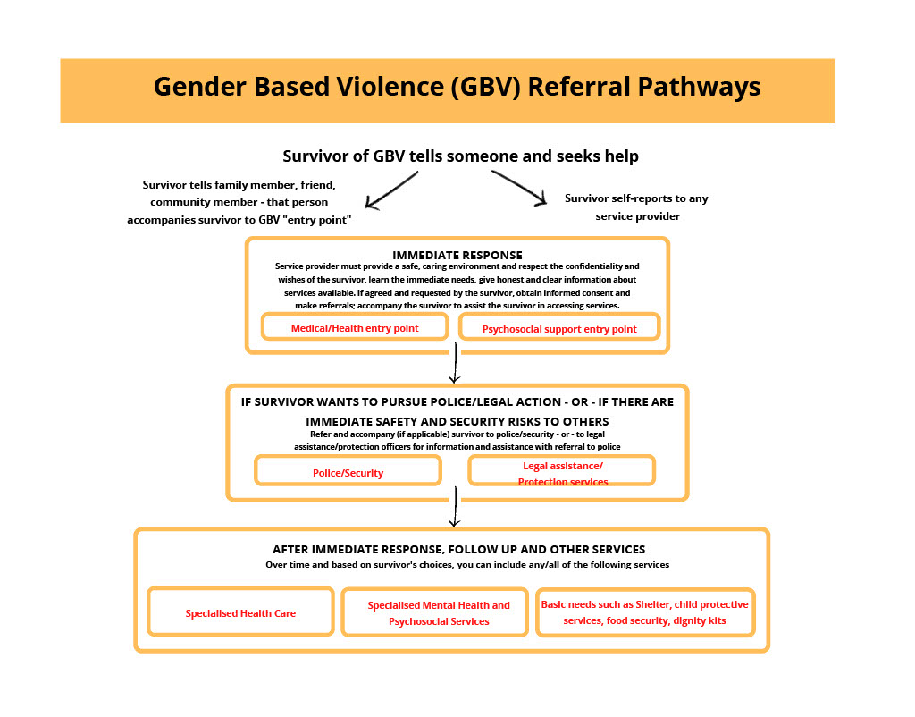

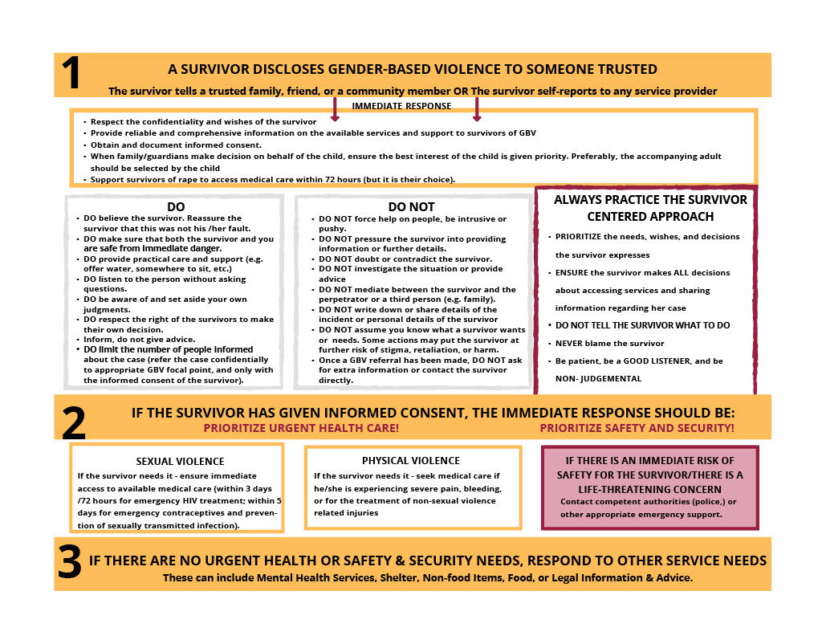

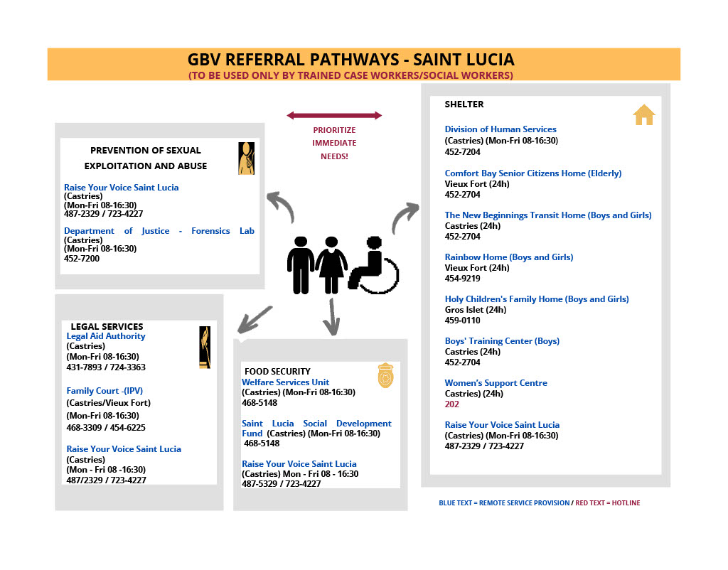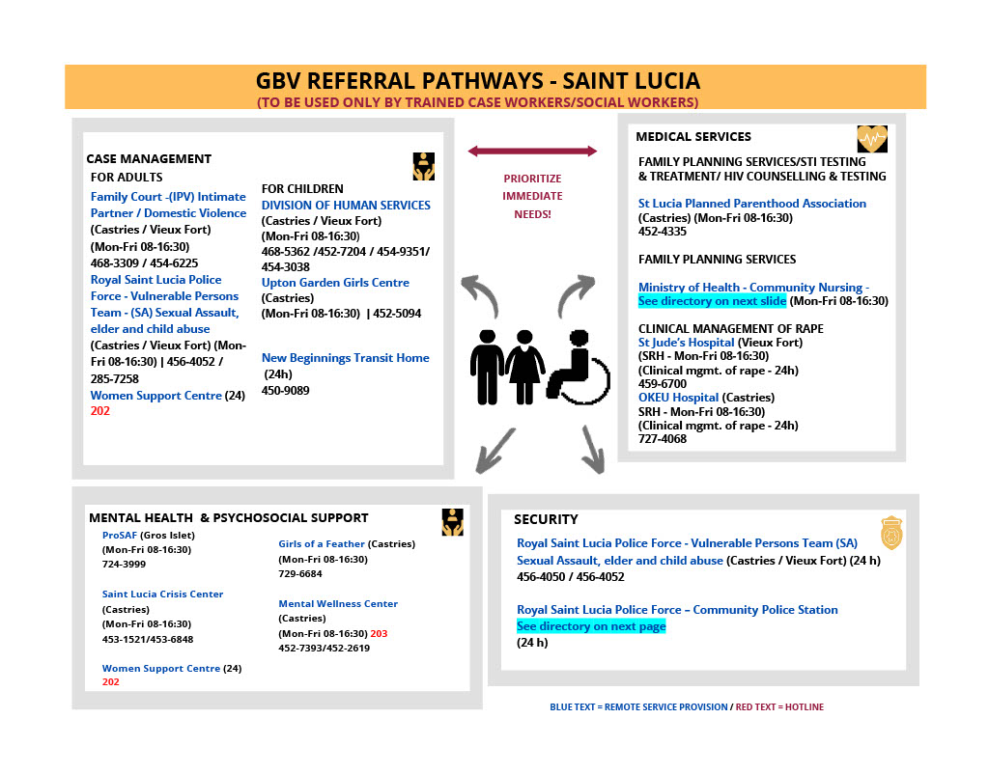

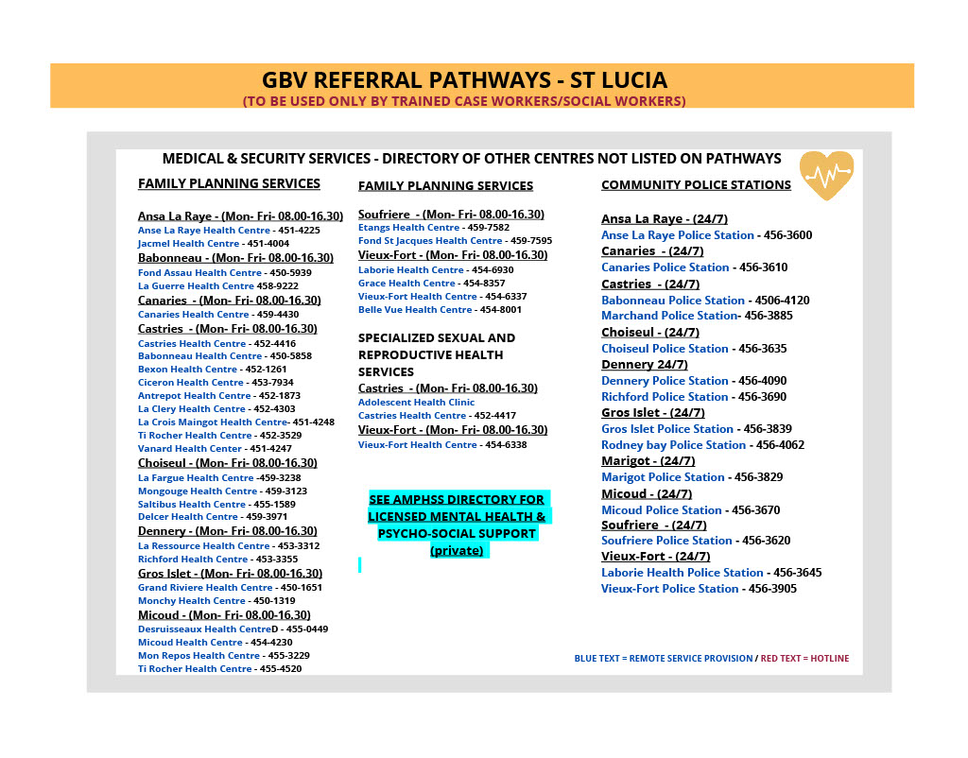

End of Document

1. The Project will not employ primary supplier, community labour or security forces. Government civil servants, who may provide support to the Project, will remain subject to the terms and conditions of their existing public sector employment agreement unless there has been an effective legal transfer of their employment or engagement to the project. ESS2 will not apply to such government civil servants, except for the provisions of Protecting the Work Force and Occupational Health and Safety.
2. Consultants will be hired to achieve some of the results under both Components 1 and 2. These are outlined below.
3. Firm with persons with various skills
4. Firm with persons with various skills
5. Division 9 no. 122 and 127 speaks to the prohibition of child labour as well as the penalties for engaging in child and young persons’ labour. Part II no. 6 speaks to Prohibition against forced labour.
6. According to the Education Act, no 41 of 1999, Division 3 27, the minimum school leaving age is 15.
7. Work considered hazardous for children is work that, by its nature or the circumstances in which it is carried out, is likely to jeopardize the health, safety, or morals of children. Examples of hazardous work activities prohibited for children include work: (a) with exposure to physical, psychological or sexual abuse; (b) underground, underwater, working at heights or in confined spaces; (c) with dangerous machinery, equipment or tools, or involving handling or transport of heavy loads; (d) in unhealthy environments exposing children to hazardous substances, agents, or processes, or to temperatures, noise or vibration damaging to health; or (e) under difficult conditions such as work for

   long hours, during the night or in confinement on the premises of the employer.
8. Division 1; Contracts of Employment, Division 8; Public Contracts, Division 10; Termination of Employment
9. The aggrieved must be adequately notified of the time and venue of the grievance meeting and submit the name and contact information of the party who will attend the meeting with him or her.
10. See in annex II, Template for reporting on incident and accidents
11. While an RCA per se is not mandatory, especially in cases where information is clear and readily available., it is nonetheless essential that the Borrower and Bank understand very well the underlying cause(s) of the incident, in order to agree on measures to prevent recurrences