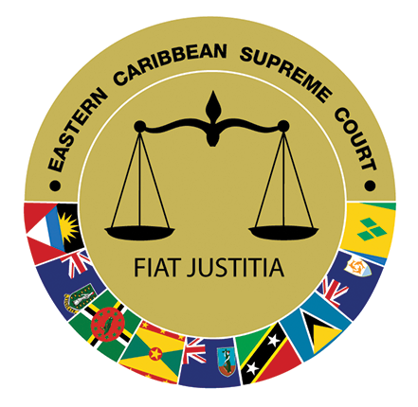
VACANCY NOTICE

Applications are invited from suitably qualified persons for appointment to the post of Executive Legal Assistant to the Chief Justice within the Eastern Caribbean Supreme Court, Saint Lucia.

JOB DESCRIPTION

JOB TITLE : Executive Legal Assistant to the Chief Justice

REPORTS TO : Chief Justice

CLASSIFICATION : MPP-5

A. DUTIES AND TASKS

- Undertake legal research for Chief Justice and Managing Judge.

- Prepare opinions for the Chief Justice.

- Perform research relating to the drafting of rules, practice directions, practice memorandum and practice guides.

- Prepare first drafts of speeches and addresses to be delivered by the Chief Justice.

- Prepare speaking notes for the Chief Justice for judicial functions.

- Investigate complaints made to the Chief Justice.

- Identify issues as regards efficiency, effectiveness and economy of the Court.

- Prepare Bench Memoranda for sittings of the Court of Appeal as may be directed by the Chief Justice.

- Prepare for delivery judgments written by the Chief Justice.

- Draft judgments for consideration.

- Prepare summaries of recently decided cases from final courts in the Commonwealth that may be of interest to the Chief Justice.

- Assist the Chief Justice, Managing or Administrative Judge with reform activities and duties arising under various enactments to be performed by the Chief Justice.

- Prepare legal opinions for the Managing Judge.

- Such other related tasks as may be assigned by the Chief Justice.

B. SKILLS, KNOWLEDGE AND ABILITIES

The incumbent should possess:

- The ability to interpret and apply laws.

- Sound working knowledge of civil and criminal practice and relevant rules of the Eastern Caribbean Supreme Court.

- A sound working knowledge of information technology applications.

- A demonstrated ability to communicate effectively both orally and in writing.

- Excellent planning and organization skills.

- Sound analytical skills.

- Understanding the need and respect for confidentiality.

- Keen eye for detail.

C. QUALIFICATIONS AND EXPERIENCE

Qualifications and skills must include the following:

      - A Bachelor’s Degree in Law.
      - A Legal Education Certificate recognized in Saint Lucia.

      - Five (5) years prior relevant working experience in a similar environment.
A working knowledge of or specialized training in the following areas would be an asset:

  - The Constitutions of the Eastern Caribbean Member States.

  - Treaties and Agreements of the OECS in relation to the Eastern Caribbean Supreme Court.

  - Legislative Drafting.

  - Protocol

  - Communication.

Applications, along with two references and certified copies of documents pertaining to qualifications, should be addressed to:

The Secretary
Judicial and Legal Services Commission
2nd Floor, Heraldine Rock Building
The Waterfront
Castries
Saint Lucia, W.I.

to reach him no later than Friday, 30th June 2023.

NB: Applications may also be submitted via email to jlsc@eccourts.org. Unsuitable candidates will not be acknowledged. Candidates meeting the minimum qualifications and experience may not be considered for an interview. Only the candidates with the best qualifications and experience will be shortlisted for interview.

