# saint lucia coat of arms

**Ministry of Education, Sustainable Development, Innovation, Science,**

**Technology and Vocational Training**

## PRESS RELEASE

**OAS Master of Arts in Development Studies**

The Organisation of American States (OAS), through the Department of Human Development, Education and (DHDEE) and The International Institute of Social Studies (ISS) are offering scholarships to individuals desirous of pursuing the Master of Arts in Development Studies.

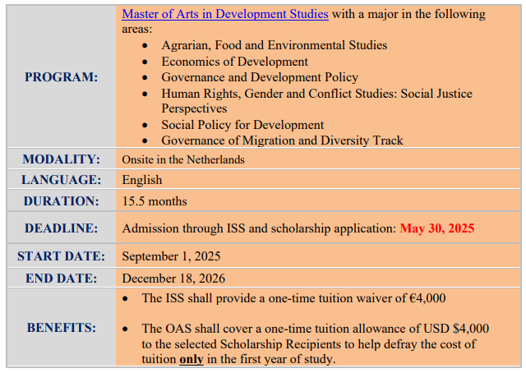

**NB: Scholarship benefits are subject to the academic performance of the scholarship recipient and based on the availability of funds. In order to receive these benefits, the scholarship recipient should not be reported with an unsatisfactory academic performance due to absences or failing courses.**

For additional information on this scholarship opportunity, interested applicants should visit the Master in Development Studies scholarship link at the OAS website:

<https://www.oas.org/en/scholarships/PAEC/2025/2025-OAS-ISS-Scholarship-Program-Announcement.pdf>

**Eligibility Requirements**

To be considered for this scholarship opportunity, an applicant must:

* Provide an unconditional admission letter from ISS;
* Be a citizen and/or permanent legal resident of any OAS member state.

…/2

2\...

The following applicants are ineligible:

* Current OAS scholarship recipients;
* OAS General Secretary, (GS/OAS) staff and their immediate relatives or GS/OAS consultants; and
* OAS Permanent officials and their immediate relatives.

**ADMISSION PROCESS**

Detailed information about the programme and profile of student’s is available through the following link: <https://www.iss.nl/en/education/ma-development-studies>.

Students are encouraged to read the programme description and ensure that the study area fulfills expectations and interests. For information about the Institute’s application process for this programme, please visit the Institute’s website: <https://www.iss.nl/prospective_students/apply_to_iss/>.

Interested applicants can contact The International Institute of Social Studies Admission’s Office at [admission@iss.nl](mailto:admission@iss.nl) for more information about the university’s admission process.

**EXPENSES NOT COVERED BY SCHOLARSHIP**

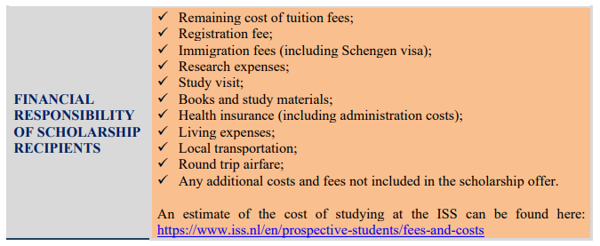

**SCHOLARSHIP SELECTION PROCESS**

Please note that the names of the scholarship recipients will be published in May/June at [www.oas.org/scholarships](http://www.oas.org/scholarships). In addition, the OAS will contact selected candidates by email with the scholarship offer and instructions. **Applicants who are not selected will not be contacted.**

Questions about this scholarship opportunity should be sent to [scholarships@oas.org](mailto:scholarships@oas.org) with the subject heading “OAS-ISS Scholarship programme”.

**Deadline for the submission of applications is May 30, 2025.**

***… End of Press Release******…***

**April 24, 2025**

*/bm*