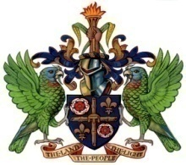

Ministry of Education, Sustainable Development, Innovation, Science, Technology and Vocational Training

PRESS RELEASE

UNIVERSITY OF NORTHERN IOWA 2025 SCHOLARSHIP OPPORTUNITY

The General Secretariat of the Organization of American States (GS/OAS) and The University of Northern Iowa (UNI) in the United States have decided to support outstanding individuals from the Americas by awarding the following academic scholarships to continue their studies.

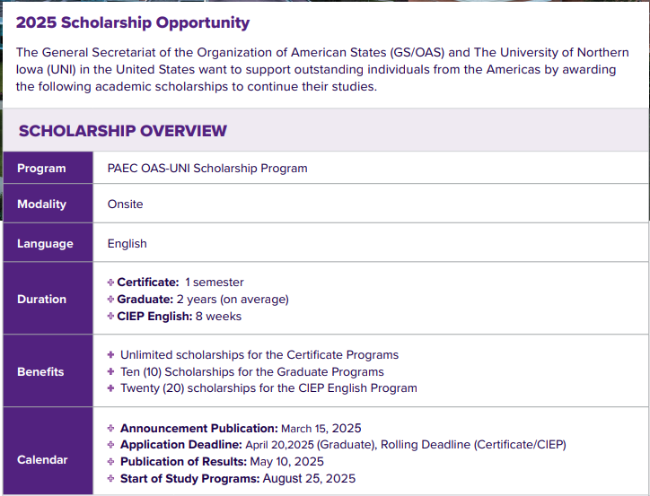
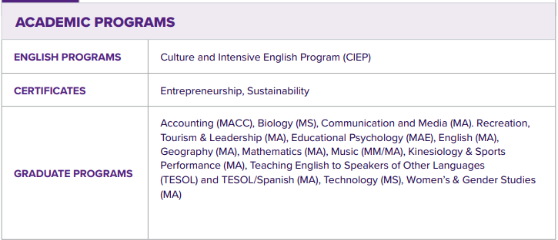

…/2

2\...

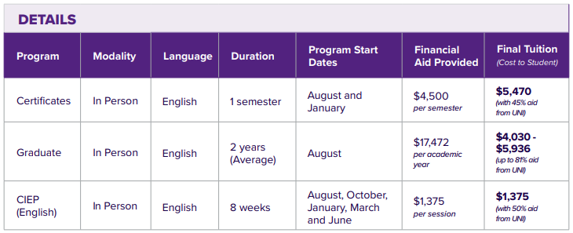

EXPENSES NOT COVERED BY THIS SCHOLARSHIP
Expenses not covered by this scholarship, falling under the sole responsibility of the scholarship recipients, are as follows:
- remaining tuition and fee costs
- housing costs
- meal plans
- round-trip airfare
- health insurance fees
- books and study materials
- any additional charges not expressly covered by the OAS-UNI PAEC Scholarship

For information on additional benefits for this scholarship offer, interested applicants should visit https://www.oas.org/en/scholarships/PAEC/2024/Announcement-Univ_Northen_Iowa.pdf.

APPLICATION PROCEDURE
Interested applicants should submit completed an application for admission at https://admissions.uni.edu/international/apply along with all supporting documents. Graduate and certificate studies require the submission of academic transcripts, proof of English proficiency, and programme-specific requirements. More information on the CIEP application can be found at https://internationalengagement.uni.edu/ciep. All programmes require students to submit the Financial Guarantee before receiving immigration documents.

For all UNI admission questions, please email UNI at international.admissions@uni.edu. For any OAS scholarship questions, please email OAS at scholarships@oas.org with the subject “OAS University of Northern Iowa Scholarship Programme.”

The Deadline for the submission of applications is April 20, 2025.

… End of Press Release …

March 14, 2025

/ra

