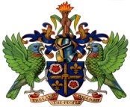

**Ministry of Education, Sustainable Development, Innovation, Science,**

**Technology and Vocational Training**

**PRESS RELEASE**

**2024- 2025 OAS - UNIVERSIDAD DEL DESARROLLO**

**SCHOLARSHIP OPPORTUNITY**

The General Secretariat of the Organization of American States (GS/OAS) and Universidad del Desarrollo in Chile have decided to support outstanding individuals from the Americas by providing the opportunity for individuals to pursue a certificate in Global Innovation and Entrepreneurship.

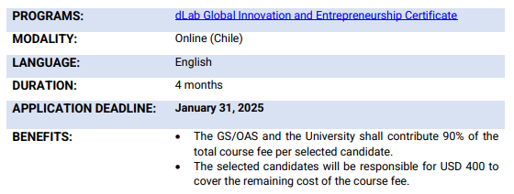

The Course will start online, through the UDD’s online teaching platform, Canvas, from April 30 – August 30, 2025. Interested applicants should submit a complete online application package including all supporting documents, via [Organization of American States (oas.org)](https://www.oas.org/fms/Announcement.aspx?id=1150&Type=4&Lang=Eng).

For additional information on this scholarship opportunity, interested applicants should visit the certificate [**https://bit.ly/oas-udd**](https://bit.ly/oas-udd). For queries about this offer and guidance on the application process, please send emails to [scholarships@oas.org](mailto:scholarships@oas.org) with the subject, “OAS-UDD Scholarship programme”.

**Deadline for the submission of applications is January 31, 2025.**

***… End of Press Release******…***

**December 3, 2024**

*/bm*