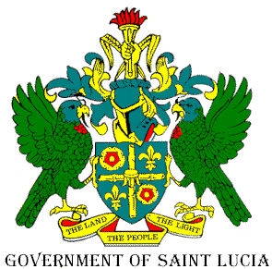

Department of Agriculture, Fisheries, Natural Resources and Co-operatives

4th & 5th Floor, Sir Stanislaus James Building
Castries, Saint Lucia

September 14, 2020

Press Release

All members and persons having claims on the funds of the OLIVE BRANCH FRIENDLY SOCIETY are asked to deliver their passbooks or proof of interest to the Office of Register of Friendly Societies located at the Department of Co-operatives, Unit 5, Colony House, John Compton Highway, Castries for verification no later than 30th September 2020.

Egbert Stevens (Mr.)
Registrar of Friendly Societies.

…………………………………..
Barrymore Felicien (Mr)
Permanent Secretary

/wsn

Telephone: (758) 452-2526 Email: ps.agriculture@govt.lc Website: www.moa.malff.com Fax: (758) 453-6314

