NOTICE

GREAHAM LOUISY ADMINISTRATIVE BUILDING

DRESS CODE   
IN EFFECT

The Department of Public Service solicits your cooperation as we seek to maintain an acceptable level of professionalism and proper office etiquette.

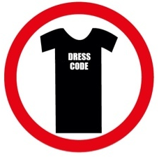

IN FULL

EFFECT

The following is provided as a guide when visiting the offices of the GREAHAM LOUISY ADMINISTRATIVE BUILDING:

* NO BANDANAS OR DO-RAGS
* NO HALTER TOPS/SPAGHETTI STRAPS OR TANK TOPS
* NO BARE STOMACHS OR BACKS
* NO OUTRAGEOUSLY SHORT SHORTS, SKIRTS OR DRESSES
* NO T-SHIRTS WITH OFFENSIVE WORDS
* NO VISIBLE UNDERWEAR