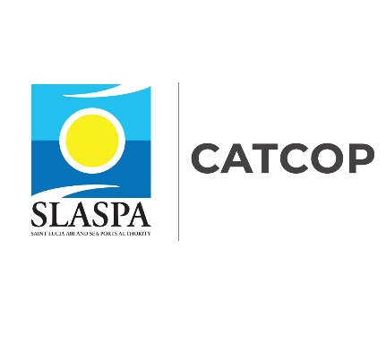
CARIBBEAN REGIONAL AIR TRANSPORT CONNECTIVITY PROJECT – SAINT LUCIA (CATCOP-SL)

Grievance Redress Mechanism (GRM)

Project Overview
The Government of Saint Lucia has received financing from the World Bank Group Financing (WB) through the International Development Association (IDA) to implement the Caribbean Regional Air Transport Connectivity Project (CATCOP). The CATCOP will be implemented by the Saint Lucia Air and Sea Ports Authority (SLASPA), and implementation of the project will be executed by a Project Implementation Unit (PIU).

The Project Development Objectives are to (i) improve operational safety and navigation efficiency of air transport and (ii) enhance resilience of Saint Lucia’s airport infrastructure to natural disasters. There are five (5) major components with sub project activities under each component of the project. Total Project cost is estimated at US$45 million, and implementation is anticipated to require about six years – from 2020 through 2026.

The five major components are listed below:
Component 1: Improvement of UVF Runway Safety and Resilience
Component 2: Modernization of Air Navigation Systems
Component 3: Institutional Strengthening
Component 4: Project Management
Component 5: Contingent Emergency Response

Grievance Redress Mechanism
The Grievance Redress Mechanism (GRM) is designed for addressing the legitimate concerns of the project affected persons. The objective of the GRM is to solve disputes at the earliest possible time that emanate from the project activities.

COMPLAINT FORM

To be completed by Complainant/Project Affected Person

COMPLAINANT INFORMATION
Name:
Address:
Phone:
Email:
COMPLAINT INFORMATION
Complaint Date:
Complaint Location:
Complaint Details:

Suspected cause of the problem:

What should be considered to avoid a repeat of the problem?

Name of person completing this form:
Signature:
Date:

For complaints, please contact Tel: (758) 457-6168 or email: catcop@slaspa.com

