Annual report of the Minister for the Public Service, Sustainable Development, Energy Science & Technology

April 2013 - march 2014
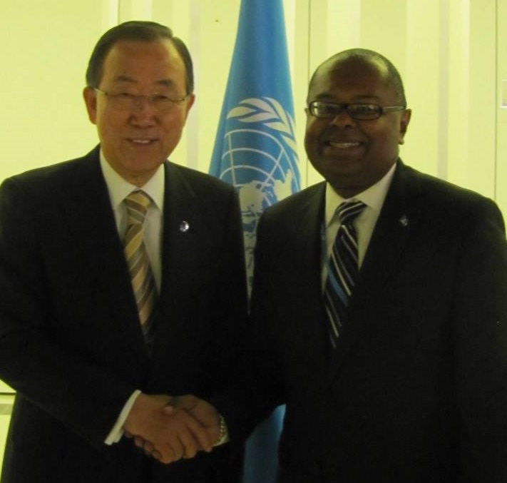

Table of Contents
Preface by the Honourable Minister for the Public Service, Sustainable Development, Energy, Science and Technology 3
Message by the Permanent Secretary in the Ministry of the Public Service, Information and Broadcasting 5
Message by the Permanent Secretary in the Ministry of Sustainable Development, Energy, Science and Technology 8
Mission and Vision of Ministries 11
Mission Statement of the Ministry of the Public Service, Information and Broadcasting 11
Vision Statement of the Ministry of the Public Service, Information and Broadcasting 11
Mission Statement of the Ministry of Sustainable Development, Energy, Science and Technology 11
Vision Statement of the Ministry of Sustainable Development, Energy, Science and Technology 11
Acroynms 12
Effective Management of the Public Service 14
Human Resource Management 14
Human Resource Development 17
Organisational Development 19
Industrial Relations 22
Public Sector Transformation 25
Telecommunications Sector 29
Caribbean Regional Communications Infrastructure Project 29
National Information and Communication Technology (ICT) Office 30
The Government Information Service 34
Information Dissemination 34
The Broadcasting Sector 36
The Revitalisation of RSL 36
Our Legislative Agenda 39
Ministry of the Public Service, Information & Broadcasting 39
Ministry of Sustainable Development, Energy, Science and Technology 42
An Energy Revolution 47
Renewable Energy 48
Energy Efficiency 50
Responsible Management of our Water Resources 53
A viable Water and Sewerage COMPANY (WASCO) 53
Water Resource Management Agency 59
Vieux Fort and Dennery Water Supply Development Project 64
Environmental Management 66
Policy and Governance 66
Protected Areas Management 68
Climate Change 72
Coastal Zone Management 74
Biodiversity and Biosafety 76
Forest and Land Resource Management 80
Solid Waste Management 86
Public Utilities 92
Science and Technology 97
Closing Remarks 102

Preface by the Honourable Minister for the Public Service, Sustainable Development, Energy, Science and Technology
I am pleased, once again, to present this Annual Report of the Ministries of the Public Service, Information and Broadcasting and Sustainable Development, Energy, Science and Technology, for the Financial Year April 2013 to March 2014. This Report, in essence, is a record of the performance of these ministries under my stewardship and identifies the measures taken by the respective agencies to advance the work programme of the Government.
This year we have used a different format from last year to present the Report. Whereas last year the Report was organized according to departments, this year we present our accomplishments by sectors. We believe the revised format will make the Report more relevant to our clients outside of the Public Service, who are not as concerned about the workings of individual departments as they are about the impact of that work on areas to which they can relate and in which they have an interest.
The last Financial Year has been challenging. Like all other Government agencies, we were called on to make greater use of the scarce resources available to us. Because of the pivotal role the Ministry of the Public Service plays in the operations of the Service, it had to lead the charge in finding ways to make the delivery of services more cost-effective. As a result, several new initiatives were embarked upon that should result in significant medium and long-term efficiency improvements in the Public Service. The Information and Broadcasting portfolio also underwent a major reorganization with the deployment of Information Officers and Technicians to strategic Government ministries in an effort to improve the reporting and dissemination of information by these agencies.
The year was also a busy one for the water and energy portfolios. The restructuring of the water sector continued with the establishment of the National Water and Sewerage Commission and the award of the first water tariff increase for over a decade. This increase, together with management-led changes in the way in which WASCO, the water utility company, operates has introduced a greater sense of stability in the water sector and although it is still early days, the improvements in WASCO’s operations are already being noticed. In the energy portfolio, much effort was expended in shaping the institutional environment for the Government’s sustainable energy programme.
The environment portfolio, as managed by the Forestry and Sustainable Development and Environment departments, also had its fair share of challenges. There were the usual issues of ensuring that we met our obligations to the several multilateral environmental agreements (MEAs) to which we are party but, more critically, we had to complete the long-awaited Limits of Acceptable Change (LAC) Study for the Pitons Management Area (a UNESCO World Heritage Site) and assist in the national recovery effort after the unfortunate passage of the Christmas Eve Trough.
I want to thank the staff of the two ministries for their hard work, dedication and professionalism during the year. We set ourselves very high standards and it was heartening to see everyone constantly striving to meet and surpass these standards. Despite the size of the work load and the constraints within which they operated, there was always an excellent esprit de corps among the staff, and the respective senior management teams must be commended for this. I also wish to thank our clients and stakeholders for their support and encouragement during the year. Finally, my heartfelt gratitude to our Development Partners who continued to provide us with assistance, in so many different forms. Without them we would not have been able to achieve much of what we did during the year.

Message by the Permanent Secretary in the Ministry of the Public Service, Information and Broadcasting
The 2013-2014 Financial Year continued to be a year of consolidation and building on previous achievements for the Ministry of the Public Service, Information and Broadcasting. The Ministry implemented policies, projects, and programmes to improve service delivery, implement cost effective measures and strengthen transparency and accountability in the Public Service.

One of the key priorities in the review period was to undertake institutional improvements in the Ministry to allow it to function more effectively within and across the Public Service. As part of the process of streamlining and rationalizing its operations, there were some major organizational changes implemented by the Ministry in the 2013-2014 Financial Year. The Government Information Service (GIS) was restructured, resulting in the redeployment of Information Officers and Technicians to other line ministries. This measure is intended to improve the dissemination of information on the Government’s programmes and projects. We are already beginning to see the benefits of this policy initiative as some of the agencies are now disseminating far more information on their work programmes.

The establishment of the National Broadcasting Network is at an advanced stage and is expected to be finalized within the first quarter of the upcoming financial year. In an effort to provide a coordinated and strategic approach to information and communication technology (ICT) and to optimize the utilization of ICT human resources within the Public Service, Cabinet approved the redeployment of ICT Officers from line agencies to the Division of Public Sector Modernization. The Computer Centre Limited, which has been renamed as the Government Information Technology Services Ltd was also placed under the Ministry of the Public Service, Information and Broadcasting.

In the area of legislative reform, the Ministry is at an advanced stage in finalizing a number of key pieces of legislation. The Public Service Management Bill has been reviewed by the working group and will be sent to all stakeholders to solicit comment and feedback. It is anticipated that the Broadcast and ICT Legislation will be tabled in Parliament during the first half of the 2014-2015 Financial Year.

The Ministry is working on a number of key initiatives to improve human resource management and development. These include the implementation of the new performance appraisal instrument, which is on-going, the finalization of the recruitment and selection guidelines which are being undertaken in collaboration with the Public Service Commission, and the revision of the Training and Development Policy. Given the constraints faced in completing the revision of job descriptions, the Ministry has taken a more targeted approach, focusing on a few agencies at a time.

Several of the buildings that house government offices are not fit for occupation and there is a need to relocate these offices. The Ministry has experienced significant challenges in securing finance and suitable office accommodation to meet the demands of agencies which need to be relocated. While progress has been made in relocating some offices, the Ministry will examine feasible options that quicken the rate of implementation of projects for relocating other government offices.

The Division of Public Sector Modernization continued to implement a number of activities that were geared at improving service delivery, efficiency and improving access to information. There were a number of significant accomplishments in the 2013-2014 Financial Year. These include, inter alia, the completion of the Web Portal, the launching of the Digitization Project, the implementation of the Internet Exchange Point, the commencement of work on developing the Contact Centre and the Vehicle Tracking Management System. The On-Line Tax Filing Project as well as the Multi-Purpose Identification System were major projects funded by the Electronic Government for Regional Integration Project (EGRIP), which came to an end in the 2013 -2014 Financial Year.

The Negotiations Unit focused on the post-implementation activities related to the 2010-2013 Collective Agreements, as negotiations with all unions and associations, with the exception of the National Workers Unions, were completed by the end of the 2012 – 2013 Financial Year. The Negotiations Unit is also collaborating with the Department of Finance, Economic Affairs and Social Security on a new framework for negotiations.
The Ministry of the Public, Information and Broadcasting is in the process of finalizing its Strategic Plan for the period 2014-2017. The Ministry has identified a number of key policies, priorities and initiatives that will contribute to transforming the public service into a more service-oriented and efficient organization that responds to the needs of both its internal customers and to the citizens of Saint Lucia.

Finally, I wish to thank the Minister for his vision, inspiration and direction and to the Managers and Staff of the Ministry for their support, commitment and perseverance in helping us build a better public service that supports our national development and improves the lives of citizens.

Message by the Permanent Secretary in the Ministry of Sustainable Development, Energy, Science and Technology
The Ministry of Sustainable Development, Energy, Science and Technology has just completed its second year as a new and independent Ministry, with all the attendant challenges and opportunities described in last year’s report. The expectations of consolidating the diverse departments and units into a functional, cohesive and united entity to “lead the charge of sustainable development on the platform of integrated and effective environmental management” have been realised beyond the indicators anticipated.

The Administrative Section was able to resolve several long-standing human resource complaints, find creative ways to upgrade staff positions and create mobility for stagnated public officers, even within a tight fiscal situation. Staff members also participated in a staff retreat at the end of the Financial Year, where the entire Ministry was brought together for the first time, to foster a spirit of togetherness and commonality of purpose among members.

The Sustainable Development and Environment Division (SDED) continued to mobilize significant resources for its work and launched the Project Preparatory Phase for two critical projects valued at US$12M and US$2.3M respectively: The Pilot Project on Climate Resilience - Disaster Vulnerability Reduction Project will prepare Saint Lucia to better adapt to the impacts of Climate Change, whilst the Iyanola Natural Resource Management of the North East Coast Project will seek to prepare management plans for the last stronghold of rare and endemic animal and plant species in the richly diverse north-east area of Saint Lucia.

The SDED also launched the Green Economy Project, which is intended to help Saint Lucia restructure its economy by focusing on sustainable consumption and production practices and preparing for the wave of environmentally-friendly technologies expected to drive future global economies.

The skilful negotiating team of the SDED continued to represent Saint Lucia proudly at major international meetings and conferences related to various Multilateral Environmental Agreements. The SDED is also implementing the Framework for Environmental Management project, which is intended to develop a governance and management framework by reviewing policy, legislation and the institutional arrangements for environmental management in Saint Lucia.

The Protected Area Management Unit successfully facilitated the completion of the much-anticipated Limits of Acceptable Change (LAC) study for the Pitons Management Area, providing useful parameters for which the Development Control Authority could now guide the sensitive development of tourism and other infrastructure within the area. The LAC will facilitate important and critical economic expansion in the Soufriere region.

The Biodiversity and Biosafety Unit completed the National Biodiversity Strategy and Action Plan, which provides a strategy for optimising the flora and fauna resources of Saint Lucia and preparing the country to access benefits from these resources. It also completed national consultations towards the realisation of a Biosafety Policy and Bill, which will address the issue of genetically modified organisms in our food supply, among other things.

The Department of Forestry has made significant strides towards preparations for the development of a Forest Sector Plan. The Saint Lucia Forest Restoration and Rehabilitation Project, a response to reforestation needs after the damage caused by Hurricane Tomas in 2010, is nearing completion. Of critical importance is the reforestation of slopes adjacent to the John Compton Dam, which is necessary for the long term stability of this region and to mitigate heavy siltation of the dam during intensive weather conditions. The Department is also making significant progress with its wildlife protection programme through an Invasive Alien Species reduction project.

The Water Resources Management Agency boasts several achievements in the development of a comprehensive hydrology network linked to early warning systems. A study identified Castries (Marchand) as the most vulnerable area to flooding, followed by Anse La Raye. The Agency conducted research work on groundwater, identifying six potential wells. It also developed an inventory on wastewater sites, thus singling out vulnerable watersheds and determining hotspots.
The Energy, Science and Technology Unit has made significant strides in managing and facilitating the introduction of renewable energy into the energy mix in Saint Lucia. This has resulted in the commencement of negotiations in earnest with both geothermal and wind developers, after careful scrutiny, due diligence and thorough technical support from several international agencies.

The Public Utilities Department has worked closely with the Energy, Science and Technology Unit and the Legal Officer, particularly with respect to the setting up of the National Utilities Regulatory Commission. This required reviews of issues related to licensing for water, fee schedules, and the necessary amendments to the Water and Sewerage Act consequent to the establishment of the Commission as an umbrella regulatory agency. Support was also provided to the proposed Eastern Caribbean Energy Regulatory Authority (ECERA) project, which seeks to set up a regional regulatory body for energy.

The Public Utilities Department was also involved in the PetroCaribe initiative by leading the negotiations with the Venezuelan Government on a new model bi-lateral agreement for the purchase of fuel from Venezuela. From there, the parties were able to move towards verifying gas specifications to inform the sales contract and negotiations with traditional regional suppliers of petroleum.

In the area of Science and Technology; tourism, agriculture and manufacturing were identified as priority areas for focus after a series of national consultations and assessments. This has resulted in the drafting of a Science and Technology Policy for Saint Lucia.

The Ministry of Sustainable Development, Energy, Science and Technology continues to remain true to its Strategic Plan, despite the fact that this plan is still under active review. That notwithstanding, it is clear that this new Ministry is maturing and beginning to operate more and more as a single, cohesive unit. Despite the many challenges faced during the year, the Ministry continues to strive to achieve the goals that it has set for itself and for our country.

Mission and Vision of Ministries

Mission Statement of the Ministry of the Public Service, Information and Broadcasting
To lead, facilitate and regulate Human Resource Management/Development and Information Communication Technology in order to deliver efficient and effective public service to our customers.

Vision Statement of the Ministry of the Public Service, Information and Broadcasting
An exemplary and goal-oriented Ministry dedicated to the delivery of excellent public service.

Mission Statement of the Ministry of Sustainable Development, Energy, Science and Technology
To lead the process of achieving sustainable development through the facilitation of an integrated and participatory approach to governance; the promotion of environmental management and innovative technologies; building capacity to adapt and mitigate the impacts of climate change; and demonstrating the value of building a green economy.

Vision Statement of the Ministry of Sustainable Development, Energy, Science and Technology
To achieve sustainable development on a platform of integrated and effective environmental management in order that socio-cultural, economic and environmental goals are realised and collectively contribute to the continuous improvement in the quality of life of all Saint Lucians.

Acroynms

AUSAid Australian Agency for International Development
CARCIP Caribbean Regional Communication Infrastructure Project
CDB Caribbean Development Bank
CFC Chlorofluorocarbons
CITES Convention on International Trade in Endangered Species
EC Eastern Caribbean
ECERA Eastern Caribbean Energy Regulatory Authority
ECTEL Eastern Caribbean Telecommunications Authority
EDRMS Electronic Document and Records Management System
ESA Electricity Supply Act
GEF Global Environmental Facility
GIS Government Information Service
GITS Government Information Technology Services
GOSL Government of Saint Lucia
HIPCAR Harmonization of ICT Policies, Legislation and Regulatory Procedures in the Caribbean Project
HR Human Resource
IRD Inland Revenue Department
ICDF International Cooperation and Development Fund
IXP Internet Exchange Point
IWECO Integrating Water, Land Resources and Ecosystem Management in Caribbean Small Island Developing States
IWRIS Integrated Water Resource Information System
LED Light Emitting Diode
LUCELEC Saint Lucia Electricity Services Ltd
MOU Memorandum of Understanding
MPSIB Ministry of the Public Service, Information and Broadcasting
MSDEST Ministry of Sustainable Development, Energy, Science and Technology
NBN National Broadcasting Network
NTN National Television Network
NWSC National Water and Sewerage Commission
ODS Ozone Depleting Substances
OECS Organisation of Eastern Caribbean States
PBX Private Branch Exchange Point
PMA Pitons Management Area
PPCR-DVRP Pilot Programme on Climate Resilience – Disaster Vulnerability Reduction Programme
RSL Radio Saint Lucia
SDED Sustainable Development and the Environment Division
SIDS Small Island Developing States
SLSWMA Saint Lucia Solid Waste Management Authority
TOR Terms of Reference
UNEP United Nations Environmental Program
UNESCO United Nations Educational, Scientific and Cultural Organization
UNFCCC United Nations Framework Convention on Climate Change
UNIDO United Nations Industrial Development Organization
USD United States Dollars
WASCO Water and Sewerage Company
WRMA Water Resource Management Agency

Effective Management of the Public Service
The effective management of the public service is the responsibility of the Ministry of the Public Service, Information and Broadcasting. There are several divisions within the Ministry that cater to the management of the human resource. This entails the areas of human resource management, human resource development and organisational development. The Ministry also houses a unit responsible for overseeing relations with trade unions, as well as the occupational health and safety of the Public Service.

Human Resource Management
The Human Resource Management Division is charged with the provision of human resource services for the Public Service, particularly in the areas of recruitment, promotion and performance management and includes the development and implementation of human resource policies and strategies which will lead to the effective management of human resources.

The following are some of the noteworthy aspects of the Division’s work programme:

- Facilitate the recruitment, selection and placement of suitable human resources across the Public Service. The Division recommends candidates to the Public Service Commission for promotion, appointment, transfer and other staff movements. The Division made a number of recommendations for staff movement during the Financial Year, with a 98% approval rate by the Public Service Commission.
Staff Movements from 2009 to 2013
Staff Appointments | 2009 | 2010 | 2011 | 2012 | 2013
Acting Appointments | 215 | 313 | 495 | 711 | 902
Promotions | 569 | 381 | 566 | 430 | 166
Appointments | 230 | 359 | 270 | 263 | 105
Transfers | 55 | 43 | 36 | 82 | 35
Resignations | 7 | 7 | 21 | 15 | 28
Terminations | 0 | 0 | 0 | 0 | 2
Professional Cadets | 7 | 7 | 2 | 8 | 3

The Division has endeavoured to process recommendations for appointment within a reasonable timeframe. It set a target process time for appointments of five working days. 90% of all complete recommendations received by line ministries/departments have been processed within the allotted time. However, recommendations are usually delayed due to errors made on the standard form for recommendations, incomplete submissions and late submission of recommendations by line ministries. The Division continues to assist HR Officers throughout the Public Service in ensuring that errors are minimized.

- Develop a new performance appraisal system for the Public Service. This initiative was piloted in three (3) ministries and one (1) department, namely, Ministry of the Public Service, Information and Broadcasting; Ministry of Physical Development, Housing and Urban Renewal; Ministry of Infrastructure, Port Services and Transport; and the Audit Department. On the basis of feedback received from these agencies, the preliminary performance appraisal instruments were revised in order to better address the needs of the Public Service. The new appraisal instruments have been finalized and ten (10) officers participated in a Train-the-Trainer course. These officers will assist in training managers, supervisors and officers throughout the Public Service for the successful implementation of the new system.

- Develop, implement and monitor human resource policies that will allow for more efficient management of the human resources of the Public Service. The Division is working towards better compliance and monitoring of existing human resource policies, such as the Staff Orders and the Pensions Act.
Consistent with efforts to ensure a thorough understanding of the human resource policies and to increase compliance, the Human Resource Management Division has met with staff of a number of government agencies to discuss government’s recruitment and promotion policy. Two quarterly meetings were also held with Human Resource Officers throughout the Public Service to discuss the expectations of the Public Service Commission and other matters relating to recommendations for staff movement.

In addition, the Division has developed a Recruitment and Selection Policy for the Public Service and this has been submitted to the Public Service Commission for approval. Prior to the implementation of the Recruitment and Selection policy, it will be presented to the Committee of Permanent Secretaries, the Committee of Human Resource Officers and key stake holders (including the Public Sector unions) in order to ensure that the provisions of the policy are understood.

- Administer compensation and benefits packages on a timely basis. This objective is two pronged; one goal is to facilitate the timely preparation of the terms and conditions of employment in accordance with the approved salaries and allowances for the position, and the other is the timely processing of pension and gratuity benefits.

Ninety-five percent (95%) of the terms and conditions letters and employment contracts were dispatched within three working days of receipt of the report for duty letter, during the current Financial Year. The accuracy rate of letters and contracts improved significantly; this was due to an added layer of vetting being performed by team leaders.

For the 2013-2014 Financial Year, the Division processed a total of 58 requests for compulsory retirements and 29 for early retirement. The late receipt of requests for retirement and contract gratuity continues to be an issue. The Division will continue to dialogue with ministries to improve this aspect of its work program.

Human Resource Development
The Training Division is the agency responsible for the human resource development for the Public Service. The Training Division provides training and educational opportunities to all levels of staff within the Public Service. This function is in keeping with the Government’s agenda to educate, train and motivate its employees. The work of the Training Division has been guided by the MPSIB’s Strategic Plan.

Below are some of the key result areas and achievements of the Training Division for the 2013-2014 Financial Year:

- The development and implementation of a Training Plan. The Training Division has developed a coherent Training Plan that aims to maximize results, given the Division’s scarce resources. The Training Plan targets key areas where there appears to be a deficiency or need at the Public Service level. The Division submits quarterly training schedules to all ministries, which outlines the training areas for each quarter.

- Continuation of the review and update of a number of existing policies that govern the Public Service. During the current Financial Year, the “Training Policy” and “Study Leave Bond” have been revised. The policies have been submitted for review and onward submission to the Cabinet of Ministers.

- Commencement of work on a Monitoring and Evaluation system to measure the impact of training. There is need for an indicator which measures the effectiveness and impact of training interventions. An evaluation tool has been developed and is being piloted. Full implementation of this system is expected in the new financial period.

- Trained 212 public officers through short-term overseas training and another 681 officers trained locally. The Division has made a concerted effort to optimize its financial allocation by increasing its in-house training in relation to overseas training. This strategy ensures that there is a greater spread of training across the Public Service. Training themes include but are not limited to peer monitoring, executive coaching, oral and written communications, preparing submission to Cabinet and customer service.

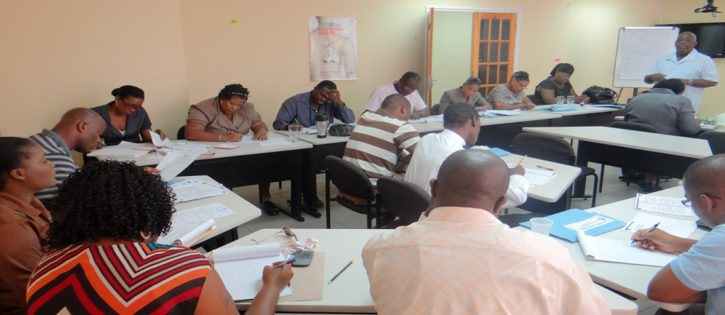
Training Session in one of the Training Rooms in the Training Department

- Continue assistance with study leave and tuition refund programmes:
- 26 new study leave with pay awards totalling $1,508,093.00
- 16 new study leave without pay awards
- 45 new awards for tuition refunds totalling $517,457
- 48 awardees for the European Development Fund Scholarship

The Division has faced some challenges in achieving the goals that it set for itself, with the primary one being resource constraints. It has attempted to use capacity and resources within other Ministries to assist in the execution of its mandate. The Division also recognizes there is need for a proper database to capture all the training data, including in-house training, information on available facilitators and overseas training. There are plans to liaise with the Government Information Technology Service (GITS – formerly Computer Centre Limited) on the use of Smart Stream to capture and record this critical information.

Organisational Development

The Organization Development Division continues in its efforts to improve performance in the Public Service at the individual, group and organization levels. Its primary goals are geared towards improving the ability of the Public Service to effectively respond to changes in its external environment, and increasing internal capabilities by ensuring the organizational structures, work environment, job designs and leadership/managerial processes fully harness employee motivation and help public officers function to their full potential.

Staffing constraints, the absence of the full cooperation of line ministries/departments and financial constraints continue to challenge the ability of the Division to satisfy all areas of its mandate. As a result, some of the targets set for the current financial year did not materialize. Notwithstanding the limitations, the Division has seen a number of successes during the fiscal year.

- Review of the Relocation Policy of the Public Service. This policy has been in effect for approximately nineteen years and has proven inadequate, thereby resulting in a myriad of issues. However, it remains an essential tool for the management of the relocation process, which is why the Division undertook a review of the Policy.

- Continued collaboration with the various ministries and departments to complete their job descriptions. The job description exercise continued in a number of agencies during the current financial period, and is expected to be completed during the first quarter of the new financial period. These agencies are:
- Ministry of Youth Development and Sports
- Attorney General’s Chambers
- Audit Department
- Ministry of Education, Human Resource Development and Labour
- Ministry of Social Transformation, Local Government and Community Empowerment
- Ministry of the Public Service, Information and Broadcasting

A critical component of the job writing exercise is the subsequent validation of the job descriptions. This process ensures the job description captures the major results for which the job is accountable, the values and characteristics of Public Service, and the depth and breadth of knowledge and skill required to do the job. The Division will train a small team of persons to assist in the validation process.

- Commencement of a management audit of Turning Point. The objectives of the audit are to evaluate how effectively the management systems of Turning Point are operating, identify areas for improvement and form recommendations for change. The audit should be completed by April 2014.

FacilitIES Management

- Relocation of the Adjudicator’s Office and the Collections Unit of the Civil Status Registry, which were housed on the William Peter Boulevard and High Street respectively, to the 20/20 Building on Brazil Street, within the same building that houses the Civil Status Registry. This new location will offer customers the convenience of applying for vital records, making rectification and collecting records under one roof.

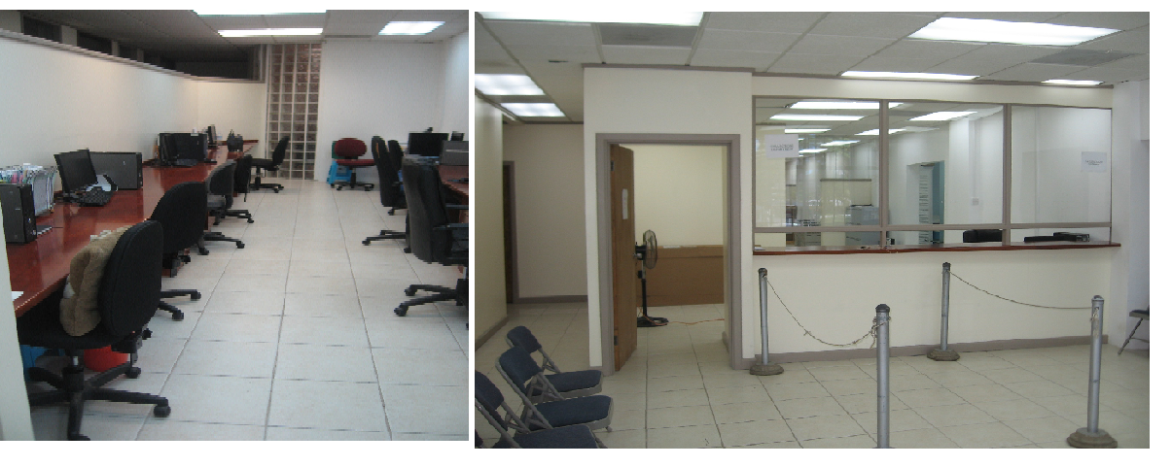
The Collection’s Unit after Relocation

- Undertake the second phase of renovations at Radio Saint Lucia. The library, newsroom, general office and studio block will all undergo a major facelift at the end of this project. Work will also be done on the electrical, plumbing and air-conditioning at Radio Saint Lucia.

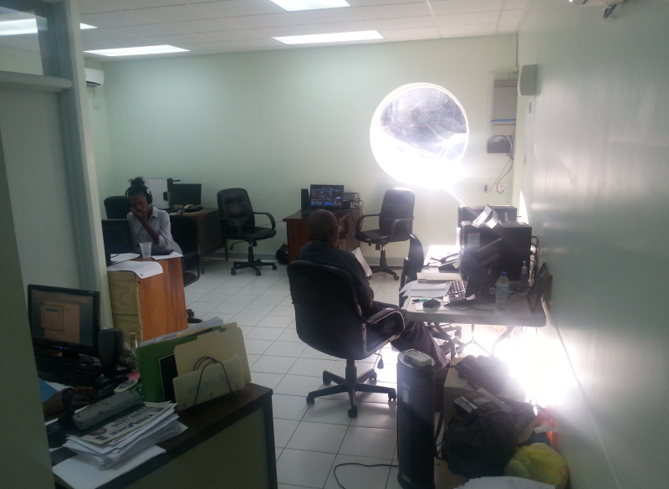
The Refurbished Newsroom of Radio Saint Lucia

- Repair of the roof of the Greaham Louisy Administrative Building. The objective of the project was to provide much needed waterproofing and efficient drainage to the roofing system for the building.

- Relocation of the District Five Education Office from the termite-invested wooden structure within the compound of the Micoud Secondary School to a more conducive work environment located along the Micoud Highway.

- Resolution of air quality issues that plagued the staff of the Ministry of Tourism, Heritage and Creative Industries. Remedial work was done on the building and all air quality issues have since been addressed.

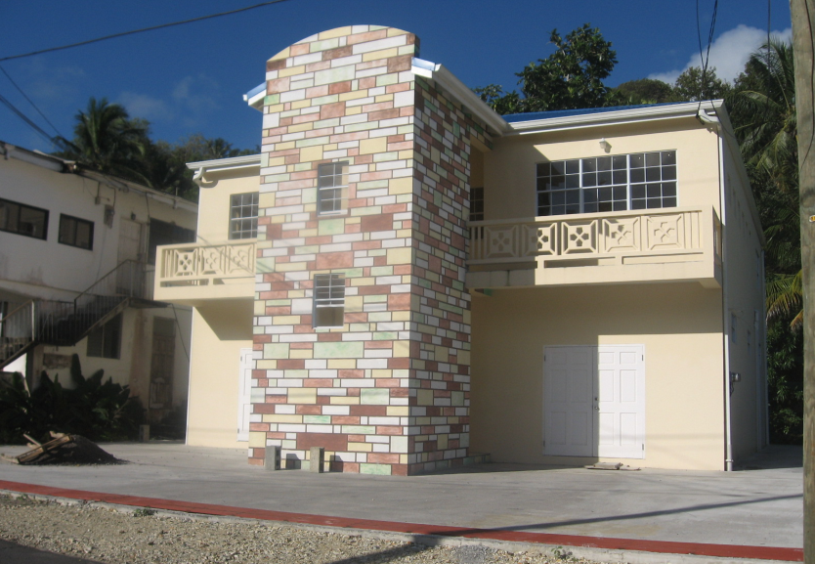
Renovation of the Early Childhood Education Unit

Industrial Relations
The Negotiations Unit has responsibility for the Occupational Health and Safety mandate of the Public Service. The Negotiations Unit, although small in staff complement, has a number of functions and plays a critical role in the functionality of the MPSIB. In addition to occupational health and safety, the Unit operates as the secretariat for the Government Negotiating Team during periods of wage negotiations, and is the primary liaison between the public sector unions and the GOSL.

The Negotiations Unit organizes bi-monthly meetings with the Civil Service Association to discuss employee grievances and conditions of work. These meetings have resulted in a reduction in the number of grievances forwarded to the MPSIB for intervention, and has allowed the two parties to build a relationship of trust, understanding and camaraderie. The Unit also organizes meetings with public officers known as “Points of Contacts” who are responsible for all industrial relations matters within their government agencies. Five meetings were convened during the financial period, and topics covered ranged from “Bullying and intimidation: A legal perspective” to “Procedure for Reporting Occupational Accidents/Injury.”

In addition to the above activities, the Negotiations Unit worked on a number of initiatives during the current (2013/2014) Financial Year. The work of the Unit has been guided by two primary objectives:

- To create greater awareness and improve safety and health in the Public Service
- To create and foster a harmonious industrial climate

Consistent with the stated objectives, the Division recorded a number of achievements, some of which are highlighted below:

- Developed and implemented standard guidelines on “the procedure for reporting occupational accidents and injuries”. The establishment of guidelines ensures that there is consistency throughout the Public Service when handling matters related to occupational accidents and injuries.

- Conducted safety and health tours of approximately 40 government agencies in collaboration with the Labour Department. The purpose of the tours was to proactively identify occupational hazards and provide recommendations to address these hazards.

- Held workshops with representatives of the GOSL and the various public sector unions and staff associations on “The implementation of collective agreements.” These workshops provided the opportunity for discussion and analysis on the provisions of the collective agreements, which are meant to assist in minimizing grievances arising out of the misunderstanding or non-implementation of collective agreements.

- Convened a meeting with shop stewards and Points of Contact on “The importance of collaboration between the Employer and the Union”. The initiative was aimed at fostering a more productive working relationship between shop stewards and points of contact to proactively and effectively deal with industrial relations matters in the Public Service.

- Ensured that all collective bargaining agreements for the 2010-2013 triennium were publicly available via the government’s web portal.

- Held meetings with key stakeholders from the 2010 – 2013 triennium negotiations process. Stakeholders included public sector unions, the Government Negotiating Team and the Department of Finance. The purpose of the meetings was to review and assess the 2010-2013 negotiations.

The Unit recognised “Occupational Safety and Health Week 2013” under the theme “A safe environment for a better Public Service.” The Unit facilitated activities from April 22nd to April 28th that focused on improving the health and safety of Public Officers.
The Negotiations Unit will continue working with public sector unions and government point persons in the new (2014 – 2015) Financial Year towards the achievement of its goals. Some are a continuation from the 2013-2014 Financial Year, while others will be newly commenced.

A fair amount of work has accomplished during the financial period, despite having its own challenges. The main challenges experienced by the Unit are non-participation by related parties, which has severely hindered the effectiveness of interventions; the attendance at point-of-contact committee meetings is very low, averaging 50%, and is indeed a cause for concern. Also, it has been difficult at times to keep to a regular schedule of meetings with some of the public sector unions. The non-availability of unions at meetings results in delays in implementing policies and in driving processes in which the unions play an integral role.

Public Sector Transformation

The Division of Public Sector Modernisation was established to provide leadership, coordination and cohesion to the implementation and monitoring of several key aspects of the modernisation agenda. Some of the focal points of the Division include: strategic human resource management, information and communications technology, e-government, legal and regulatory framework and policies and processes.

“The Multi-Channel Contact and Data Centre” (MCDC), a project funded by the Government of Taiwan, speaks specifically to the transformation and modernization of the Public Service.

The MCDC is intended to provide the Saint Lucian citizenry and visitors with improved access to government information, assistance and services. This will require the deployment of technologies, systems, as well as the related processes and procedures, which will enable greater levels of effectiveness and efficiency in public service delivery. The level of success achieved will be based, to a large degree, on the extent to which both the front end and back end are developed and integrated. Consequently, the MCDC comprises several key components.

Integrated Contact Centre (311/911/999)
The contact centre will serve as an all-purpose facility that residents can easily access to obtain information on government services through a dedicated, toll-free 311 number. Live operators will answer calls and provide customers with the information or resources required.

To date a Manager for the Contact Centre has been employed, along with nine Customer Service Agents who are presently undergoing extensive training. Customer Service Agents are being trained in customer care, active listening, call procedures, technology systems supported and a host of services provided by line agencies within the government. Some of the agencies to which the Agents are being exposed include: Inland Revenue, Customs and Excise, Civil Status Registry and the Ministry of the Public Service, Information and Broadcasting. Agents will be expected to learn and understand the functionality of processes within government agencies in order to assist the public.

Counter Services Officers who interface with the general public are also being trained alongside the Contact Centre Agents. These Counter Service Officers will receive remedial and refresher training in a host of skills related to their respective job. The expectation is that this training will assist in improving service to the public and will ensure the level of service received by customers is of a consistent quality across the board. The Integrated Contact Centre will be fully operational by May 2014.

Electronic Document and Records Management System
The overall information and knowledge management requirements of the GOSL will be addressed using an electronic document and records management system. An EDRMS is a software application that manages a range of digital information and combines both document management and records management functionality. The primary focus of document management is short-term access to, and use of, digital documents. In records management the emphasis shifts to managing information over time for the purposes of evidence, adhering to legislative and governance requirements, and ensuring on-going authenticity.

A Taiwanese consultant team delivered various workshops designated to obtain the relevant information and functional requirements and inputs from the GOSL related to the EDRMS. Based on the information gathered, an EDRMS prototype has been designed. A contract has been awarded for the development of the EDRMS and it is expected that roll-out will occur in phases over an 18-month period.

One subcomponent of the EDRMS is the Correspondence Management System, using the Knowledge Tree Software platform. This system facilitates the relay of correspondence among agencies and users within agencies. The equipment has been obtained for the facilitation of the Correspondence Management System, and this system has been rolled out to a select few agencies on a pilot basis. The system will continue to be rolled out in phases during the course of the new Financial Year (2014-2015).

Digitisation Centre
This project component aims to accelerate the digitisation of systematically and strategically selected government records and will ensure content relevant to the Government and people of Saint Lucia is made available to them electronically. The Centre will digitize staff records of all public officers as well as other critical documents and records of national significance.

The Digitisation Centre was launched in January 2014 and is now fully operational. The Digitisation Centre is housed on the 4th floor of the Greaham Louisy Administrative Building, in what was formerly the Documentation Centre. The working space has been made more functional and user friendly. The Centre has provided amenities where citizens can walk in an access records via computer.

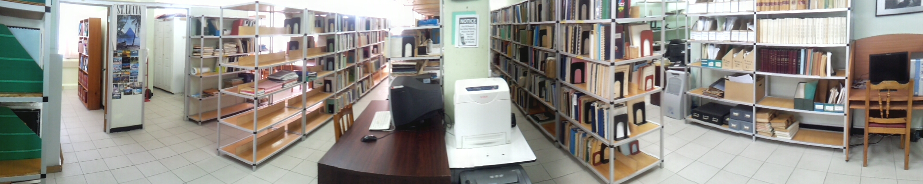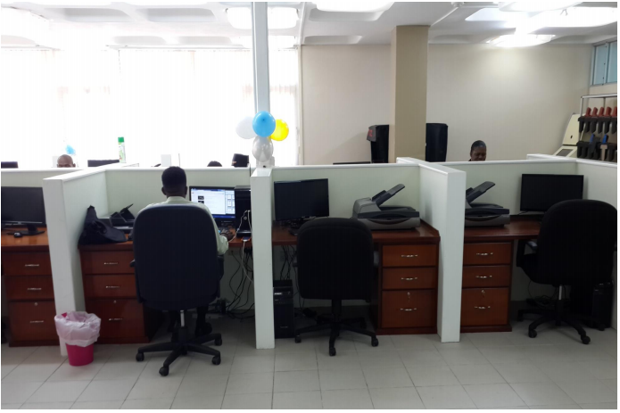
Left: Old Documentation Centre. Right: Renovated and Refurbished Digitization Centre

Fleet Monitoring and Tracking System
The fleet of Government vehicles represents a significant investment to the GOSL, as well as an on-going concern with respect to the high operating and maintenance costs associated with these vehicles. Recognizing this fact, the government, through the Division of Public Sector Modernisation, worked towards the installation of an Automatic Vehicle Monitoring and Tracking system. The system will allow for improved management and coordination of the fleet of government vehicles.

The contract has been awarded to a supplier and installation will begin in May 2014. The vehicle tracking device will be outfitted on government’s fleet of over 300 vehicles. The vehicle tracking system will allow for the following to be done:
  - Vehicle Tracking
  - Monitoring of Driver Behaviour
  - Better Fleet Management
  - Increased Fleet Accountability

A Fleet Management Policy has also been established and this document will guide the management and use of all government vehicles. It is expected that this document will be brought to Cabinet during the first quarter of the new financial year. This initiative will start the thrust towards better asset management on the part of the GOSL.

Telecommunications Sector

Caribbean Regional Communications Infrastructure Project
The objective of this project is to increase access to regional broadband networks and advance the development of an ICT-enabled services industry in Saint Lucia. This objective is expected to be achieved through: (a) targeted investments in ICT infrastructure that fill the accessibility gaps and bottlenecks identified by recent assessments and surveys; (b) creating an enabling environment that fosters competitive access to infrastructure; (c) enabling and supporting the creation of e-services, including e- and m-government services; and (d) strengthening of institutional capacity/arrangements to ensure effective programme implementation and outcomes.

Internet Exchange Point (IXP)
The CARCIP connectivity component provides technical support to establish an Internet Exchange Point. The IXP is a critical component of telecommunications infrastructure that allows local Internet service providers to exchange locally-destined Internet traffic between their networks without cost, resulting in the elimination of backhaul costs. This will result in improved access speeds and reduced latency as well as reduced costs to the consumer.

The Saint Lucia IXP was launched in February, 2014. Internet traffic originating from Saint Lucian Internet Service Providers (ISP) will now terminate on another local internet service provider’s network without having to go through lengthy, expensive, international routes. The net effect will be a reduction in the time it takes for data to move between customers of the island’s various internet service providers, resulting in the potential for higher connectivity speeds and a better quality of internet service.

Business Incubation and Training Grants Component
This newly-launched component of CARCIP provides EC$2.5 million in grant funds to eligible training institutions and to micro and small ICT businesses. The theme of the Project is “Fostering Innovation, Building Competence”.

In the Business Incubation Grant element, the Project seeks to facilitate the launch and growth of successful ICT-enabled businesses and create a culture of innovation and entrepreneurship through ICTs. EC$1 million is available in this area for new ICT businesses as well as to improve or enhance existing businesses through the use of ICT.

The Training sub-component is designed to complement on-going efforts of the Government to prepare young people for a competitive, information-based job market. The project will provide grant funding to a total of EC$1.5 million for capacity building and to train and certify youth in IT-related skills such as software and apps development, database management, web development, and computer animation.

Unified Communications System
CARCIP’s work will allow for the installation and use of a “Unified Communication System.” This system is expected to replace the PBX which is presently in use by the GOSL. The new system will meet Government’s data and voice requirements; improve productivity and responsiveness while reducing recurrent telecommunications and ICT expenditure. The new system will have the added functionality of allowing for the convergence of video, voice and data communications on a shared network (government) infrastructure. The TOR for the system have been prepared and it is expected that a contract will be granted within the first quarter of the 2014-2015 financial year.

National Information and Communication Technology (ICT) Office
The ICT Unit of the Division has also been busy with activity, and the facilitation of a number of projects. Some projects are of an infrastructural nature whilst others are policy related.

- In November 2013 the Division submitted the National Information and Communications Technology (ICT) Policy and Strategy, 2013–2018 to the Cabinet of Ministers for consideration and subsequent approval.
- The Division will now oversee the acquisition of all Information and Communication Technology (ICT) and telecommunications goods (equipment, devices and systems) and services are subject to technical evaluation by the Division of Public Sector Modernisation.
- Also in November 2013, the GOSL, in collaboration with the International Telecommunications Union, completed a National Broad Band Policy (2013 - 2018). Guided by the National ICT Policy, the GOSL is committed to a national strategy to strengthen the information and communication technology sector in Saint Lucia with countrywide broadband infrastructure - an essential enabler for economic and social development of the country.

Community Access Centres
The communities of Micoud and Vieux Fort will be home to the next establishment of Community Access Centres. The Micoud and Vieux Fort Community Access Centres will be built almost concurrently, with similar start and end dates. Preparatory work is on-going for both facilities and the floor plans and designs have been completed for the Centres. The designs are presently being reviewed by officials from the Ministry of Infrastructure and the Ministry of Physical Development, Housing and Urban Renewal.

An invitation to bid will be sent out by May 2014, and the subsequent mobilization and construction will commence by July, 2014. It is expected that both Centres will be completed during the upcoming (2014 – 2015) Financial Year.

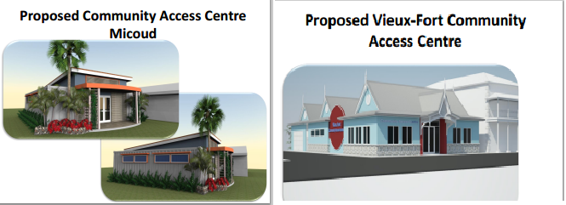
Plans for the Proposed Micoud and Vieux-Fort Community Access Centres

Government Web Portal
The GOSL launched the government web portal in January 2014. The launch marked the successful completion of the first phase of a project to redesign and upgrade the Government’s online presence. The new portal provides enhanced features and services to the general public by serving as a central access point and facilitating increased collaboration and communication among Government departments and agencies. The portal supports the strategy of “a user‐centric, online gateway for citizens, businesses, and non‐residents to Government information and services.” This development is expected to bring about greater accessibility and transparency in Government operations, as members of the public will have easier, continuous and convenient access to public sector services and information. Concurrent with this launch was the revamping of the Government’s social media presence through a more dynamic GOSL Facebook page.
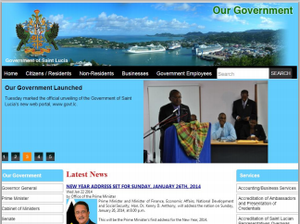
New GOSL Web Portal

Free Wi-Fi Zone in Soufriere
The GOSL has articulated its intention to significantly improve internet connectivity island-wide. In pursuit of this, a Wi-Fi zone will be set up in the town of Soufriere. Preparations are at an advanced stage, with all the infrastructural work and equipment being installed and fitted. This project was made possible with the assistance of the National Telecommunications Regulatory Commission through the use of the Universal Service Fund.

The Soufriere Community access Centre will function as the hub for the Wi-Fi zone, and users will be able to access the internet free-of-charge anywhere within a quarter mile radius from the centre. It is expected that the Wi-Fi zone will be fully functional by May 2014.

Tax e-Filing
As part of the Government of Saint Lucia’s mission to improve service delivery, a new facility has been implemented to allow taxpayers and their representatives to access tax services via the internet. This project has been in train for two years and is now functional. It allows users access to a number of online services, such as:
- E-User Registration - allows persons to sign up for an account to access the online Tax e-filing system and be able to access tax accounts and perform transactions online.
- Taxpayer e-Registration - enables general registration as taxpayers and registration for specific tax types. Users will also be able to update or amend personal information.
- e-Filing/e-Declaration - allows online submission and validation of tax returns and declarations. The system also allows registered persons to query their respective tax accounts and returns/declarations filed via the online system.
- e-Payment - This facility will be available soon and will allow for the online payment of taxes

Multi-purpose Identification Card (MPID)
The MPID system was installed, tested and accepted during the Financial Year. The system is being developed under the Electronic Government for Regional Integration Project, which recently concluded. The Consultants expect that roll-out of the system and the new ID cards will be done during the new Financial Year. The intention at this point will be to phase out the system of old ID cards. Thus far, the MPID system has been connected to the Electoral Department’s ID card system and in the near future there will be connectivity to the National Insurance Corporation database.

The Government Information Service

Information Dissemination
The main objectives of the Department during the 2013-2014 financial Year were to:
- Provide a steady flow of credible information to Saint Lucians at home and abroad via a multiplicity of media platforms - Television, Radio, Print and Internet. Where possible, this would be done in both English and Kweyol.
- Feature the work/activities of identified GOSL agencies through daily reports and monthly features.
- Consistently promote the use of GIS/NTN services to audiences.

Achievements during the 2013 – 2014 Financial Year
Some of the achievements/major activities of the Department include:

- Increased output over the previous year:
- 340 features & other productions
- 846 Government Notebook radio reports
- Over 600 Press Releases
- Two Year-in-Review productions with English and Kweyol versions - a first for the GIS
- Full, timely coverage of the aftermath of the Christmas Eve Trough. GIS obtained the first aerial and ground images that informed the GOSL, development partner agencies and other governments of the gravity of Saint Lucia's situation following the extreme weather event.

- Establishment of regular news broadcast. News Breaks were presented in English and Kweyol - the ultimate aim is to combine the two broadcasts into a single nightly news programme highlighting GOSL information from all its agencies and statutory corporations.

- Increase public engagement via Social Media. The GIS/NTN has begun increased public engagement via social media, utilizing a more dynamic approach to social media postings. The page is used to disseminate information on GOSL programmes, activities, services, policies as well as on GIS/NTN programming.

- Main contributor to the recently launched GOSL Web Portal. – The web portal launched in January 2014; the web portal is a gateway to government information and services.

Reorganization
The Government Information Service (GIS)/National Television Network (NTN) underwent significant changes to its staff complement and modus operandi during the current Financial Year. During the period under review, 10 staff members were redeployed to 6 underserved Ministries to help focus attention on the work carried out by these agencies for public benefit.

National Broadcasting Network (NBN)
In 2013, the Government of Saint Lucia approved the formation of the National Broadcasting Network. This media entity envisions the merger of Radio Saint Lucia, a statutory corporation, and the National Television Network - the GOSL cable television channel.

The amalgamation of the two media platforms should lead to efficiency gains in programming, use of personnel, production, operational costs, facilities management, cross training, shared experience and knowledge.

The Broadcasting Sector
Saint Lucia has one State-owned television station, the National Television Network; and one State-owned radio station, Radio Saint Lucia. During the previous (2012-2013) financial year Radio Saint Lucia underwent significant changes to the Management and Board, business model and image. RSL was re-launched under a campaign dubbed “RSL Reloaded.” The re-launched station featured rejuvenated and revamped programming, all of which was meant to increase interest in the statement and thereby increasing listenership and marketing revenue.

The Revitalisation of RSL
Despite the challenging environment in which RSL operates, the company has maintained its exemplary broadcast quality and continues to be a breeding ground for today’s premier broadcasters. The 2013 – 2014 Financial Year was filled with promise, milestones, and regrettably a few missed opportunities.

The company registered significant achievements during the current fiscal year. In 2013 – 2014 RSL was able to realize:

- Increased advertising revenue. The company has fared better in this Financial Year than the previous one. Increased advertising revenue and prudent fiscal management have resulted in the station being able to settle some of its long outstanding debts.

- Improvements to property, plant and equipment. The company is on the second phase of remedial works of its premises. This phase encompasses the total rehabilitation to the News and Accounts office spaces and upgrade to the reception area. The company has also obtained new and up-to-date equipment, ranging from mixers, laptops, and headsets to a new telephone system. The new equipment is valued at over twenty five thousand dollars and this investment is expected to improve efficiency at the station.

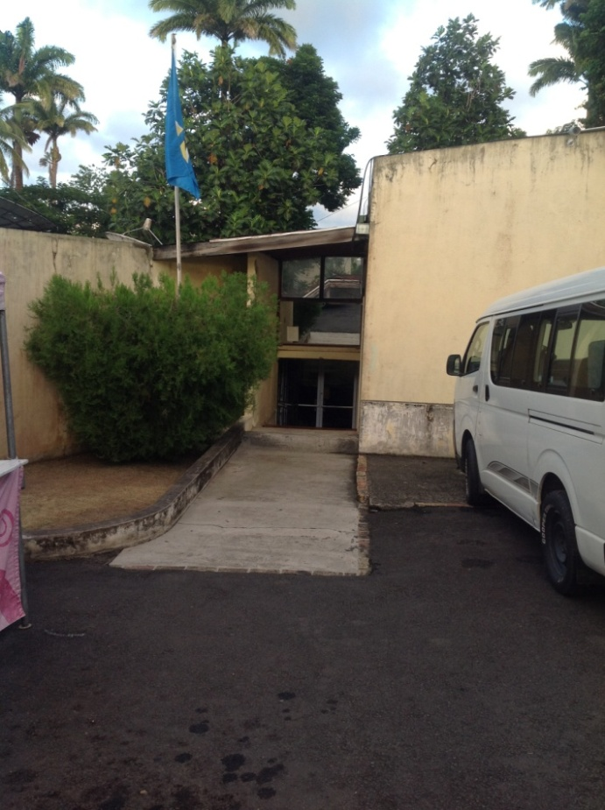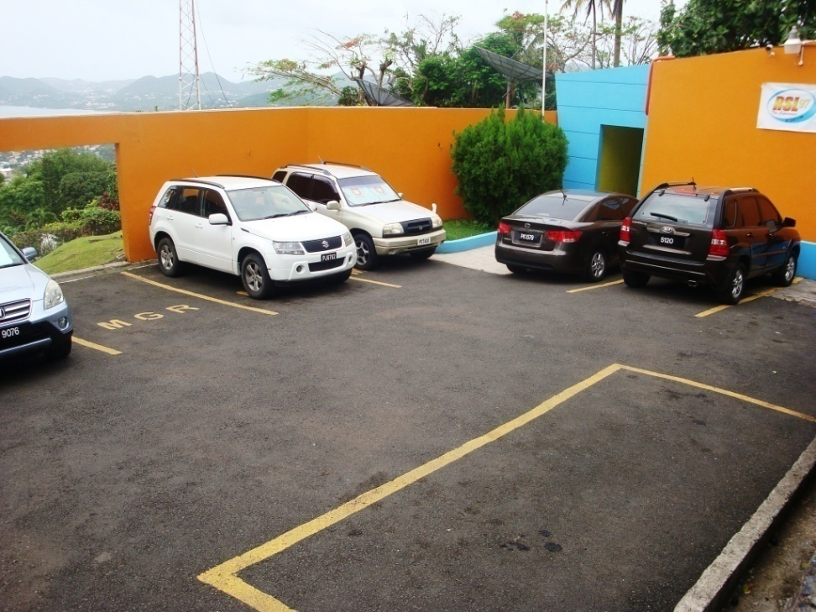
Before and After views of the Entrance to Radio Saint Lucia

- The launch of over ten new programmes. New programmes were launched in 2013 in an event dubbed “RSL Reloaded,” and programmes continue to be added to the station’s schedule. The RSL management and staff continue to brainstorm on ways to improve the station’s programming. RSL has partnered with two state agencies (Nurses Association & the Royal Saint Lucia Police) to provide two new weekly programmes.

- A new and recognizable change in image. The change in image has resulted in a positive performance in the 2013 Media Survey, with RSL moving from 5th position to an average of 3rd in all the times assessed in the survey for the year. The company has made a concerted effort to make its presence felt via social media. A YouTube channel and an active Facebook page have assisted in promoting RSL’s product and plans.

In order to standardize operations and affirm the company’s commitment to proper standards, new policies were established in the following areas:
- Confidentiality
- Health & Safety
- Intellectual Property Rights
- Salary Advance

Specialized Programmes
In a fast changing market, the ability to exploit opportunities is critical to survival. RSL has been able to capture moments of national significance, in a fashion that was second to none.

- Parliamentary Discussion – The station covers live broadcasts of Parliamentary discussions, including the Throne Speech, Budget Address, and debates of the Lower & Upper House.

- Vaughan Noel Tribute - The RSL family bade farewell to its iconic broadcaster, Andrew Vaughan Osborne Noel with live coverage of a memorial service attended by past and present RSL staff.
- Sports Awards - Radio St. Lucia executed an outstanding broadcast of the 2013 Sports Awards and was the recipient of an award for its promotion of local sports.

- Calypso Explosion - Recognizing the station’s core listenership, a deliberate effort was made to create a niche throughout the Carnival Season by becoming the premier station for all things Calypso. This decision led to the creation of “The Calypso Explosion” – three programmes used to celebrate and promote the Calypso art form.

- Christmas Kaleidoscope - Radio St. Lucia continues to be a leader in Christmas programming. The numerous programmes, outside broadcasts, giveaways and philanthropic endeavours are always welcomed by our valued listeners and the public at large.

Our Legislative Agenda

Ministry of the Public Service, Information & Broadcasting
The Legal Unit of the MPSIB is responsible for all legal matters pertaining to the Public Service. This responsibility includes the review and creation of appropriate legislation, the interpretation and practice of administrative law and the evaluation of any complaints or disciplinary matters which may arise. The Legal Unit must vet and in some cases prepare all the contracts and lease agreements that are entered into by the MPSIB on behalf of the GOSL.

The issue of indiscipline remains current for the Public Service. During the financial year there were twenty requests for disciplinary action, all of which have been forwarded to the Public Service Commission for further action. Four public officers were suspended and two officers were terminated as a result of disciplinary action. Management of the MPSIB believes that these few reported cases are only the tip of the iceberg. Many managers from government agencies have chosen to either ignore disciplinary cases or not report them.

The MPSIB believes that disciplinary matters must be taken more seriously. A strong message must be sent to delinquent officers that there will be consequences to breaches in the terms and conditions of employment. Unfortunately there is no legislation at this time that explicitly addresses the issue of discipline. The issue of discipline falls within the ambit of the Public Service Commission.

Within the final quarter of the 2013 – 2014 Financial Year the Public Service Commission completed its final review of new draft Disciplinary Regulations and General Regulations. The expectation is that the Commission will complete its review of the entire suite of Regulations by the first quarter of the new Financial Year and the Commission will consequently be better placed to deal with disciplinary matters.

Summary of Legislation and Regulations
The major legislative project being undertaken is the Public Service Management Bill. This piece of legislation will set the foundation for Saint Lucia’s public sector management going forward and when approved, will provide for a modern legislative framework for the Public Service. The Bill, which is still in draft form, has been reviewed by both the Legal Unit and a working committee set up to review the Bill. Once the stakeholder consultation is complete, the Bill will be submitted to Cabinet for consideration and onward transmission to Parliament.

Four other pieces of legislation have remained a priority for the Ministry:

- Broadcasting Authority Bill and Regulations
- Data Protection Act No 11 of 2011
- Computer Misuse Act No 12 of 2011
- Electronic Transactions Act No 16 of 2011

The draft Broadcasting Authority Bill and the accompanying Regulations were submitted to the Media Association for review and comments. It is expected that this legislation will be introduced in Parliament in the first half of the new Financial Year.

The ICT legislation has been reviewed with assistance from HIPCAR, recommendations have been made and all the amendments drafted. Due to the length of each piece of legislation, the decision was taken to submit the legislation to the Attorney General’s Chamber incrementally for review, approval and setting of a commencement date. The Data Protection Act has been approved and it is expected that a commencement date will be given to the legislation by May 2014. The Computer Misuse Act and the Electronic Transactions Act are presently being reviewed by the Attorney General’s Chamber.

Other initiatives

Mediation Services
Many conflicts that arise in the Public Service can be prevented before escalating to major issues. Mediation is one means by which conflicts can be amicably resolved. During the financial year, seventeen senior Public Officers were trained to perform mediation. The training was provided by the Royal Institute of Public Administration International.

There have been many inquiries about the mediation process and the MPSIB will conduct a series of workshops and sensitization sessions on the mediations process. There was only one request for mediation during the 2013-2014 Financial Year.

Administrative/ Constitutional Law
A number of senior appointments have been made within the last few years. It is essential that these officers receive the requisite training in the area of Administrative/ Constitutional Law. The training sessions were not pursued in the current year due to financial constraints. However, the Ministry will look to more innovative ways to conduct this training in the new financial year.

Ministry of Sustainable Development, Energy, Science and Technology
The Legal Unit within the MSDEST has been quite active. The dynamic nature of this Ministry requires the constant review of legislation, regulations and other legal documents. During the Financial Year, seventeen (17) Memoranda of Understanding and nineteen (19) contracts were prepared. Some of these were with international organisations, others between ministries and others with private individuals. In addition to the preparation of legal documents, several laws and items of legislation have been reviewed in order to achieve more effective and responsive environmental management.

Summary of Legislation and Regulations
 | Department | Legislation | Description | Status
1 | WRMA | Water and Sewerage Act | Minor Amendments were requested. The previous Deputy Director was consulted and a Draft Amendment Bill was prepared for final review. | -Drafting instructions submitted by WRMA. The document will be submitted to the Drafting Unit after discussion with the Director of WRMA.
2 | WRMA | Water and Sewerage Act (Water Resources Management) Regulations No. 7/2009 | Minor amendments: All forms; where it refers to “Minister of Agriculture” to be changed to “Minister responsible for Water”  -Request for amendments to the Fees schedule to be sent. | Amendments to be submitted again to the Drafting Unit.
3 | WRMA | Water and Sewerage (Water Resources Management) (Fees) Regulations No. 68/2008 | Minor amendments: Change fees, include “Commercial” on 5th Schedule | See Above
4 | Public Utilities Department | Water and Sewerage (Service Standards) Regulations (NWSC) | Recently the NWSC introduced a 60% increased water tariff. This caused much debate, which justified the review of that Regulation. | Consultations with key stakeholders have been held and comments given. The draft regulations were re-circulated for review and submitted to the Drafting Unit.
5 | Public Utilities Department | Telecommunications: -(Fees) Regulations  - Exemption Orders Regulations  -Classification Notice Regulations | Minor adjustments to regulations | Submitted to the Drafting Unit for Review
6 | Energy Science and Technology (EST) | Renewable Energy Incentives | Prime Minister announced renewable energy incentives in the Budget Speech. An Incentives Bill is to be drafted to encourage investments and users in renewable energy. | Amendments to the Income Tax Act and the Land and House Tax have been submitted for approval by EST. Collaboration with Finance, IRD, MSDEST have been on going
7 | SLSWMA | Waste Management Act and Waste Management Amendment Act | Minor amendments were requested. Previous Deputy Director prepared the Amendment Bill for final review, however Schedule 3 needed more discussion, therefore it was not finalized.  Schedule 3 (23) (3- 5):  -address Minister of Finance  -Environmental Levy considering Vat  - Fees to be revised from Fiscal Year 2014/2015 as per Cabinet Conclusion No. 615 of 2013 | - Amendments reviewed by Ministry of Finance and team.  - Draft will be circulated to the SLSWMA for their review.  - This Act needs further review to include provisions of Basel, Rotterdam and Stockholm Conventions. Some of the classifications of hazardous wastes and some of the schedules need to be amended.
8 | Public Utilities Department/ Energy, Science and Technology | National Utilities Regulatory Commission  (January 2014) | The Bill is to address the formation of a multi-sector Regulator for the Energy Sector which includes Water and Electricity. The NWSC will be subsumed into this Regulatory Authority. The ESA will be reviewed in conjunction with the energy and water sectors legislative framework. | First Draft National Utilities Regulatory Commission Bill submitted and consultation held.
9 | Forestry Department | Wildlife Protection Act | - Amendments by the Forestry department have been submitted. Currently a review and assessment of those changes are being conducted | - Amendments submitted for review  - Cabinet memo to be prepared to introduce new schedule of fees
10 | Energy, Science and Technology | Waste to Energy RFP (to be drafted) | This will be drafted with the assistance of Carbon War Room and will be reviewed by the Attorney General’s Chambers. This is expected to be ready within 2-4 months for review. | Awaiting the assistance of Carbon War Room
11 | Biodiversity Unit | Biosafety Policy and Bill (November 2013) | Consultations and review currently undergoing for submission to the Drafting Unit. | -Final draft has been concluded and submitted.  -Presentation have been made to the Minister
12 | SLSWMA | Management of Containers Bill | This bill is designed to reduce littering and the amount of space occupied by plastics in landfills.  - Consultancy was conducted with a range of stakeholders.  -A final report was submitted to the Authority in 2008.  - It was decided that the Drafting Unit conduct a review and comparison of the Barbados Returnable Containers Act Cap 395B | Review to be conducted by the Drafting Unit
13 | SDED | Montreal Protocol (Substances that Deplete the Ozone Layer) | Requires amendments to address  - Issues identified by stakeholders, including electronic licensing elements/procedures, which needs to come on stream soon.  - CFC’s to be removed from the Regulation forms. Forms only mentions ODS and not refrigerants.  - Address the responsibilities of ministers for issuing licenses  - Penalty is needed to be included to deal with ODS | Amendments submitted for review

14 | EST | Geothermal Development Bill | MSDEST is exploring the assistance from either World Bank or Carbon War Room for review of this bill to incorporate international standards. The same drafter will be utilized for the revision.
15 | Protected Areas Management | Environment Impact Assessment Regulations (already in draft form) | - Limits of Accessible Change Study has been completed to review the current state of development in the PMA. This was necessary to comply with requirements set out by the World Heritage Committee. | - Discussions have ensued with the Planning Division.  - Ministry is exploring the support and advice from World Bank and Carbon War Room
16 | Energy, Science and Technology/Public Utilities Department | Electricity Supply Act | The ESA is in need of a total review to ensure that legislation meets the current trends as it relates to the energy sector. Issues such as regulation, licenses, independent power producers, renewable energy mix, tariff, net metering/billing etc. need to be addressed.  Currently ECERA has been set up to develop a regional treaty for the OECS States and to review the national legislative framework for its member states. This environment will kick start a number of changes to each country’s ESA. | - ECERA has recently awarded the consultancy contract to review the legal basis for the legal and regulatory framework;  - Consultant will be meeting team soon.
17 | Biodiversity Unit | Biodiversity Conservation and Sustainable Use Bill | Have to be reviewed to include provisions of the Nagoya Protocol on Access and Benefit Sharing. Currently looking for funds to conduct this review. | -Proposal prepared and approved by Regional ABS Initiative  - Funds allocated for Saint Lucia

18 | Forestry Department | Invasive Species Bill and Draft Strategy | The outgoing Consultant will be available to discuss IAS and to indicate the urgency to comply to have legislation enacted.  -Regulations need to be drafted for the Bill. | - Bill and Draft Strategy have been submitted to the Drafting Unit.  -Currently no funding is available to draft -Regulations pending
19 | Forestry Department | CITES Regulations to be developed | CITES Act already been accepted, however neither commencement date nor regulations developed. CITES secretariat promised to assist the funding of a drafter to develop regulations. Forestry Department will write the CITES Secretariat to request formally for the funding to draft Regulations. | -Funding has been received in principle from CITES
20 | SDED | Environment Management Bill | Currently being reviewed by a Consultant. A report is due shortly to chart the way forward etc. | Consultancy ongoing
21 | SLSWMA | Basel Convention on the Control of Trans boundary Movements of Hazardous Wastes and Their Disposal  Saint Lucia has ratified this convention since 1993. There is no legislation to support its implementation. | -Whilst the Waste Management Act has some provisions of the Basel Convention, most of the obligations can be governed in a new piece of legislation to cover the convention.  -The Waste Management Act with its Amendment (10/2007) do make some provisions, however the draft model legislation developed for the parties shows some inconsistencies and deficiencies. | Way forward to be determined
22 | Forestry Department | Forest Bill | To be revised and determined whether the current Forest, Soil and Water Conservation Act should be revised | Pending Forestry Department’s decision
23 | Forestry Department | Forest Policy (Draft) | To be revised. | Pending Forestry Department’s decision

An Energy Revolution
Saint Lucia exhibits tremendous potential for the development of renewable energy, particularly in the areas of solar energy, wind energy and geothermal energy. The Energy, Science and Technology Unit has worked assiduously towards the development of a viable supply of renewable energy during the current (2013-2014) Financial Year. As was indicated in last year’s Report, the work programme of the Unit is predominantly long-term in nature. The Energy, Science and Technology Unit, alongside its parent ministry has worked assiduously in building a foundation for a sustainable energy sector.

Saint Lucia recently became the second country to join the “Ten Island Challenge.” The Ten Island Challenge was launched at the Rio+20 Summit in Rio de Janeiro in 2012 and seeks to provide a platform for progressive island governments to reduce their dependence on fossil fuels “through the acceleration of commercial opportunities on islands” by attracting investments and technologies in renewable energy and energy efficiency.
Holding Discussions with Sir Richard Branson at the Creating Climate Wealth Summit

Renewable Energy

Development Partner Conference and Stakeholder Consultations
Saint Lucia is actively pursuing a number of sustainable energy initiatives. In order to ensure the optimum use of the available resources, including financial and technical support, efforts must be taken to support collaboration, synergy-building and the avoidance of duplication. In addition, it is important to ensure that a holistic, co-ordinated strategy is employed that covers all key aspects of national sustainable energy development.

Furthermore with respect to assistance from donors and international partners, measures must be put in place to ensure that the requests for assistance match the strengths and expertise of the agencies and that there is broad collaboration amongst all energy partners. Developing a national energy roadmap that adequately addresses all these considerations and issues will ultimately produce the results articulated in Saint Lucia’s national energy policy.

A development partner conference is planned for June 2014 in order to clarify the roles of the myriad multinational agencies that are providing support to the renewable energy development of Saint Lucia. A National Stakeholder Consultation was held on 28th February, 2014 as a precursor to the Donor Conference. This brought together representatives from the public and private sectors, including Invest Saint Lucia, the Ministry of Agriculture, Food Production, Fisheries and Rural Development, the SLSWMA, LUCELEC, Energy and Advanced Control Technologies, The Caribbean Electric Utility Service Corporation and other agencies to discuss their vision for Saint Lucia’s renewable energy sector.

Wind Energy
Two encouraging proposals are being reviewed for the development of a wind farm on the east coast of the island. The MSDEST is working with the potential developers and coordinating discussions with LUCELEC and the Ministry of Physical Development, Housing and Urban Renewal to ensure the necessary permits are obtained for the initial phase of wind testing.

Geothermal Energy
The earlier part of the Financial Year focused on actions to address the legal aspects of advancing geothermal development in Saint Lucia and on resolving the issues surrounding the choice of developer. In October 2013, the MSDEST approached the World Bank to assist in the development of a geothermal energy roadmap. The roadmap focuses on the steps required to carry out exploration drilling, confirm the geothermal resources and the subsequent development needs to reach the stage for power generation. A mission from the World Bank visited Saint Lucia in January 2014 to meet with relevant stakeholders and commence work on the development of the roadmap. The Government is also working closely with the Clinton Climate Initiative (CCI) and making use of CCI’s substantial experience and expertise in geothermal development, particularly in contract negotiations.

The Government expects soon to sign a new Memorandum of Understanding and Geothermal Development Agreement to pave the way for exploration and development of the geothermal resource.

Solar Energy
The Government has partnered with the Carbon War Room to develop and publish Requests for Proposals (RFP) for a utility-scale solar photovoltaic energy plant. The Carbon War Room recently executed a successful RFP for Necker Island in the British Virgin Islands, which attracted several reputable, world-class tenders.

Waste to Energy
Discussions have been initiated with the Carbon War Room and the St. Lucia Solid Waste Management Authority on securing the right technology mix for a waste-to-energy facility in Saint Lucia that addresses the utilization of both solid and liquid waste.

Developing New Contacts with UNIDO
In July of 2013, the Minister visited the Headquarters of the United Nations Industrial Development Organization (UNIDO) in Vienna, Austria to hold discussions with the newly elected Director General, Li Yong, and other senior officials on possible areas of collaboration with the Government of Saint Lucia in the area of sustainable energy. While in Vienna, the Minister also met with the Director for the Latin America, Caribbean and Europe Region of the OPEC Fund for International Development (OFID), the Director, of the Division for Latin America, Department of Technical Cooperation, International Atomic Energy Agency (IAEA), the Executive Secretary of the Preparatory Commission for the Comprehensive Nuclear-Test-Ban Treaty Organization (CTBTO), and the President of the EU-LAC Foundation.
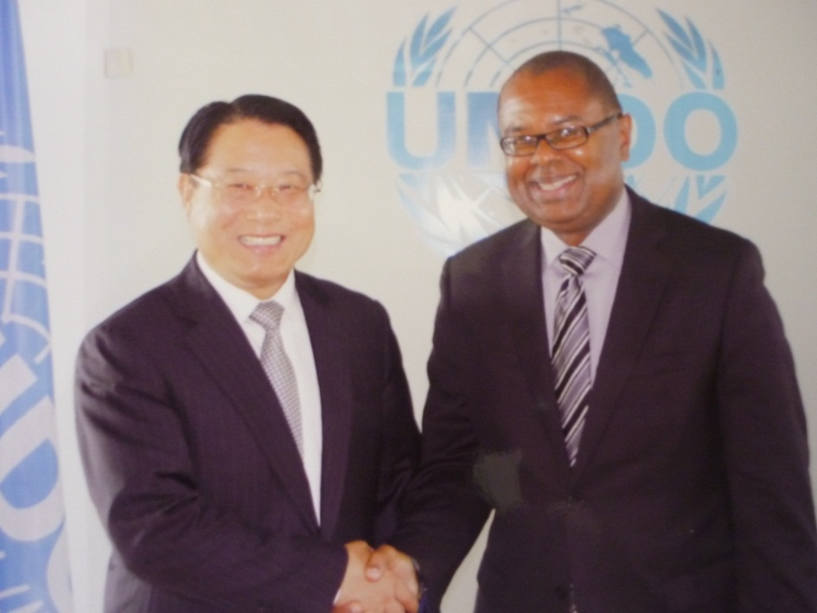
Minister Fletcher Meeting the Newly Elected Director General of UNIDO – Mr. Li Yong

Energy Efficiency

Sustainable Energy in the Public Sector
As part of its strategy to reduce electricity consumption in the public sector, the MSDEST has identified a number of public buildings for the installation of solar photovoltaic systems to generate electricity and to retrofit existing lighting to more efficient lighting.

Specifications have been developed for replacement LED lights to retrofit the Tissue Culture Laboratory at the Union Orchid Garden. A public tender was initiated and several bids were received. Unfortunately, none of the bids met the specifications that were advertised.

The Greaham Louisy Administrative Building has been marked for a retrofit to more efficient LED lighting. Data on the existing installed lighting have been received but additional data are required. The MSDEST is working with the Electrical Department of the Ministry of Infrastructure to conduct an audit on lighting levels at work spaces in the building.

An invitation to bid has been published for the installation of two 25kWp photovoltaic systems, one for the National Emergency Management Office headquarters and the other for the Mental and Wellness Centre. The bids have been opened and will be evaluated during the first quarter of the 2014-2015 Financial Year.

Hospitals have been identified as a category of buildings that hold potential for significant energy savings. In this regard, the MSDEST has submitted a proposal for funding of sustainable energy measures for the new St. Jude’s Hospital. There has also been discussion with the Ministry of Health on advancing the concept of smart hospitals in Saint Lucia.

Energy-Efficient Street Lighting
The Government of Saint Lucia commenced a pilot LED street lighting project in May of 2013. Forty-eight street lights were purchased and installed through funding provided by the GOSL. The pilot project was used to introduce LED lighting technology to Saint Lucia and to monitor and assess its performance. The information gathered will be used to inform a policy and strategy for retrofitting all street lights on the island.

There were some early challenges with the lights because of the presence of day burners - lights that remain on during the day. This problem has since been addressed and the pilot project is progressing smoothly. The MSDEST is currently working with LUCELEC to establish a protocol for the installation and management of LED street lights. To date, preliminary reports from LUCELEC indicate an estimated 63% savings in energy consumption from the LED lights compared with the previous period. This is extremely promising and makes a solid case for a transition to LED lighting.

A national committee has been established to advise on the way forward in the retrofitting of street lights on island. The committee, which includes LUCELEC, the Association of Engineers, the Ministry of Infrastructure, and the Saint Lucia Bureau of Standards has prepared and agreed on the specifications for LED lights for the island-wide retrofit. The Clinton Climate Initiative has been engaged in the initiative and will assist in preparing a request for proposals for LED street lighting. Going forward, a national street light policy will be developed to define the roles and responsibilities with respect to Street Lighting. This is expected to be completed by the end of 2014.

Tax Incentives Framework
In operationalizing the tax incentives announced by the Prime Minister in his 2013-2014 Budget Address, the Division held several meetings with the Ministry of Finance, the Customs Department and the Inland Revenue Department to deliberate on the implications of the proposed tax incentives. A proposal has been developed and a draft bill will shortly be submitted for consideration.

With respect to the exemption of import duties and excise taxes of sustainably fuelled vehicles, the Ministry of Finance has indicated that according to the 2007 Common External Tariff of the Caribbean Community, the minimum allowed import duty for any vehicle is 10%. Any lowering of the import duties below this minimum in a Member State must be approved by the Council for Trade and Economic Development (COTED). It is the intention, therefore, to seek a reduction of the import duties on the relevant vehicles to 10%.

Responsible Management of our Water Resources

The island’s water resources are managed primarily by three entities: the Water and Sewerage Company, the National Water and Sewerage Commission and the Water Resource Management Agency (WRMA). It is with an understanding of the need for coherence in the management of this critical and limiting natural resource that all of these agencies were placed under one parent ministry in December 2012.

WASCO is the primary provider of water on the island, both at a residential and commercial level. The WRMA is the Agency responsible for the management of this critical resource, particularly at a policy level. The WRMA also monitors and measures the water resource island-wide. The NWSC functions as the independent regulator within the sector.

A viable Water and Sewerage COMPANY (WASCO)
The 2013-2014 Financial Year was marked by (i) the introduction of a tariff increase in April; (ii) implementation of an approved new organisational structure; (iii) continuation of the amnesty programme for reconnections; (iv) improved performance in training and certification of water operators; (v) realisation of government's approval of the debt/equity swap; and unfortunately (vi), the extensive damage to water intakes and raw water lines caused by the passage of the extreme weather event on 24th December, 2013.

Overall, while WASCO's efforts were encouraging, there were numerous continuing challenges, predominantly in the quality of infrastructure, efficiency of methods and operations, capacity and productivity of the human resource, quality of customer service and adequacy of internal support systems. In recognition of those challenges and the incapacity to redress them satisfactorily, an approach to partnerships with regional and extra-regional sister utilities and industry associations commenced and showed some promise, albeit slowly, towards enabling the development of plans and processes for progressive improvements in performance.

By the end of 2013, the outlook for 2014 continued to be encouraging despite the persisting challenges.

Operations
Key Infrastructure
By the end of 2013 WASCO maintained 45,439 active accounts. In addition, there were 16,633 inactive accounts. The island-wide water coverage ratio stood at 94%. Despite that coverage, some communities and localities experienced water shortages due primarily to the inadequacy of pumping capacity and network infrastructure. The entire system relied on a network of numerous pumps and tanks for enabling the transmission of water.

The key infrastructure which support the service are:
- 600 miles of pipes
- 81 reservoirs of various types and sizes
- 18 treatment facilities (with varying levels of treatment)

The cost of transmission (electricity for pumping) is very high and represents the second highest element of total cost. The maintenance cost of infrastructure is also very high. Due to the incapacity to undertake capital investment, the condition of the infrastructure remained in a deteriorating state contributing to increased cost and inefficiencies in operations.

Consumption and Connections
A total of 2,045,935,768 gallons of water were recorded and billed for the period, representing an estimated 44% of total abstraction. The non-revenue-water ratio remained disturbingly high at an estimated 56%. This has been attributed primarily to huge losses in the entire network due to aged and poor quality infrastructure.

There were 1,520 new water connections and 1,230 reconnections under the amnesty programme. Overall, there were 9,786 reconnections.

Noticeably, WASCO experienced improved collection results, attaining an average of 89% of billings by the end of the year. This is attributed to its sustained effort at encouraging customers to pay their bills on time.

Projects Undertaken
The following Projects were continued and/or commenced during the period.
- Cas En Bas Mains installation
- Rocky Lane/Green Mountain, Dennery
- Over the Bridge, Dennery Water Mains Extension Project
- Bruceville, Vieux Fort Water Extension Project
- Geographic Information System (GIS)

Dredging of John Compton Dam
Two attempts were made to recruit a suitably qualified firm to undertake the de-silting of the John Compton Dam. Both attempts failed, resulting in the rejection of all bids submitted. WASCO subsequently engaged the Caribbean Development Bank (CDB) to enable grant financing for a consultancy to properly define the problem, determine costs for the project and prepare tender documents. By the end of the year, the outlook on the commencement of the de-silting project moved to the second half of 2014.
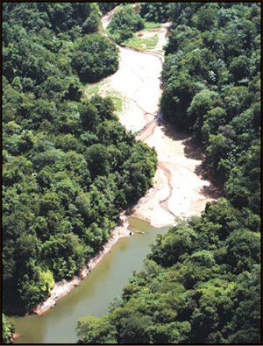
Heavy siltation at the John Compton Dam

Extreme Weather Event December 24, 2013
The extreme weather event on December 24, 2014 caused extensive damage to water intakes and raw water lines island-wide. The water systems were restored progressively, with over 80% of supply fully restored by the end of the year. The entire system of intakes and raw water lines remains vulnerable and must be redeveloped to increase their resilience. The total preliminary quantifiable cost of the damage was estimated at EC$2.86 million as at the end of the year.

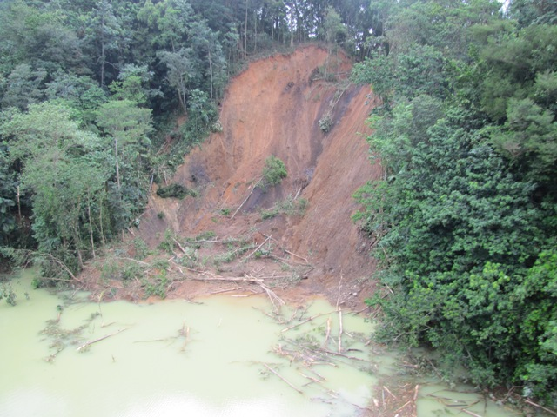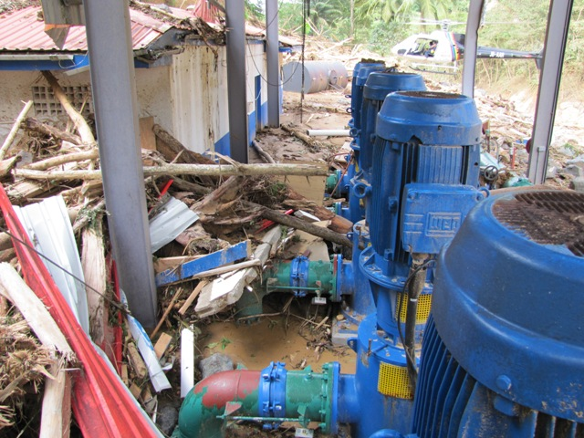
Damage suffered after the December 24th Trough at the John Compton Dam

Organisation and Human Resource
The implementation of the approved re-organisation plan commenced in July 2013. By the end of the year, new contracts along with key performance indicators had been issued to all management level personnel and a new Managing Director was appointed. Some of the remaining positions were advertised while the others were earmarked for the first quarter in 2014.

A major component of the human resource development agenda in 2013 was the training and certification of water operators. A total of 50 employees have attained certification in various training categories and levels. The certification is an internationally recognised designation, which is increasingly becoming a regulatory requirement and also a requirement in major sectors such as the travel and tourism sector.

Information Technology
WASCO remained deficient in information technology and consequently its operations and services have been severely challenged. Efforts were made to alleviate that situation by actively exploring the possibility of a Customer Information system software service agreement with LUCELEC. Other efforts were in the consideration of a phased-in process for electronic meter reading and initial considerations of possibilities for updating the accounting software along with hardware requirements.

Communications and Public Relations
Besides routine notices, advertisements and press releases, very little public education, community relations and publicity were undertaken.

Finance
The unaudited financial statements for the period showed a loss in the amount EC$4,016,497. The tariff increase, which raised billings by EC$1.5 - EC$1.7 million monthly, improved WASCO's cash-flow ability, albeit only marginally, enabling payment of monthly electricity bills that averaged at EC$1.0 million. It also allowed WASCO to commence repayment of the outstanding debt due to LUCELEC for past bills that had remained unpaid. The financial situation continues to be a significant challenge.

WASCO's long-term debts totalling EC$93.0 million were absorbed by the government in a debt/equity swap. This strong intervention placed the company in a position to consider strategically, possibilities within its means, for improvements to its systems.

Challenges
The three (3) major challenges are (i) financial constraints; (ii) deficiencies in human resource capacity and productivity; and (iii) possibilities of extreme natural events such as droughts, hurricanes, hydrologic events and earthquakes.

Water Resource Management Agency
The mandate of the Water Resource Management Agency is to enable the sustainability of economic growth, human development and the environment, by promoting and facilitating the efficient and effective management of Saint Lucia’s water resources. The work programme of the Agency can be summarized under the following broad headings:

Integrated Water Resource Information System
An Integrated Water Resource Information System (IWRIS) is being designed to provide information on water resources quickly and easily in a graphical manner. The system is 95% complete. Components include water-related assets such as hydro-meteorological stations and water intakes; field observations; groundwater information; computer/equipment inventory; abstraction licences; and publications and articles. This IWRIS has the potential to expand as the water assets are fully realized.

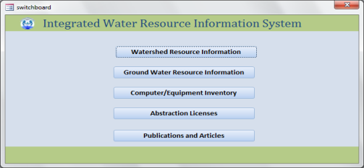
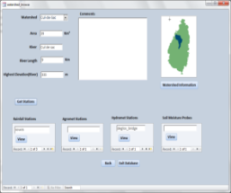
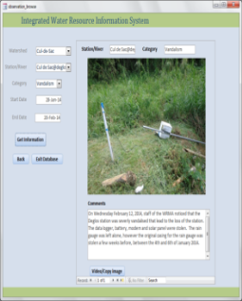
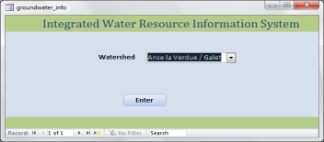
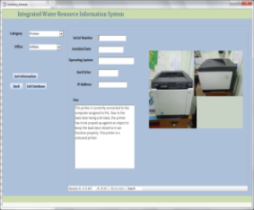
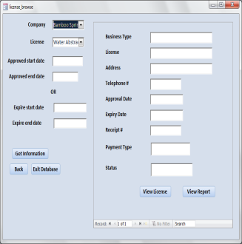

IWRIS Interface

The water resources database and reporting system were further updated. Thirty hydro-meteorological stations were maintained throughout the year. Data collection spanned the period from April 2013 to March 2014 and the database is now 92% up-to-date as at the end of the year. Data collection includes information on river flow, rainfall, water quality and in some cases water level at four main rivers (Canelles, Mabouya, Deglos and Dauphin).

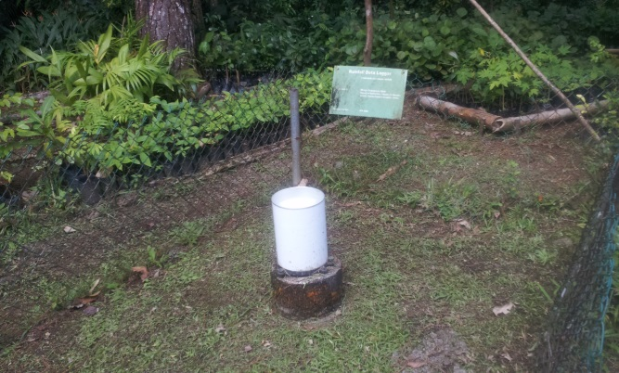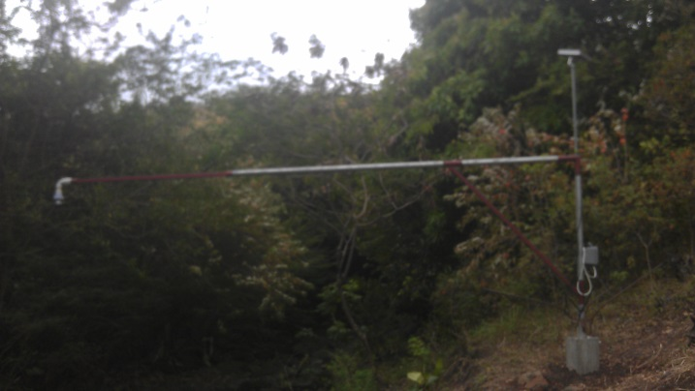
Rainfall logger at Barre de l'Isle (left) and water level recorder in Dauphin watershed (right)

Environmental Education
The Agency continued its environmental education campaign with two main objectives, (1) to change public behaviour on water conservation, use and management, and (2) to create a greater sense of appreciation for the country’s water resources. The primary target audience of the campaign was the youth, particularly primary and secondary school students. School visits were made throughout the year, and these visits involved presentations and field visits, which included water quality testing with students.

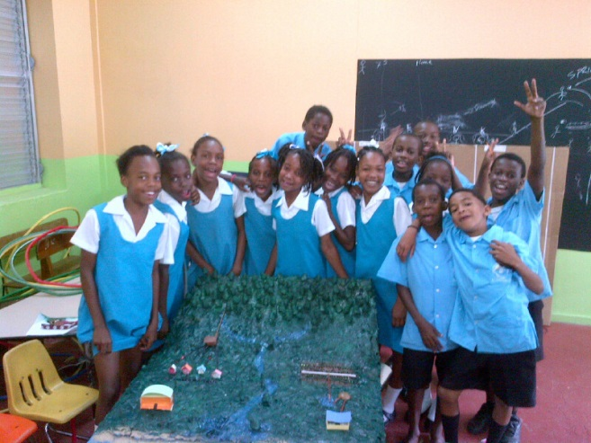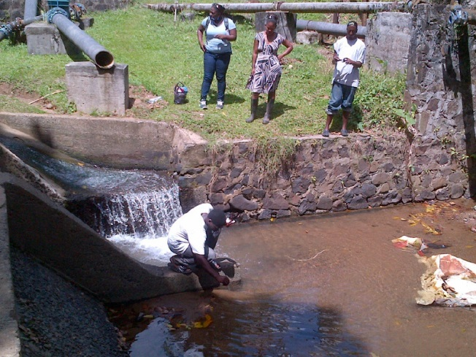
Students of the Marchand Primary School with watershed model (left) and the Babonneau Secondary School (right) participating in water quality testing

Collaborative Efforts
Meetings were held within the period to develop the TOR for an Inter-Sectoral Water Advisory Committee. The formation of the Committee is expected to assist in enhancing coordination among ministries and in supporting participatory approaches in planning and decision-making on water-related issues.

A lack of timely cooperation with partner agencies in the past has resulted in delays in the maintenance and update of databases, especially in the areas of data sharing. The Agency is developing MOUs with the government agencies with which it works closely. The MOUs will formalize the relationship between the Agency and its governmental partners and clearly define the roles of different agencies. One MOU between the Agency and Meteorological Services is being finalized and the other between the Agency and the Department of Fisheries is still in draft form.

Legislative and Policy Agenda
The Water and Sewerage Act is currently being reviewed and amended.

The Agency reviewed the Water and Sewerage (Fees) Regulations through financial assistance provided by the National Water and Sewerage Commission. A report of the recommendations has been completed and will soon be submitted to Cabinet.

Capacity Building
Two WRMA Officers attended an eight-month training programme in Hydrology at the Caribbean Institute for Meteorology and Hydrology (CIMH).

Early Warning System
The Early Warning System and Hydrological Monitoring for Water Management and Disaster Risk Reduction Project was implemented during the period. The system features a number of core components. These include: (i) Stakeholder consultations were held to determine the priority sites for installation of early warning systems; (ii) agency staff trained in the development of hydrologic modelling; (iii) modelling of the Castries watershed; (iv) analysis of Roseau watershed indicating areas of groundwater potential; (v) report of existing wells and a recommended monitoring schedule; (vi) a draft report of the Fond d’Or watershed indicating potential for groundwater availability; (vii) stakeholder consultations towards achieving participation with other waste-related agencies in hot spot assessment and defining waste control areas; (viii) identification of major watersheds (15 watersheds were selected) for field studies; (ix) commencement of field assessments; and (x) commencement of the procurement of equipment, hardware and software required for the project implementation.

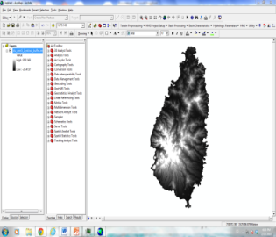
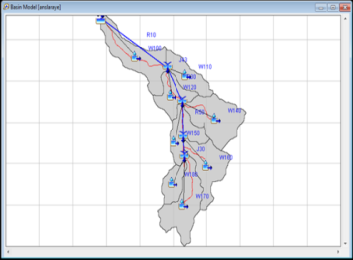
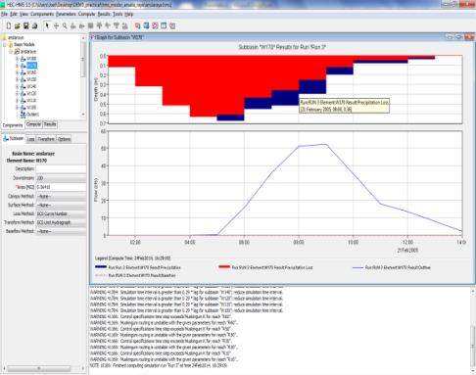

Digital elevation maps + Hec GeoHms
HEC-HMS
Analysis of water flows, water levels and delay time at different sections of the river

The Hydrologic Model at Work
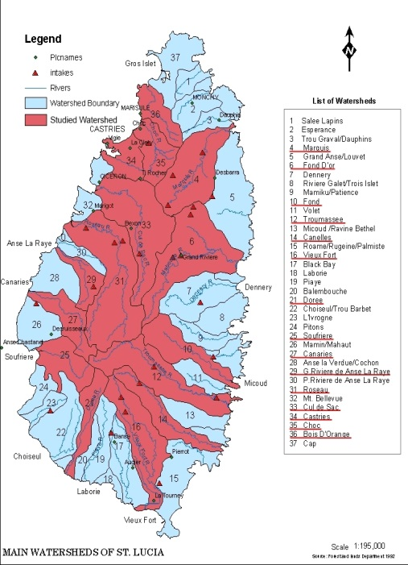
Major Watersheds Selected for Field Investigations

Challenges
Theft and vandalism of hydro-meteorological equipment have plagued the Agency throughout the Financial Year. Defacement of the equipment has resulted in some gaps in the data, as it takes some time to repair or replace equipment. During the 2013-2014 Financial Year, three stations were vandalized, namely; (1) Mabouya, at which the solar panel and battery were stolen, (2) Deglos, at which the complete station was stolen, with the exception of the water level recorder, and (3) Bexon Primary School compound, at which a rain gauge was stolen.
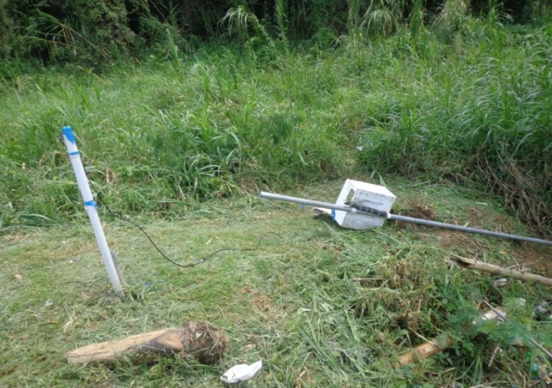
Vandalized Hydro-met Equipment

Vieux Fort and Dennery Water Supply Development Project
The water supply in the south of the island is inconsistent during both the dry and wet seasons. During the dry season there is insufficient production and storage to adequately service Vieux Fort, Laborie and environs from the Grace and Beausejour intakes, while during periods of intense rainfall the intense turbidity of the water makes treatment almost impossible.

The situation in Dennery is even more acute. That community suffers from the same problems just described for Vieux Fort, but the absence of a complete filtration process means that Dennery North also often experiences poor water quality.

To address these perennial vexing problems, the Government of Saint Lucia, through collaboration among the Ministry of Planning, the Ministry of Sustainable Development and WASCO on November 1st, 2013 officially launched the Vieux Fort and Dennery Water Supply Development Projects. These projects are supported by the Caribbean Development Bank and the Caribbean Aqua-Terrestrial Solutions program. The first phase of the project will provide a medium-term water supply redevelopment plan for the areas, as well as preliminary conceptual designs, performance and other technical specifications, and tender documents for the proposed capital works. This work will build on significant preliminary investigations that were conducted by Professor Frank Dale Morgan of the Massachusetts Institute of Technology (MIT).

The Mexican Government, through an intervention spearheaded by the Minister for External Affairs, has also committed significant grant funds for the development of the Dennery Valley Water Supply.
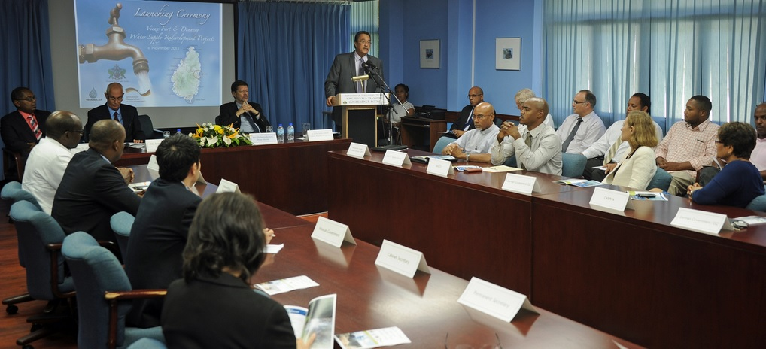
Prime Minister Anthony Launching the Vieux Fort-Dennery Water Supply Development Project

Environmental Management
The Sustainable Development and the Environment Division is one of the core agencies responsible for the environmental management of Saint Lucia’s ecological resources. The Protected Areas Management Office is another key stakeholder in the management of environmental resources in Saint Lucia. Both agencies work with a number of Development Partners locally and abroad to advance the cause of proper environmental management and achieving development through sustainable means.

Policy and Governance

Implementing a Framework for Environmental Management
This project was born out of the CDB-funded technical assistance project entitled “Institutional Strengthening of OECS Member States in Environmental Management” executed by the OECS. The technical assistance contributed to Saint Lucia’s efforts to implement the National Environmental Management Strategy/National Environmental Policy and address some of the challenges of environmental mainstreaming. The objective of the project is to improve environmental governance and management in support of environmental mainstreaming in Saint Lucia through an enhanced policy, legal and institutional framework.

The project seeks to deliver a sound framework for enhanced environmental management, inclusive of a revised National Environmental Policy and Management Strategy, an Environmental Management Bill, a transition/business plan for the SDED and a feasibility study for the establishment of a dedicated environmental fund for Saint Lucia.

The company “Environmental Solutions Ltd” has been contracted for this project and completion is expected by May 2014.

Ocean Governance
In the 2014-2015 Financial Year, Saint Lucia will pursue the development of an Ocean Governance agenda to address the management of national ocean space. One of the issues to be addressed with urgency is that of Maritime Boundary Delimitation. Since gaining independence in 1979, Saint Lucia has formally agreed on only one maritime boundary agreement, with Martinique. There is a need to formally define the maritime boundaries with other countries, including Saint Vincent & the Grenadines and Barbados. This effort will be jointly led by the office of OECS Commissioner and the MSDEST with support from the OECS and the Commonwealth Secretariat.
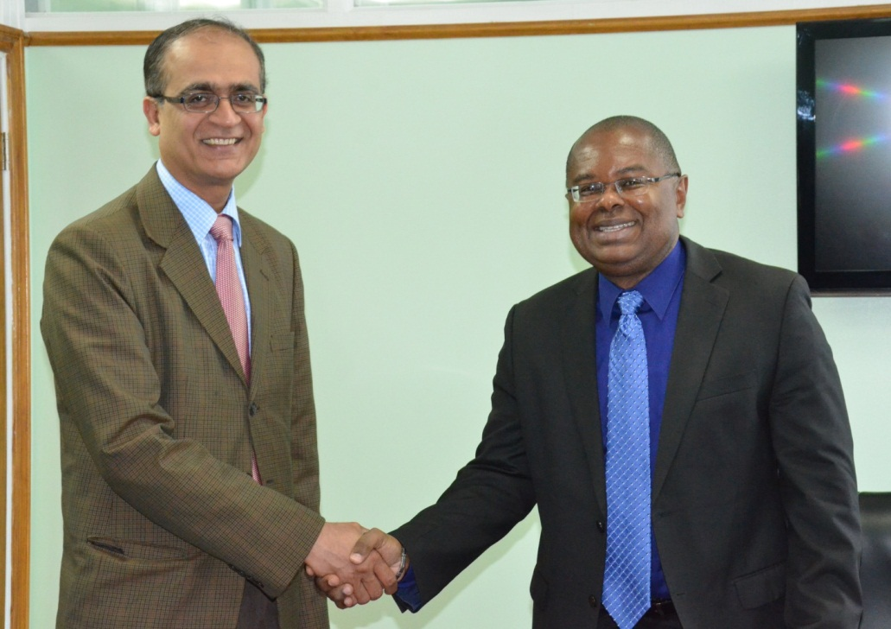
Minister Fletcher meeting Commonwealth Deputy Secretary General to
Discuss Support for Oceans Governance

National Environment Commission
The key responsibilities of the Commission are to advise the Minister with responsibility for the Environment on environmental and relevant sustainable development issues and to promote an integrated and coordinated approach to addressing environmental issues in Saint Lucia.

The Commission has been reactivated and it is envisaged that it will establish itself as the main multi-sector adviser to the Minister in the light of the increasing challenges associated with environmental management in Saint Lucia.

Protected Areas Management
The single most important priority for the PMA during the current (2013-2014) Financial Year was the completion of the Limits of Acceptable Change (LAC) Study. The study also addressed key outputs of the broader protected area programme goal, which is working towards establishing and sustaining an effective and integrated system of protected areas.

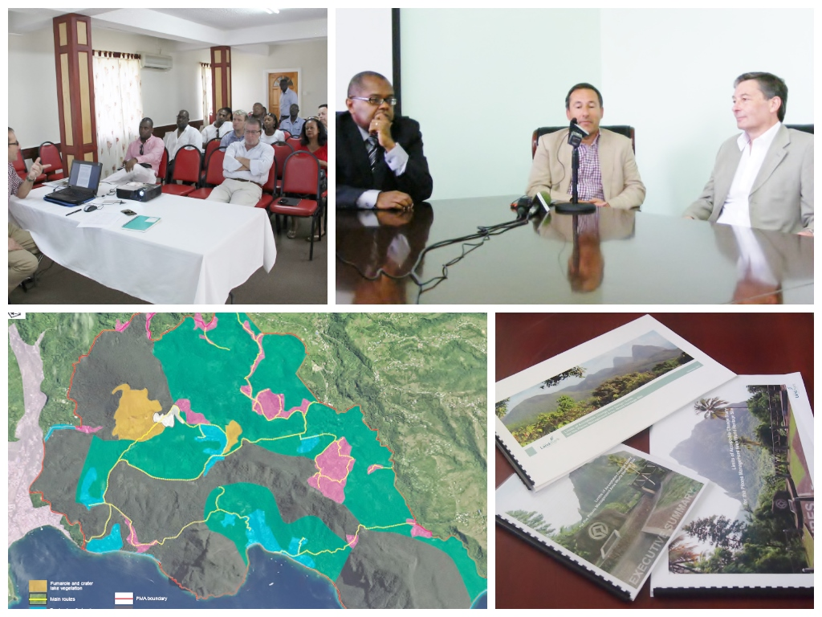
Developing the Limits of Acceptable Change Study Report

The commissioning of the Limits of Acceptable Change Study was an essential part of Saint Lucia’s commitment to the UNESCO World Heritage Committee for addressing issues within the PMA. After an intense period of data collection, consultation and dialogue among stakeholders, the Protected Management Areas Office can now report that a major target has been achieved. Of great significance is the report's conclusion that “since attaining World Heritage Status, the features of the PMA that confer Outstanding Universal Value have largely been preserved”.

While the completion of the Study is a significant milestone, the Office must now respond to the new challenge of monitoring new and/or proposed developments planned for the PMA to ensure conformity with the stipulations of the Study. This added responsibility would require, among other things, addressing the human resource constraints of the Protected Areas programme and the Protected Areas Management Office in particular. At its most recent meeting, the Pitons Management Area Advisory Committee agreed that the Protected Areas Management Office should undertake the following actions:

  - Provide greater information and interpretation of the PMA for visitors and liaise with landowners and members of the local community to raise awareness of the Limits of Acceptable Change Study.
  - Establish a strong working relationship with the Development Control Authority.
  - Set up a system to monitor the changes in the landscape of the PMA using the important viewpoints as the basic unit of assessment of the maintenance of the outstanding universal value of the PMA.
  - Commission a detailed survey of the flora and fauna throughout the PMA from which accurate geographical information system maps are to be created, which identify areas of high biodiversity value that should be preserved.
  - Collaborate with stakeholders to identify and address any threats to the biodiversity (terrestrial and marine) and general health of the PMA.
  - Liaise with local businesses and community organisations to help maximise the economic potential of the PMA while remaining within the Limits of Acceptable Change.

Other Notable Achievements
The Protected Areas Management Office can also report some success in other programme areas. These include:
- Submitted the 2014 Sate of Conservation Report for the PMA to the UNESCO World Heritage Committee.
- Commenced eradication of invasive alien species (IAS) plants on Gros Piton.
- Engaged the community to increase public awareness of the Protected Areas Management Office and the Pitons Management Area in general, and of the potential to leverage funds from the GEF Small Grants Programme Office in Saint Lucia for small projects within the PMA.
- Created opportunities for dialogue and collaboration amongst agencies with an environmental mandate operating within the PMA.
- Established networks to facilitate collaboration with critical stakeholders, such as the Soufriere Marine Management Authority, Saint Lucia National Trust and other departments of the MSDEST. This network extends to the Soufriere Regional Development Foundation, the Environmental Health Office in Soufriere and the Soufriere Action Theatre among others.
- Enhanced the aesthetics of the PMA Inscription Monument in collaboration with the Soufriere Infant School and the Soufriere/Fond St Jacques Constituency Council.

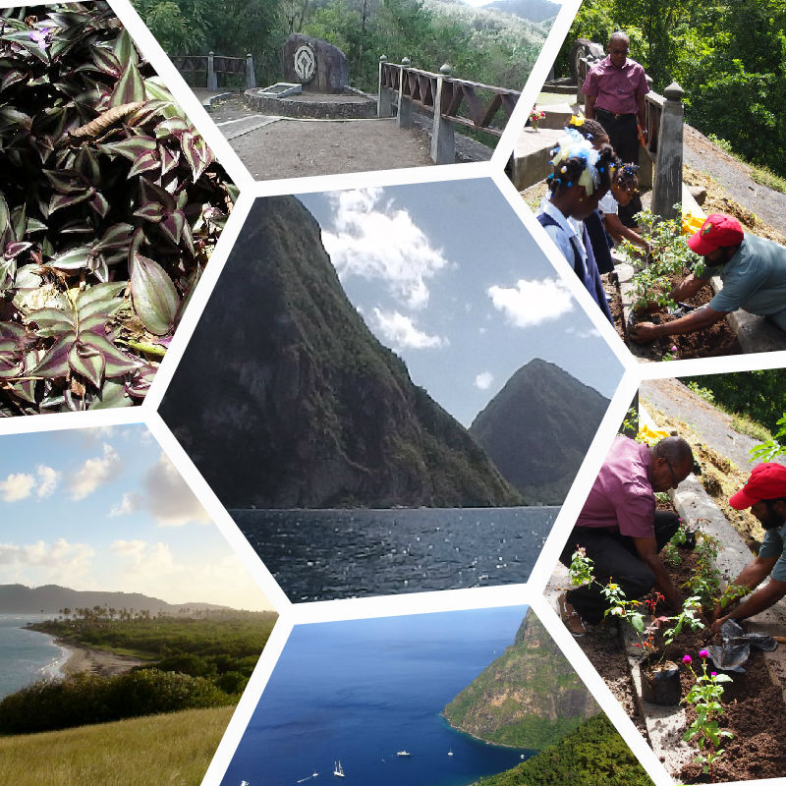

Scenes within the PMA

Climate Change

Special Programme on Adaptation to Climate Change - Photovoltaic System (Marchand Community Centre)
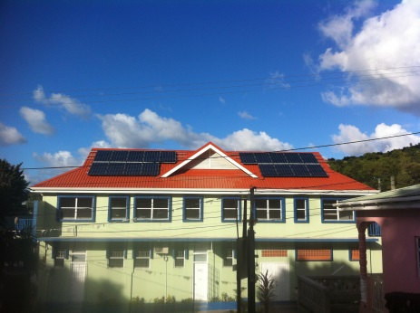
Solar PV Panels on the Marchand Community Center

The Special Programme on Adaptation to Climate Change Project focuses on the implementation of select adaptation measures designed to address climate change impacts. This pilot adaptation measure seeks to demonstrate the design and implementation of appropriate interventions to reinforce critical infrastructure (e.g. hospitals, shelters) to withstand the effects of intensified hurricanes in the Castries region of Saint Lucia.

In addition to enhancing the water storage capacity, structural integrity of the building and the natural ventilation of the building, the project was expanded to include the installation of a solar photovoltaic system. Since the building is also used as an emergency shelter during disasters, the availability of auxiliary power is critical to its operations.

This component was funded by Caribbean Renewable Energy Development Programme (CREDP) and the Caribbean Community Climate Change Centre and cost US$94,801.

Loss and Damage
The Saint Lucia delegation to the 19th Conference of the Parties (COP19) of the United Nations Framework Convention on Climate Change (UNFCCC), led by the Hon. Dr James Fletcher contributed to realizing a landmark international agreement on Loss and Damage as it pertains to the impacts of climate change on Small Island Developing States. This agreement seeks to establish the Warsaw International Mechanism for loss and damage associated with climate change impacts, as the main vehicle under the United Nations Framework Convention on Climate Change to promote the implementation of approaches to address loss and damage in a comprehensive, integrated and coherent manner.
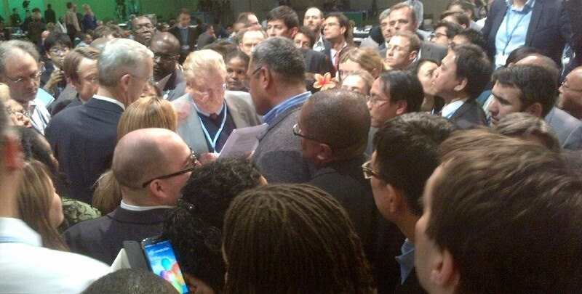
Minister Fletcher in intense negotiations involving the US, EU, G77 and AOSIS that
led to the historic International Climate Change Agreement on Loss and Damage

Third National Communication
Saint Lucia has commenced preparation of its Third National Communication in fulfilment of its obligations under the United Nations Framework Convention on Climate Change. The core elements of the Third National Communication report are information on emissions and removal of Greenhouse Gases and details of the activities undertaken by Saint Lucia to implement the Convention. The National Communication usually addresses national circumstances, vulnerability assessment, financial resources and transfer of technology, training and public awareness. The completion date is set for August 2016, and the project is expected to cost US$500,000.00.

A full scale implementation of the Third National Communication will take place in the upcoming financial year and will commence with the National Inventory Report on Greenhouse Gas to the UNFCCC.

Climate Change Adaptation Policy
In order to respond to the myriad impacts of climate change on Saint Lucia, a climate change adaptation policy has been developed. The policy recognizes the role of government, the private sector and other stakeholders in the successful implementation of adaptive measures in Saint Lucia. The objective of the Climate Change Adaptation Policy is to ensure a coordinated and holistic approach to addressing the short to long term effects of climate change. This policy has been revised and is expected to receive Cabinet’s endorsement by July 2014.

Coastal Zone Management

North-west Coast Water Quality Demonstration Project
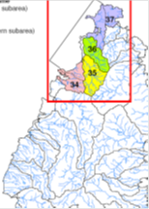
The North-west Coast Water Quality Demonstration Project was driven by the concerns over coastal water quality along the north-west coast of the island, plus the national obligations under the Land Based Sources of Marine Pollution (LBS) Protocol of the Cartagena Convention. Phase One of this Project was completed in 2011 and was followed by the completion of Phase Two in August 2013. This project was implemented by the GOSL through the Sustainable Development & Environment Division, with financing provided by UNEP - Caribbean Environment Programme. The Caribbean Environmental Health Institute (now Caribbean Public Health Agency) was the executing agency.

Phase Two of the Project focused on analysing and providing options for water pollution remediation at the high risk sites (hotspots) identified in Phase One. There was collaboration with the owners and operators of establishments within hotspots, to apply some of the short-term and low-cost interventions recommended.

The SDED will continue to work with UNEP to develop a technical report from the final report for sharing throughout the wider Caribbean, with special focus on the distribution/sharing of the rapid risk assessment tools designed for use by manufacturing, hotel, school, automotive garage and marina operators. The project cost is US$35,000.00.

Coastal Zone: Capacity Building for Wastewater Management in Saint Lucia
The GEF – Caribbean Regional Fund for Wastewater Management Project for the wider Caribbean region focuses on capacity building for personnel involved in all levels of wastewater management in Saint Lucia. Media personnel are also a target group of this project, as it is envisaged that they are key to promoting awareness of the benefits surrounding proper wastewater management.

Biodiversity and Biosafety

Revision of the National Biodiversity Strategy and Action Plan and Preparation of the Fifth National Report Project
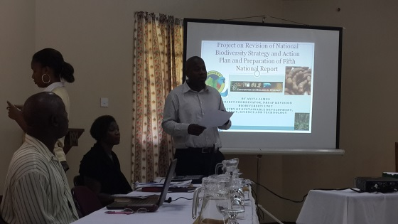
Consultation on Biodiversity Strategy and Action Plan

The main objectives of the project are to revise the National Biodiversity Strategy and Action Plan and to prepare the fifth national report by 2014. The project supports integrating the obligations of Saint Lucia under the Convention on Biological Diversity into its national development and sectoral planning frameworks.

The project is expected to be completed by the first quarter of the 2014-2015 Financial Year. So far, several community-based consultations have taken place in an attempt to ensure full acceptance of the Strategy.

Nagoya Protocol Ratification
Saint Lucia is to continue pursuing the completion of project documents for ratification and implementation of the Nagoya Protocol. This protocol speaks to access to genetic resources and the fair and equitable sharing of benefits arising from their use. Only three Caribbean countries have signed so far.

EU-Access and Benefit Sharing (EU-ABS) Project
The Government has received approval in principle of a European Union-Access and Benefit Sharing (ABS) project for Saint Lucia. The main deliverables will include: development of a strategy and action plan and legislative drafting including general awareness-raising in 2014; and specific awareness raising activities and establishment of the specific elements of the adopted framework in 2015.

Training & Equipment
Opportunities for training have been identified and confirmed for laboratory identification of Genetically Modified Organisms (GMOs). This is to be undertaken in collaboration with a public agricultural and livestock agency in Chile. The procurement of equipment and establishment of a laboratory for the identification of GMOs in Saint Lucia is scheduled for 2014-15.

Green Economy Initiative
Saint Lucia has expressed an interest in being one of the pilot countries of the Caribbean Green Economy Initiative. The Green Economy Project is intended to help Saint Lucia restructure its economy by focusing on sustainable consumption and production practices and to prepare for the wave of environmentally friendly technologies expected to drive future global economies. Consequently, with the assistance of UNEP, Saint Lucia is set to undertake a pilot project for a Green Economy. The first steps will include a Green Economy Assessment of Saint Lucia and defining the parameters for a Green Economy model in the Saint Lucian context. It is anticipated that work on this project will commence within the upcoming financial year.

In March, 2014 the Hon. Minister was invited to participate as a speaker at the first Partnership for Action on Green Economy (PAGE) conference in Dubai, United Arab Emirates. At the Conference the Minister, who was the only representative from the Caribbean, spoke on the importance of a Green Economy strategy for Small Island Developing States like Saint Lucia that are looking to stimulate economic development and create new, green jobs.

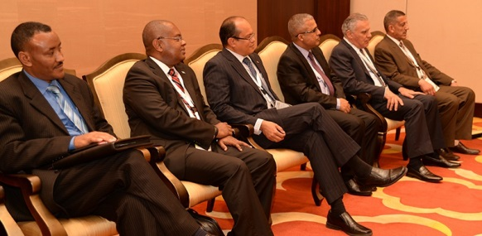
Minister Fletcher with other Environment Ministers
at the first PAGE Conference

Global Environment Facility
Saint Lucia has utilised most of the funding allocated under the fifth GEF allocation. A balance of approximately US1.2 million for Climate Change mitigation is to be allocated for geothermal development.

The development of the project documents for the IWECO and Iyanola Projects is far advanced and it is expected that implementation will commence in the coming financial year. The Iyanola - Natural Resource Management of the North East Coast Project will seek to prepare management plans for the last stronghold of rare and endemic animal and plant species in the richly diverse north-east area of Saint Lucia.

Resources under the 6th GEF allocation are expected to be announced in the middle of 2014 and to be made available in the succeeding months.

Disaster Risk Reduction

In May 2013, the Minister was an invited panellist at a Featured Event discussion on “Strengthening Partnerships towards Disaster Risk Reduction for Small Island Developing States” at the Global Platform for Disaster Risk Reduction, which was held in Geneva, Switzerland by the United Nations Office for Disaster Risk Reduction (UNISDR). The Global Platform is a forum for information exchange, discussion on latest developments and partnership building across sectors, with the goal to improve the implementation of disaster risk reduction.
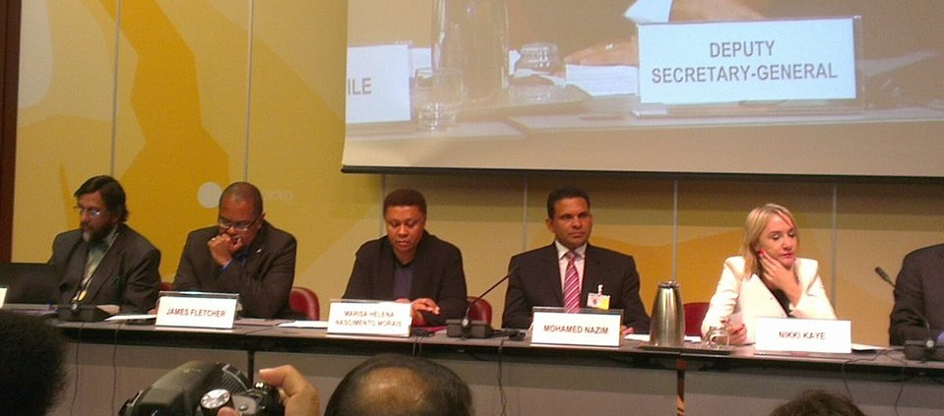
Hon. James Fletcher on the Global Platform Featured Event Panel Discussion in Geneva with the
Chairman of the Intergovernmental Panel on Climate Change (IPCC), Dr Rajendra Pachauri

Multilateral Environmental Agreements
The negotiating team of the SDED continued to represent Saint Lucia competently at major international meetings and conferences related to various Multilateral Environmental Agreements on Climate Chang, Natural Resource Management, Biodiversity and Sustainable Livelihoods.

Forest and Land Resource Management
The mandate for “Forest and Land Management” is administered by the Forestry Department. The Department was previously housed within the Ministry of Agriculture but has since been relocated within the MSDEST. The Department has been more effective within this structure as it can now work closely with partner agencies such as the WRMA and the Sustainable Development and the Environment Division.

An Integrated and Evidenced-Based Approach to Governance in the area of Sustainable Development

The Department is working towards the development of a five (5) year strategic National Forest Management Plan (2014-2019). This plan will be complimented by the National Forests Sector Policy Document. Flora and Fauna International have agreed in principle to provide $50,000 USD to assist with the development of the plan. The first draft of the TOR has already been completed.

Data have been collected from 25 data points on wildfires in two of the five ranges, namely the Dennery and Quilesse ranges. This data will be entered into a database, and will inform decisions on the implementation of the National Wildfire Management Plan.

During the financial year, officers from the Forestry Department met with representatives from the CITES secretariat, to discuss the provision of funding (by CITES) to assist with the development of CITES Legislation and Regulations.

The Department worked towards the implementation of the Invasive Alien Species (IAS) National Strategy. The Department conducted an island-wide IAS impact awareness survey and undertook searches for alien iguana in sub-communities in Soufriere. The Invasive Alien Species regulations have been submitted to the Attorney General’s Chambers for drafting and subsequent enactment of legislation. IAS plants were eradicated near the World Heritage Site.

The Department, with the assistance of the Critical Ecosystems Partnership Fund, developed a logical framework for the Iguana Action Plan, and developed biosafety plans and protocol for offshore islands. The Iguana Action Plan still requires background information, data analysis and a strategy for the eradication of alien invasive iguana on the island.

Improved Management of the Natural Environment

The Department’s focus under this strategic objective was the protection, restoration and rehabilitation of forests. The Department maintained 10,135 metres of boundary lines and 3,750 metres of forest access. The Patrols and Surveillance Unit conducted 20 forest patrols with the collaboration of the Drug Squad of the Royal Saint Lucia Police Force. During this exercise, the Department discovered 25 hectares of forest reserves that had been converted into lands for marijuana production.

Fifty-five (55) hectares of landslide areas were restored within the forest reserve. The Department surpassed the restoration target of 50 hectares that it had set at the start of the year. During the exercise 34,047 plantings were made, including 6,002 wildlings.
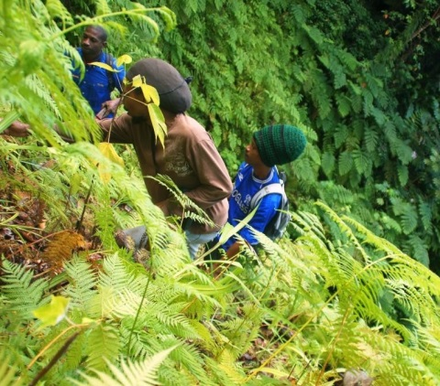
Forestry Staff Engaged in Restoration and Rehabilitation Work

The Department undertook an assessment of Forest areas following the passage of the December 24th, 2013 trough and completed rapid assessments of 20 major rivers and 14 units of forest reserves and other forested Crown and private lands.
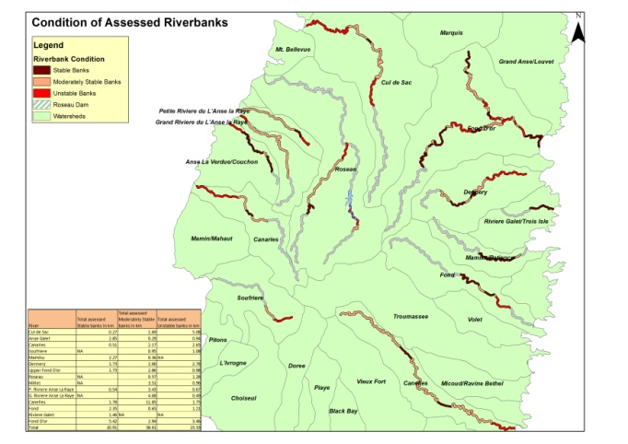

Geographical Information System Map showing Condition of Assessed Rivers

The Department developed tools that will allow for effective and efficient forest and land resources management. The outputs from these tools include:

- 3 maps produced for the IWECO project
- 2 maps for the Iyanola project
- 15 maps under the AUSAid project

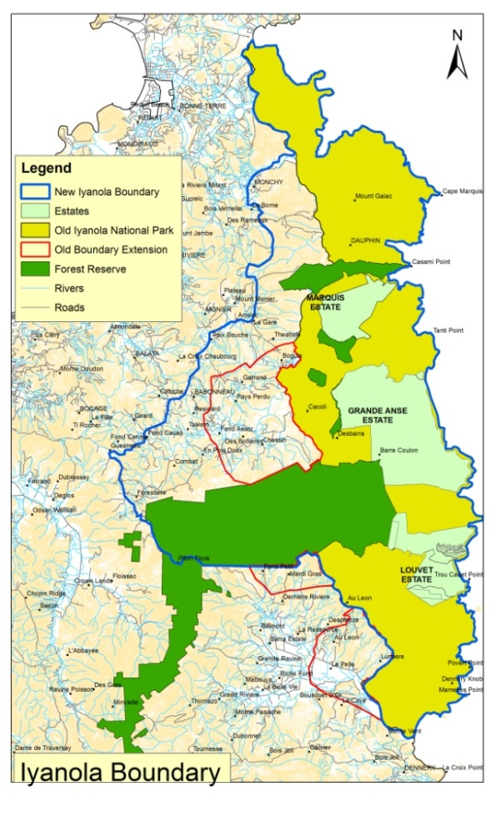
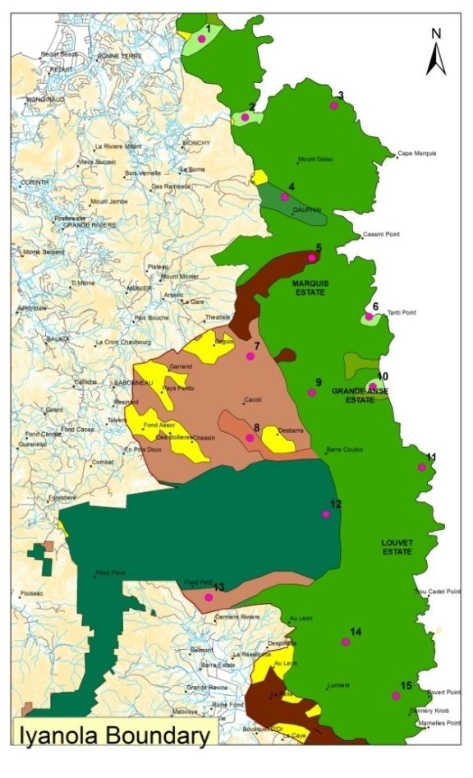
Boundaries of Critical Ecosystems and other Geographic Information to Facilitate the Development of the Iyanola Project

The Department prepared an MOU with the Germany-based Association for the Conservation of Threatened Parrots (ACTP) for the construction of a new Wildlife Conservation and Education Centre at Union. Preliminary plans for the centre have begun and draft floor plans have been developed.

The Green Economy, Sustainable Development, Livelihoods and Quality of Life

The Department is committed to facilitating the realisation of economic gains from the ecosystem through the responsible use and management of environmental resources. Saint Lucia’s ecological resources are of tremendous worth environmentally and financially, and proper management and use of these resources can lead to a steady flow of revenue for the GOSL and sustainable livelihoods for citizens.

A total of $194,826.00 was generated in revenue for the financial year. The revenue breakdown for the financial year is as follows:
- Forest trails - $75,396.00.
- Rainforest Sky Rides User Fees - $70,256.00
- Sales of forest produce - $38,489
- Rentals, fees and forfeitures - $10,685.00.

Revenue Trend for the period April 2006 to March 2014

The Forestry Department is working towards the decentralisation and eventual privatisation of the Christmas Tree program. Five farmers have been approved to participate in the programme and half a hectare of land has been approved for pilot sites. The sites are in Marquis, Dennery, Vieux Sucre, and Mayers. One thousand seedlings have been prepared and will be ready for transplanting in May 2014.
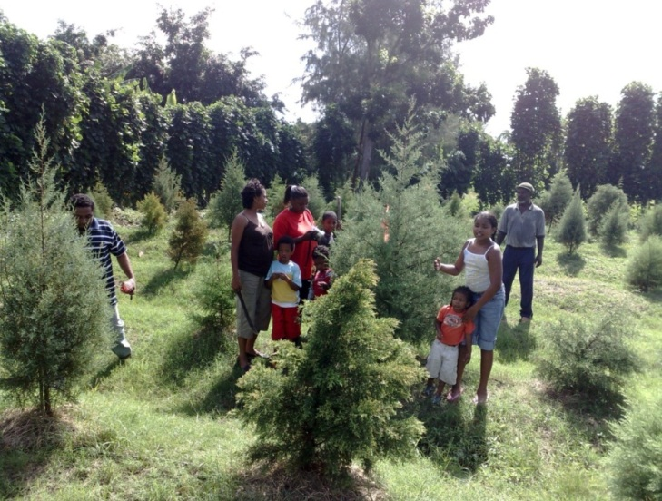
Cultivation and Sale of Christmas Trees

Five tappers have been identified to participate in the Sustainable Management of the Lansan trees in the Barre De L’Isle. This project is still in its pilot phase. Two tappers have received training in tree identification and harvesting of lansan resin. A database has been developed to capture information during this pilot programme. This information will allow for the evaluation of the program’s success.

Solid Waste Management
The Board of Directors and staff of the Saint Lucia Solid Waste Management Authority successfully navigated the organization through a very challenging period. The main programme areas were able to achieve reasonable successes, given the resources at the Authority’s disposal. The Board of Directors continued to lead the Authority through the development of institutional policies relevant to the management of human as well as financial resources, while guiding the Authority through a period of impending cash-flow insolvency. As the period nears its end, it is becoming more apparent that the efforts are bearing fruit.

Administration
The Administration facilitated meetings of the Board, and its four (4) committees i.e. Human Resource Committee, Technical Committee, Finance Committee and Legal Committee. A Memorandum was developed and presented to the Cabinet of Ministers seeking decisions that would assist in ensuring the viability of the SLSWMA. The results of the deliberation are encouraging. Among the items for consideration were the revision and regulation of the fee structure for services, the imposition of an additional revenue measure, provision for the amendment to the governing legislation to reflect current governance arrangements and, direction regarding arrangements for debt servicing. These are all intended to be instituted in the upcoming (2014-2015) Fiscal Period.

Operations
Waste Collection
The period saw a steady performance by collections contractors, despite changing arrangements for collection in selected areas in order to address problems presented as a result of non-compliance with established arrangements. The Christmas Eve trough presented a serious challenge to contractors as a result of the extent of waste generated by the resulting clean-up. Fortunately, the disposal facilities at Deglos and Vieux-Fort were not adversely affected by the extreme weather event, and were kept open to facilitate disposal.

Waste collection in one zone was seriously hampered, leading to numerous complaints being forwarded to the Authority during the protracted period. Measures were instituted to rectify the situation.

Waste Disposal
The disposal sites operated with less frequent breakdown of mostly older pieces of equipment as the result of concerted efforts at maintenance. However, there remains a need for a systematic approach towards the replacement of the less efficient pieces.

Challenges
The major challenges faced by the Operations Department revolved around the lack of adequate financial resources for the following:
- The upgrading of the electrical system at Deglos to facilitate the commissioning of the tyre shredder and reactivation of the autoclave.
- The need for a systematic renewal of the heavy equipment fleet to ensure maintenance of hygienic standards on the landfills.
- The procurement of a heavy duty pump to control water accumulation at the disposal sites.

Education and Public Information
The Authority is tasked with assisting in the development of positive attitudes and behaviours among the Saint Lucian populace, through its various education and awareness initiatives. This role, though challenging, was often accomplished through the print and electronic media as well as school and community outreach initiatives.

During the Financial Year, the Authority opted for an upgrade of the already existing website instead of the construction of a new one, in keeping with the cost-containing measures encouraged by the organization. Such an initiative was necessary to facilitate a more appealing and user-friendly experience. Greater use was made of social media through the Authority's Facebook page as periodic updates on the activities of the Authority were undertaken.
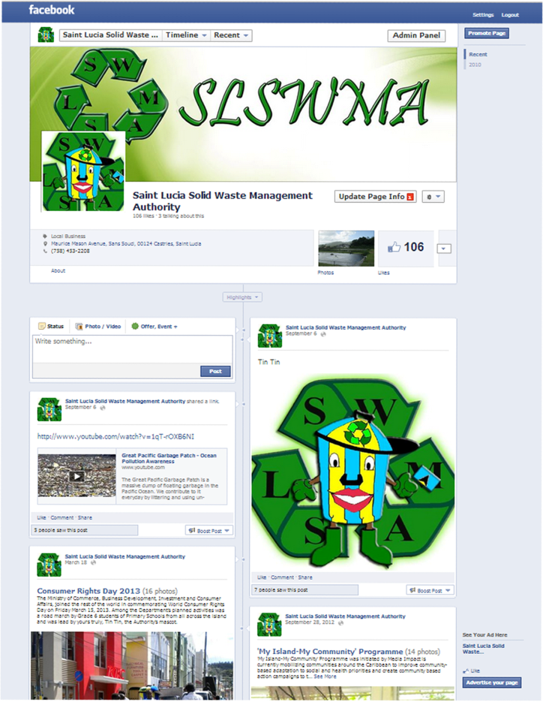
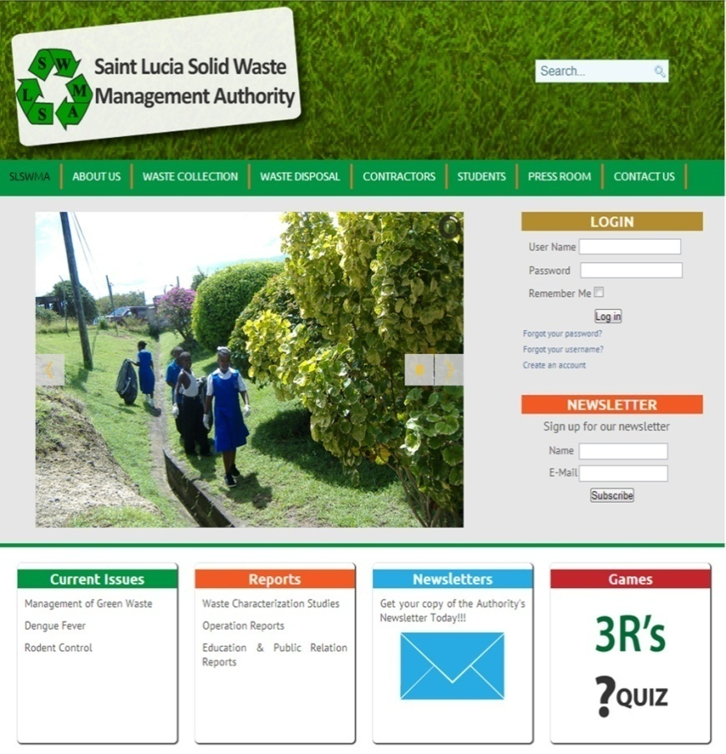

SLSWMA Website and Facebook page

Collaboration with stakeholder agencies remained a significant aspect of the work of the Department, as it creates synergies which also redounded to lower costs associated with the implementation of initiatives.

A notable component was the school/youth outreach programme. Activities took the form of presentations, mascot visits, clean-up activities, disposal and sanitary landfill site visits. Twenty (20) schools and youth groups benefitted from this initiative.

The Authority, in collaboration with Zonal Supervisors of the Operations Department, continued efforts at minimizing community hotspots and nuisances associated with communal bins and persistent dumping outside collection days. Efforts to effect change in the affected communities included house-to-house visits, formal and informal meetings and the use of the electronic media. Initiatives were undertaken in Sunbilt/Cedars/Patterson’s Gap, Morne du Don, Castries/Gros-Islet Highway (Marisule) with a satisfactory level of success. Despite collaboration with the various stakeholder agencies including the schools in Soufriere, the community of Palmiste is yet to achieve an acceptable level of success. Work will continue in this community during the next financial year.

The Authority continued to serve as the reservoir of public complaints and steward of the complaints database. This component of the programme facilitated expression of customer dissatisfaction with respect to solid waste management on the island, particularly with the services offered by the Authority. A total of three hundred and eighty six (386) complaints were processed as at 28th February, 2014 (for the current financial year).

Public Complaints Processed
Quarter | Number of public complaints
April - June (1st) | 101
July - September (2nd) | 111
October - December (3rd) | 122
January - February (4th) | 52
Total | 386

The number of complaints was higher than usual. However, this can be attributed to operational challenges experienced by one waste collection contractor. All complaints were forwarded to the Operations Department for investigation and closure.

Recycling Study
A study commissioned to determine the current status of solid waste recycling on the island was undertaken in collaboration with the Taiwan ICDF Overseas Volunteer attached to the Authority for a period of six months. The output of the exercise included a report that will assist the Authority in the further development of solid waste recycling on the island.
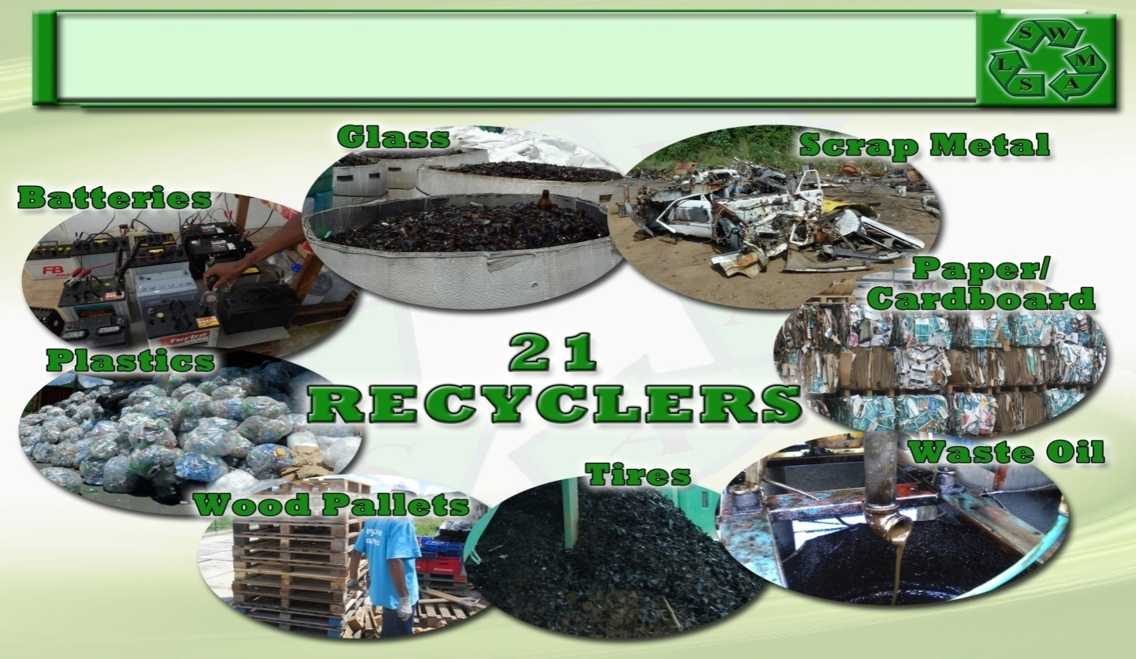
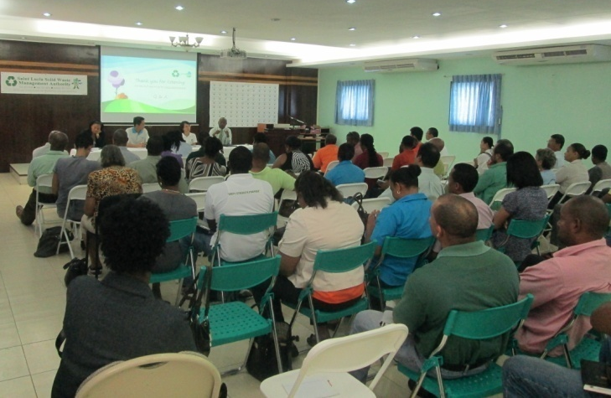
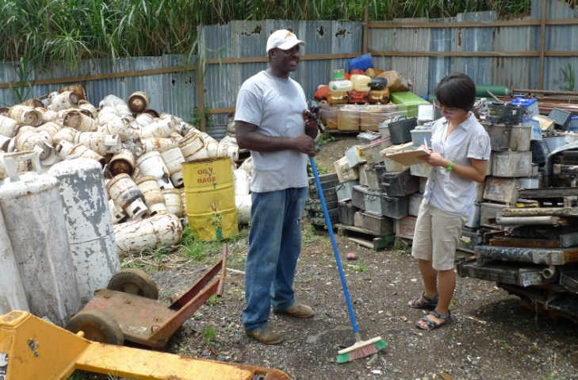

Photographs of recycling study cover (top), public consultation (left), Volunteer at work (right)

The coming year will see the Authority continue to work towards the development of a more holistic waste management system. The Authority will continue to restructure the legislative foundation under which it functions through the revision of the Waste Management Act and the enactment of the Management of Containers Bill.

Public Utilities
The Public Utilities Department continued to deliver on its mandate in the telecommunications, water and electricity sectors.

Water

National Water and Sewerage Commission
The Secretariat to the Commission is staffed with an Executive Director and an Administrative Assistant. Additional officers are required, but these persons will be hired once permanent office space is secured and the evolution of the NWSC to the National Utilities Regulatory Commission (NURC) takes place.

Process Manual
In order to bring predictability and consistency to the regulatory process, the NWSC commissioned and produced a Regulatory Process Manual. The Manual is intended to guide the NWSC Commissioners and staff on the steps involved in performing key regulatory activities. It will also serve as a guide to new employees and Commissioners who need to become familiar with the essential features and processes of the NWSC.

Customer Service Standard
Customer Service Standards Regulations for the water sector have been developed. The purpose of the Customer Service Standard is to establish standards for water and sewerage in areas such as metering, meter testing, service interruptions, billing, connections and disconnections.

The document contains five main sections. Part One will deal with preliminary matters such as the citation and interpretation of terms used in the Regulations. Part Two provides for the potable water services standards to be observed by a service licensee, example the service licensee would be required to provide potable water supply services that are consistent with applicable health and environmental standards. This section will also articulate standards for service interruptions, service connections, water quality metering and meter testing. Part Three addresses sewerage services, while Part Four will address billing matters, collection, disconnection, provision for deposits and reconnection. Part Five will address miscellaneous matters such as customers’ rights, complaint records, road works, public safety and liability insurance, system records and force majeure.

The completed Customer Service Standard has been submitted to the Attorney General’s Chambers for necessary action.

Water and Sewerage Tariff
The National Water and Sewerage Commission (NWSC) approved a 66.15% tariff increase for water. The tariff increase is allocated as follows: 10.43 % for the dredging of the John Compton Dam and the remaining 55.72% as the new rate. The effective tariff increase for sewerage was 50.8% and this charge will apply until the end of the Triennial period (September 2012 to August 2015).

Energy
Eastern Caribbean Energy Regulatory Authority
Saint Lucia and Grenada agreed to follow through with their commitment on the establishment of the Eastern Caribbean Energy Regulatory Authority (ECERA). The objective of the project is to establish and operationalize a regional approach to the development of the electricity sector in the OECS participating countries.

ECERA will be expected to design and implement mechanisms to curtail the growth of electricity costs, reduce cost volatility by diversifying energy supply away from fossil fuels and ensure least cost investments in the electricity supply.

ECERA’s initial project implementation period is from July 1, 2011 to June 15, 2016. However, because of start-up delays the project is due to end in December 2017. The project is currently undertaking most of its ground work through various consultancies. All of the consultancies are scheduled to be completed by the end of the 2014 calendar year.

The Government of Saint Lucia has indicated to the World Bank and the OECS Secretariat its concerns about the limited participation of OECS Member States in ECERA and has stated that unless a critical number of four (4) Participating Member States can be achieved, it would not consider the initiative to be viable.

PetroCaribe
In 2012, the GOSL revived discussions with the Government of the Bolivarian Republic of Venezuela to operationalize the PetroCaribe initiative in order to diversify its sources of fuel for electricity and transportation. During the 2013-2014 Financial Year, the MSDEST led discussions with the Venezuelan Government to finalize the bilateral agreement for the purchase of fuel under PetroCaribe. The new bilateral agreement was signed by Prime Minister Hon. Kenny Anthony at the CELAC Summit in Havana, Cuba in January, 2014. The MSDEST, through the Minister, also participated in several meetings during the year aimed at paving the way for the establishment of a PetroCaribe Economic Zone, which will allow Participating Countries to derive even greater economic and social benefits from the PetroCaribe arrangements.

National Utilities Regulatory Commission
The Department has been working towards the development of the legislative environment for a multi-sector utility regulator. This multi-sectoral regulator will be responsible for operators in both the water and electricity sectors. The proposed National Utilities Regulatory Commission Bill is aimed at allowing liberalized and non-discriminatory entry into the utilities sector and enabling a robust competitive environment in which there is fairness, transparency and accountability on the part of the regulators of the sectors. National Consultations on the Bill have taken place and the legislation is expected to be completed within the first quarter of the new Financial Year.

Telecommunications

National Telecommunications Regulatory Commission
After protracted discussion and consultation among the Public Utilities Department, the legislative unit of the Eastern Caribbean Telecommunications Authority (ECTEL) and the Legislative Drafting Unit, the Telecommunications Fees Regulations and Telecommunications Licence Classification Notice have been finalised and submitted by the Ministry of the Public Service, Information and Broadcasting to the Ministry of Legal Affairs for action.

Selected Telecommunications Indicators for Saint Lucia (Source: ECTEL)
 | 2009 | 2010 | 2011 | 2012 | 2013
Provider Revenue (EC$M) | $238 | $243 | $245 | $240 | $227
Investment (EC$M) | $54 | $36 | $19 | $29 | $23
Employment | 566 | 520 | 519 | 506 | 425
Fixed Line Penetration | 24% | 23% | 22% | 21% | 20%
Mobile Penetration | 116% | 120% | 131% | 129% | 125%
Broadband Penetration | 11.7% | 12.6% | 13.1% | 13.3% | 14.6%
Local Fixed Traffic (million minutes) | 183 | 173 | 158 | 147 | 143
Local Mobile Traffic (million minutes) | 215 | 243 | 204 | 241 | 217
International Incoming Traffic (million minutes) | 67 | 51 | 51 | 43 | 36
International Outgoing Traffic (million minutes) | 40 | 34 | 36 | 25 | 25

The Fees Regulations will, among other things, enable the GOSL to licence Cable TV Providers, TV Stations and Radio Stations. There are approximately twenty FM Radio Stations, eleven TV Stations and four Cable TV Stations operating on island without any licensing regime.

Science and Technology
The Energy, Science and Technology Section within the MSDEST is responsible for overseeing the science and technology initiatives of the GOSL. The following are a few of the major Science and Technology initiatives that were undertaken.

Perception of Science and Technology Study
The Unit undertook a “Perception of Science in Secondary Schools Study.” This was primary research undertaken by the Unit with the following objectives:

- To provide insights into the perception of science held by secondary school students in Saint Lucia.
- To identify possible key factors contributing to the low level of performance in science subjects.
- To develop recommendations to improve the performance of students in the science subjects.

Ten (10) Secondary Schools were selected for this analysis and a total of three hundred and one (301) students participated in the study. This sample size constituted about 11% of the population of Form 3 students on island.

The Unit has produced a report based on the findings, which will be circulated among local and regional stakeholders. The Unit intends to use the recommendations emanating from the report to develop new initiatives and projects to address some of the needs identified. The results of the report will also be presented to all Science heads-of-department at a future conference.

Situational Analyses of Science and Technology in Priority Sectors
The proposal that informed the Situational Analyses was the “Strengthening the Institutional Framework for the Promotion of Science and Technology” Project, which ran from 2011 to 2013. This project sought to strengthen the institutional and policy foundation for the advancements of Science and Technology as a key input into the Sustainable Development process. The project focused on four main areas: institutional strengthening, situational analysis, policy formulation and awareness-building.

The main objectives of the project were to:
- Re-establish a formal institutional mechanism to provide direction on the advancement of science and technology
- Strengthen linkages between key agencies involved in activities related to science and technology
- Determine the status of science and technology in Saint Lucia
- Commence the elaboration of policy measures to advance science and technology in Saint Lucia
- Undertake public awareness in an effort to promote science and technology in Saint Lucia

A total of sixteen interviews were conducted with resource personnel from six key areas: Education, Agriculture, Manufacturing, Tourism, Commerce and Creative Industries. The interviews were documented and collated into sectoral reports, which represented situational analyses of science and technology in various sectors.

These Analyses will be used primarily to assist and inform in the formulation of a Science and Technology Policy. The Policy will serve as an umbrella framework for future science and technology initiatives, through the formalisation of a national science and technology programme for St. Lucia with related objectives.

Development of Science and Technology Policy
The Unit contracted a consultant to develop a National Science and Technology Policy for Saint Lucia. Several consultations and meetings were held and a draft policy paper has been prepared.

Science and Technology for Entrepreneurship
The Unit has been taking steps to make science and technology a stronger pillar of development. These include measures aimed at creating a closer link with industry and entrepreneurship. The proposed interventions include an inter-ministerial committee looking at providing seed funding for innovation and building capacity for your entrepreneurs.

Science and Technology Summer Camp
The MSDEST, through the Energy, Science and Technology Unit, hosted the first National Science and Technology Summer Camp from August 12th – 16th, 2013, at the Orchid Gardens, Union, under the theme: Unlocking Saint Lucia’s Potential through Science, Technology and Innovation. The Science and Technology Summer Camp was facilitated by world-renowned Global Enthusiast for Creative Learning, Dr Edwin Sobey, a forerunner in Robotics, Innovation, and Project Development.

The summer camp afforded thirty-three (33) students the opportunity to learn principles of science and technology in an enjoyable, interactive and collaborative environment. Specific areas addressed throughout the duration of the camp included electricity and work, simple machines, robotics and project development, with robotics forming the main area of concentration. Through this introduction, students understood how robots work and were able to tap into their creativity to build their own automated machines that undertook a range of functions. The ultimate goal was to not only increase confidence and knowledge in Science, Technology and Innovation but foster entrepreneurship, marketability and job creation amongst our students.

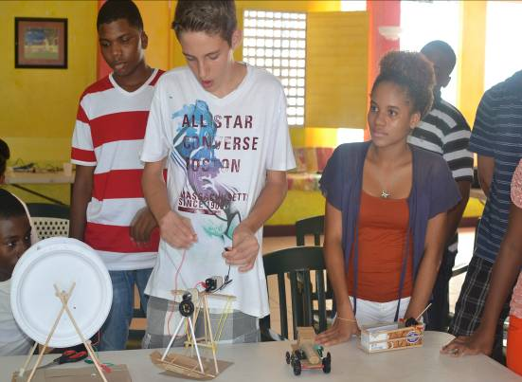
Demonstration of finished project

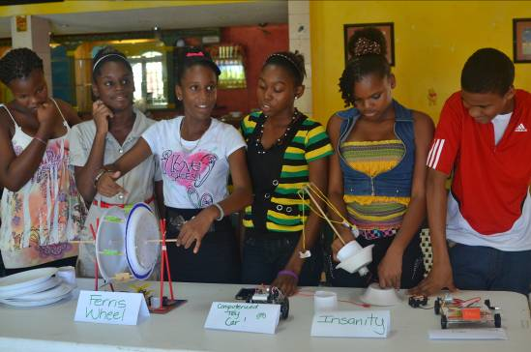
Students Displaying Some of their Scientific Creations

Workshops/Trainings/Seminars and Conferences
A Training Workshop for Primary and Secondary School Science Teachers was held on June 17th -19th, 2013. This initiative was undertaken in collaboration with the Ministry of Education, Human Resource Development and Labour. The facilitator was Dr Edwin Sobey. The main aim of this workshop was to train teachers in the use of innovative methodologies for Science instruction. Most schools on the island were represented, with teachers promising to apply the techniques learnt in the classroom.

Science and Technology Stakeholder Consultations
Six (6) science and technology consultations were held with stakeholders from diverse thematic areas: Natural Resources, Production Sector, Services Sector, Education Sector, Research and Development Sector and Sustainable Development. Following these consultations, a report was prepared on the outcomes of each consultation, resulting in a total of six (6) reports. After review by the stakeholders, these reports were submitted to the consultant hired for the development of the National Science and Technology Policy, Strategy and Action Plan. The results emanating from these reports are supplemented with Situational Analyses in priority areas.

Closing Remarks
The 2013-14 Financial Year was filled with its share of challenges. Although there was a recurring theme of resource constraints in almost all sections of this Annual Report, it is also clear that the ministries did a remarkable job of accomplishing more with less.
The senior management of the two ministries as well as their line staff demonstrated resilience, resourcefulness, creativity and perseverance in the way they mobilised and leveraged resources to support their respective work programmes. While some adjustments to the scope of some of the programmes had to be made during the year, all of the agencies executed their mandates very skilfully and effectively.
This will have to remain the modus operandi of the agencies for the foreseeable future. We will have to actively and aggressively pursue new funding sources to continue the good work that has started and to initiate some very urgent new interventions. At the same time, we must use our existing resources in an efficient and cost-effective manner that will not only allow us to gain maximum benefit for the government and people of Saint Lucia, but continue to garner the respect and support of our Development Partners. We wish to reiterate our gratitude to our many Development Partners who make our work possible and who continue to support our agencies and our Government during these challenging times.
We look forward to another productive year in service to the Government and people of Saint Lucia.

