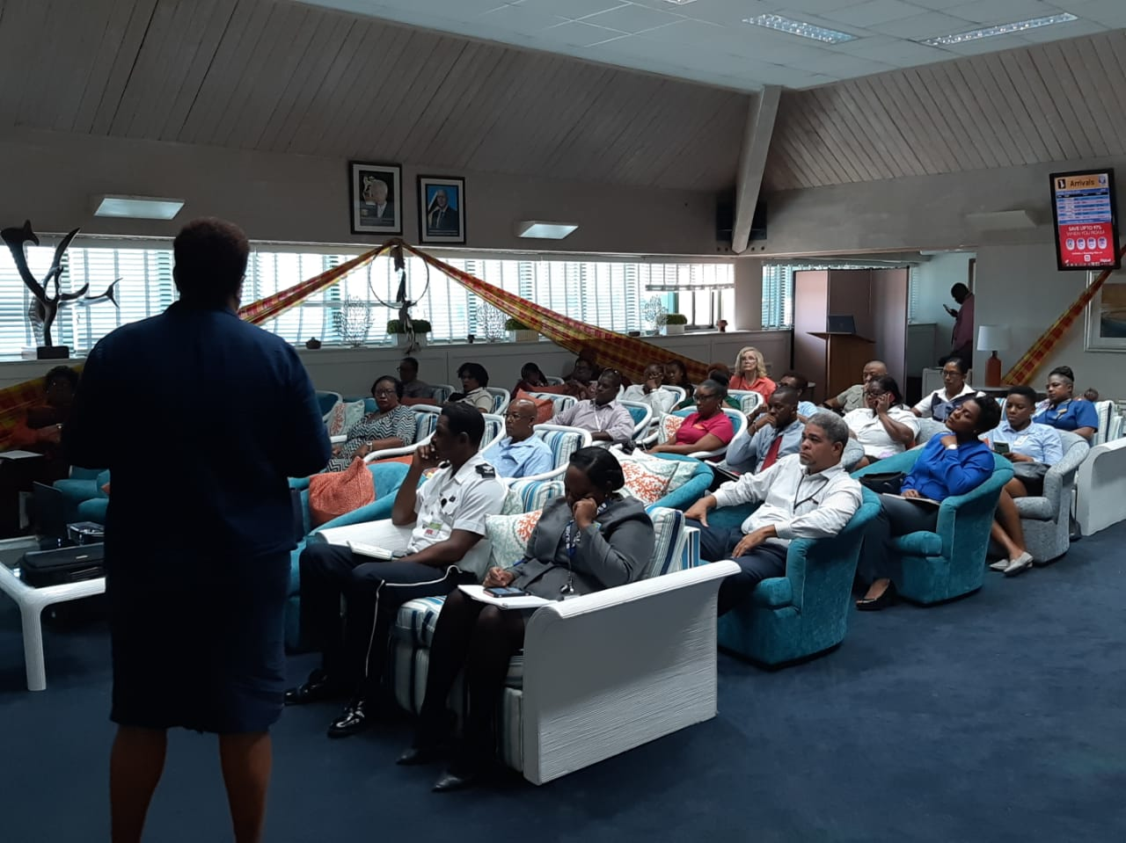

Government of Saint Lucia

Stakeholder Engagement Plan (SEP)

Caribbean Regional Air Transport Connectivity Project (CATCOP)
(P170860)

DRAFT – FOR DISCLOSURE AND CONSULTATION

April, 2023

Revision Record

Revision | Date | Author(s) | Remarks
1. | 09.30.2019 | SLASPA | Draft
2. | 10.31.2019 | SLASPA | Advanced Draft
3. | 11.07.2019 | SLASPA | Draft- for internal review
4. | 11.08.2019 | SLASPA | Draft – for internal review
5 | 03.02.2020 | SLASPA | Draft for Disclosure and Consultation
6 | 08.04. 2021 | SLASPA | Draft for Disclosure and Consultation
7 | 28.12.2021 | SLASPA-PIU | Revised Draft for Review
8 | 04.11.2022 | SLASPA-PIU | Revised Draft for Review and Clearance

Acronyms

ADS-B Automatic Dependent Surveillance-Broadcast
CATCOP Caribbean Regional Air Transport Connectivity Project
CERC Contingency Emergency Response Component
C-ESMP Contractor’s ESMP
DIPE Department of Infrastructure, Ports and Energy
DSD Department of Sustainable Development
ECCAA Eastern Caribbean Civil Aviation Authority
ESMP Environmental and Social Management Plan
ESA Environmental and Social Assessment
FOD Foreign Object Debris
GFLCA George F. L. Charles Airport
HIA Hewanorra International Airport
IATA International Air Transport Association
ICAO International Civil Aviation Organization
LWC Labor and Working Conditions
OHS Occupational Health and Safety
PSMA Point Sable Management Area
RESA Runway End Safety Area
SEP Stakeholder Engagement Plan
SLASPA Saint Lucia Air and Sea Ports Authority
SLU George F. L. Charles Airport (IATA airport code)
UVF Hewanorra International Airport (IATA airport code)

Table of Contents
Revision Record ii
Acronyms iii
1. INTRODUCTION 1
1.1 BACKGROUND 1
1.2 PROJECT DESCRIPTION 2
1.3 PROJECT LOCATION 6
2.2 Overview of Works 10
1.4 SUMMARY OF POTENTIAL ENVIRONMENTAL AND SOCIAL RISKS, IMPACTS, AND MITIGATION MEASURES 12
2. SUMMARY OF PREVIOUS STAKEHOLDER ENGAGEMENTS 14
3. STAKEHOLDER ENGAGEMENT PLAN (SEP) 16
3.1 STAKEHOLDER ENGAGEMENT 16
3.2 WORLD BANK REQUIREMENTS 16
3.3 SCOPE OF SEP 17
3.4 SEP OBJECTIVES 17
4. STAKEHOLDER IDENTIFICATION AND ANALYSIS 18
4.1 STAKEHOLDER IDENTIFICATION 18
4.1.1 Potential Stakeholders 19
4.1.2 Affected Parties 19
4.1.3 Other Interested Parties 20
4.1.4 Disadvantaged/Vulnerable Individuals or Groups 21
4.2 STAKEHOLDER ANALYSIS 21
4.2.1 Stakeholder Analysis Process 21
4.2.2 Government of Saint Lucia (GoSL) 22
4.2.3 Statutory Bodies 23
4.2.4 Regional Agencies 24
4.2.5 Non-Governmental Organizations (NGOs) 24
4.2.6 Airport Internal Stakeholders 24
4.2.7 Local Community 24
4.2.8 Other Private Interests 25
4.2.9 Funding Entities 26
4.2.10 Summary of Project Stakeholder Needs 26
5. STAKEHOLDER ENGAGEMENT PROGRAM 27
5.1 PUBLIC SCOPING MEETINGS 27
5.2 INFORMATION DISCLOSURE 27
5.3 STAKEHOLDER CONSULTATION PROCESS 28
5.4 TIMELINES 32
6. GRIEVANCE REDRESS MECHANISM 33
6.1 PURPOSE 33
6.2 OBJECTIVES OF A GRIEVANCE REDRESS MECHAMISM (GRM) 33
6.3 MECHANISM FOR GRIEVANCE REDRESS 33
6.4 ROLES AND RESPONSIBILITIES 33
6.4.1 Role of the Communications and Community Liaison Officer (CCLO) 34
6.4.2 Role of the Environment and Social Specialist (ESS) 34
6.4.3 Composition and Role of the Grievance Redress Committee (GRC) 34
6.5 GRIEVANCE MECHANISM STRUCTURE 35
6.5.1 The First Tier for Redress 35
6.5.2 The Second Tier for Redress 37
6.5.3 The Third Tier for Redress 37
6.6 ADDRESSING SEXUAL EXPLOITATION AND ABUSE AND SEXUAL HARASSMENT (SEA/SH) 37
6.7 Creating Awareness 42
6.8 Reporting 42
6.9 Periodic Review by the GRC 42
6.10 GRM Jurisdiction 43
6.11 Grievances Levels 44
7. REPORTING 42
7.1 OBJECTIVES 42
7.2 REPORTING TO STAKEHOLDERS 42
ANNEXES 1
Annex A: Grievance Office Log 1
Annex B: Grievance Register 2
Annex C: Complainant / Project Affected Person Form 4
Annex D: Grievance Acknowledgement Form 5
Annex E: Disclosure Form 6
Annex F: Meeting Record Format 7
Annex G: Tracer Matrix For Grievances 9
APPENDICIES 10
Appendix 1: Stakeholder Contact Meeting for Hewanorra International Airport on October 27, 2019 10
Date 11
Meeting called by 11
PURPOSE OF MEETING 11
CHAIRPERSON 11
Attendees 11
ABSENT 11
Appendix 2: Stakeholder Contact Meeting for George FL Charles Airport on November 11, 2019 14
Appendix 3: Sample Stakeholder Consultation Notes Template 17
Appendix 4: Grievance Mechanism - ADDRESSING SEXUAL EXPLOITATION AND ABUSE AND SEXUAL HARASSMENT (SEA/SH) INCLUDING GENDER BASED VIOLENCE (GBV) 18

INTRODUCTION

BACKGROUND

The Caribbean Regional Air Transport Connectivity Project (CATCOP) is proposed to be funded by the World Bank Group (WBG) and has as its development objective to improve air transport safety in compliance with international and regional standards and enhance resilience of airport infrastructure to natural disasters. The project’s focus is to (i) improve runway safety and resilience; (ii) improve air traffic safety and efficiency; and (iii) build capacity in air transport management.

Currently there are two airports in Saint Lucia which are vital for the regional movement of people and goods and for the tourism sector with its increased demand. The island has two airports: Hewanorra International Airport (UVF), the main international airport located in the south of the island, and George FL Charles Airport (SLU), a smaller airport which provides regional connectivity from the capital city of Castries in the north. Together, they account for commercial air travel non-stop services to 21 international destinations. The coexistence of the two airports at different locations on the island improves the island’s resilience to major climatic hazard.

The existing airport infrastructure faces non-compliance with the international standards on safety, operational and logistical aspects and is highly vulnerable to natural disasters and climate change. The pavement of UVF’s runway is in poor condition and its aircraft approaches are characterized as non-precision, both of which limit arrivals during poor meteorological conditions resulting in aircraft arrival delays, periodic diversions to alternate airports, and occasional flight cancellations. Also, certain International Civil Aviation Organization’s (ICAO) safety standards are not being met, e.g., runway classifications in relationship to types of aircraft operating, pavement condition, and lack of Runway End Safety Areas (RESAs). While the SLU location is convenient to the capital and major population/tourism centers, it is smaller than UVF, situated in a highly constrained setting with little opportunity for expansion, and non-compliant with several ICAO safety standards such as runway shoulders and RESAs. Potential impacts from climate change, including extreme temperatures, could cause further buckling of airport runways, pavements, and access roads, while flooding can inundate and damage runways and parked aircraft, both of which can result in extended airport closures.

The Government of Saint Lucia (GoSL) has commissioned the preparation of a master plan for UVF. Based on a preliminary review, the draft master plan is found to prioritize the expansion of passenger handling capacity without enough emphasis on airfield safety and resilience improvements. The Draft Plan considers the construction of a new main terminal, air traffic control tower, and an extended aircraft parking apron, but due to financial constraints it does not sufficiently emphasize certain airfield safety and resilience improvements necessary to comply with ICAO SARPs such as runway end safety areas (RESAs) and rehabilitation of the runway. No significant works are planned for SLU.

The Saint Lucia Air and Sea Ports Authority (SLASPA) is the airport operator and air traffic services (ATS) provider in Saint Lucia. The GoSL will implement the CATCOP through SLASPA. For the civil aviation related activities, the project Implementation Unit (PIU) under the SLASPA will closely collaborate with the Civil Aviation Department of the Ministry of Finance, Economic Development and the Youth Economy.

PROJECT DESCRIPTION

The Project Development Objective (PDO) is to improve air transport safety in compliance with international and regional standards and enhance resilience of airport infrastructure to natural disasters. The development objectives would be achieved through a combination of safety and operational improvements at Saint Lucia’s two existing airports – Hewanorra International Airport (UVF) and George F. L. Charles Airport (SLU) – and strengthening the capacity of SLASPA. The Project would comprise four components, as described below. The total Project cost is estimated at US$45 million.

Component 1: Improvements of UVF runway safety and resilience
This component is estimated to cost USD$31.7 million. This component seeks to improve the operational safety and climate/disaster resilience of St. Lucia’s UVF runway which is its most critical piece of aviation infrastructure, and support Saint Lucia to comply with ICAO’s Standards and Recommended Practices (SARPs) through a series of priority civil works described below.

- UVF runway rehabilitation (estimated cost US$ 24.2 million including design). Rehabilitating and upgrading the UVF runway is the highest priority airfield project considering the runway’s poor and deteriorating condition and the steady growth in passenger traffic over the last nine years (5.6% CAGR). It has been 26 years since the last full runway pavement rehabilitation and numerous cracks are evident along the entire length of the runway. Weather resistant paving material would be used to the maximum extent practicable to help improve resilience to extreme temperatures. Rehabilitating the UVF runway and establishing shoulders of at least seven and a half meters on each side would comply with ICAO’s requirements for runway dimensions and pavement condition for a code E airport. It would further improve aircraft operating safety by reducing risk of damage to the aircraft undercarriage associated with weak and cracked pavement condition and to aircraft jet engines associated with loose pavement materials. In addition to rehabilitating the runway pavement and constructing shoulders (which currently do not exist) the project would also include installation of an energy-efficient and disaster resilient LED lighting system, contributing to climate mitigation, and new markings for the runway.

- Runway End Safety Areas (RESA) for both UVF runway ends (estimated cost US$ 1 million including design). In compliance with ICAO’s requirements, the proposed construction of paved stopways and RESAs would contribute to mitigating the risk to aircraft and of potential associated fatalities associated with runway excursions. The project would include 60 meters of paved stopway from each runway end and non-paved but reinforced grounds for at least another 90 meters (for a total of 150 meters from the runway end). The paved stopways and RESAs would contribute to reduce the risk of aircraft fire or other damage in cases when an aircraft undershoots or overshoots the runway during a landing or overshoots during an aborted take-off. Paved stopways and RESA’s are required by ICAO and their implementation would contribute to St. Lucia’s efforts to abide by the POS Declaration signed on their behalf by ECCAA in 2014. In particular, it would facilitate Saint Lucia’s efforts to achieve ICAO certification of at least one of its two international aerodromes. An airfield engineer would be engaged to prepare a detailed design for construction of the paved stopways and Runway End Safety Areas at UVF, including considerations of climate / disaster resiliency.

- UVF airfield drainage/resilience improvements (estimated cost US$5 million including resilience plan and conceptual design preparation). Done in concert with the runway works listed above, these investments would improve airport resilience to natural disaster events by reducing the risk of airfield flooding associated with the annual rainy season, hurricanes, and climate change and thus by contributing to safer operating conditions. The specific resilience works and budget would be integrated with each above project based on an ‘Airfield Resilience Plan’ to be prepared by a drainage expert. The expert would be asked to prepare a detailed design for upgrades to airfield drainage to reduce the risk of airfield flooding associated with the annual rainy season, hurricanes, and climate change. Upgrades could include, but are not limited to, improvements and/or expansion of drainage canals/pipes in critical locations such as the drainage pipe under the runway in the original river location. This plan would be prepared in the context of leveraging the civil works associated with the runway rehabilitation and development of paved stopways and RESAs.

- Upgrade to the Aerodrome and Fire Fighting Service Rescue Improvements for UVF (estimated cost US$1.5 million including design). This would improve capacity of firefighter management and control during emergency events, including providing full line of sight from the control room to the entire length of Runway and contributing to efficient management of emergency operation. In addition, the inclusion of a Training/Lecture Room facility. Currently the kitchen and Lunch room area is use for Officer Training activities. These tasks would be completed in the context of an operational and organizational audit related to emergency services incorporated in Component 3. Specifically, the final design for the upgraded firefighters control room and the Training/ Lecture Room, would be developed after the audit is completed. An Architect would be engaged for the design effort.

Component 2: Modernization of Air Navigation Systems

The estimated cost of this component is USD$4M. This component seeks to improve air traffic safety and efficiency through the modernization of air navigation systems and includes:

- Installation of an Instrument Landing System (ILS) for UVF Runway (estimated cost US$ 2.5 million). This would provide a precision instrument approach greatly enhancing safety during aircraft arrivals and also reducing delays, diversions, and cancellations in poor weather situations, thus reducing fuel consumption and associated greenhouse gas emissions. An airspace and procedure design specialist would be engaged to design an instrument approach procedure associated with the new Instrument Landing System (ILS) for UVF Runway 10. Further, the specialist would develop specifications for the ILS installation including appropriate resiliency measures considering the harsh marine environment and risk of natural disasters and prepare an associated maintenance program for the system.

- Introduction of Automatic Dependent Surveillance - Broadcast (ADS-B) (estimated cost US$ 1.0 million). Provide ADS-B for both airports in Saint Lucia by installing one or more ground stations, equipping the air traffic control towers at both airports with a monitor, training air traffic controllers, and equipping Saint Lucia-based aircraft. This would contribute to improvement of aircraft operations safety at the two airports by allowing continuous position reports of most aircraft thereby greatly improving situational awareness for air traffic controllers and pilots. An additional task for the above referenced airspace and procedures specialist would be an ADS-B receiver antenna siting study to ensure unobstructed signal reception for aircraft operations at both of Saint Lucia’s airports. Ideally one site could be identified providing coverage for the entire island, but this may not be feasible given the highly mountainous terrain in St. Lucia and the need for the site to be readily accessible for maintenance. Nevertheless, given the small diameter of the relatively simple antenna, which typically is co-located at a cell phone tower, and given the fact that additional antennas should be mounted on the control towers of the two airports, the system can be considered as very resilient.

- ATC-related technical studies and update of UVF Aeronautical Charts (estimated cost US$0.5 million). As referenced above, an airspace and procedure design specialist would be engaged to support deployment of an ILS and ADS-B as well as updating all of the UVF aeronautical charts for assisting in air navigation. Assuming detailed topographical data for Saint Lucia is available, these technical studies (ILS procedure design and specifications, ADS-B receiver antenna siting, and UVF aeronautical charts preparation) are expected to cost in the range of US $400K to $600K. It is likely that one specialist consultant could conduct these studies.

Component 3: Institutional Strengthening

This component is valued at US$4 million and focuses on institutional strengthening and project management through a broad review of opportunities for improving management and oversight of the air transport sector and staffing of SLASPA. Specific elements include:

- Institutional Strengthening – SLASPA and Department of Civil Aviation (estimated cost US$5 million). GoSL is keen to conduct a broad review of opportunities for improving its management and oversight of the air transport sector as part of the Project through strengthening SLASPA and the Department of Civil Aviation as well as improving collaboration with ECCAA. Agreements have been reached to include as a first step a “gap analysis” (estimated cost of US$0.5 million) in the form of a broad organizational and operational review of airport management in coordination with ECCAA to determine the areas with the greatest opportunity for improvement including (a) safety and security (including ICAO and ECCAA compliance); (b) financial management and performance; (c) operations and maintenance; (d) climate resilience best practices; (e) regulatory oversight and (f) analysis on recruitment, retention and promotion barriers for women in the aviation sector and development of a Gender Action Plan and (g) with the advent and continuation of the global COVID-19 pandemic, a Covid-19 Response Strategy Study to guide Saint Lucia’s resilience and recovery from its effects. Based on the results of the gap analysis specific studies and/or investments would be agreed upon during appraisal and incorporated in the Project. As described above, one early element of the gap analysis would be an operational and organizational audit related to airport emergency services.

- Training of ATC and other Airport Technical staff (US$ 0.5 million). Given the above referenced new equipment installations (i.e., ILS and ADS-B), as well as the new UVF aeronautical charts, appropriate training would be provided to air traffic controllers and supervisory staff in coordination with ECCAA. Also, the project would promote the recruitment of female air traffic control trainees and development of supervisory skills for existing female staff. Aspects of climate/disaster resilience and best practices would be covered, as appropriate, as part of the training activities.

Component 4: Project Management

- Project Management (US$ 4.8 million). Given the size and the scope of the Project, a dedicated implementation team would be financed to provide overall management, supervision, fiduciary control, and monitoring and evaluation (M&E) of the Project. Since such implementation team does not currently exist within SLASPA, a new team would be established within SLASPA with specialists covering safeguards, and technical matters procurement, financial management. This would include (i) acquiring and implementing Project Financial Management System acceptable to the World Bank that facilitates the recording, control and reporting of project transactions; and (ii) hiring an international procurement consultant to support SLASPA at key stages of the procurement process. This component will also finance annual audits that will be performed by an independent auditing firm.

Component 5: Contingent Emergency Response Component (CERC)

The Project includes a Contingent Emergency Response (CER) component with initial ‘zero’ allocation. This component would finance the implementation of emergency works, rehabilitation and associated assessments, at the GoSL’s request in the event of a disaster. The component would be triggered and disbursed in accordance with an Emergency Action Plan prepared by the GoSL and the CERC’s implementation modalities.

PROJECT LOCATION

The project location is in Saint Lucia (Figure 2.1a) mainly at the Hewanorra International Airport (UVF) in the town of Vieux Fort and George F. L. Charles Airport (SLU) in the town of Castries (Figure 2.1b).

Figure 2.1 a, b: Saint Lucia geographic location, topography and airport locations

    - Hewanorra International Airport

The UVF is the main gateway to international destinations and is located at the southern end of the island in the town of Vieux Fort (Figure 2.1b and 2.1c). UVF is approximately one-hour drive from the capital city of Castries and an hour and a half drive from the main tourism center located in the north of the island. Although operational hours published in the Eastern Caribbean Aeronautical Information Publication (ECAR/AIP) for UVF is from 6:00 am to 11:00 pm daily, like the SLU, the airport remains open later to accommodate delayed and emergency flights when provided with early notification.

The UVF is assigned an International Civil Aviation Organization (ICAO) aerodrome reference code (ARC) of 4E. Key design features of the existing UVF are as follows:

- Non-precision approach runway
- Runway oriented west/east: runway 10/28 (RWY 10/28)
- Runway measures 2744m (L) x 46m (W) or 9,003 x 150 feet
- Runway strip around 2866m (L) x 152m (W) with runway approximately central within the strip
- Aerodrome elevation 4.2m (14 ft.)
- Runway threshold elevation 3.3m above sea level (ASL) at west end and 3.1m ASL at east end
- Approach and runway lighting
- Radio navigation and landing aids: non-directional (radio) beacon (NDB) and Very High-Frequency (VHF) Omnidirectional Range/Distance Measuring Equipment (VOR/DME)
- Terminal building situated about 325m north of runway center line (on eastern half of runway) accessible by two (2) taxiways
- Disused runway oriented southwest to northeast about 260m (853 ft.) north of RWY 10/28
- Area of the disused runway separated from the main compound by chain linked fence and secured gate (Gate 11)
- Gate 11 approximately 160m (525 ft.) from RWY 10/28 via closed taxiway A (TWY A)
- Eight (8) foot high perimeter fence along boundary consists of mixture of wire mesh, barbed wire and razor wire

More aeronautical information of a lasting character essential to air navigation at the UVF is available in the ECAR/AIP.

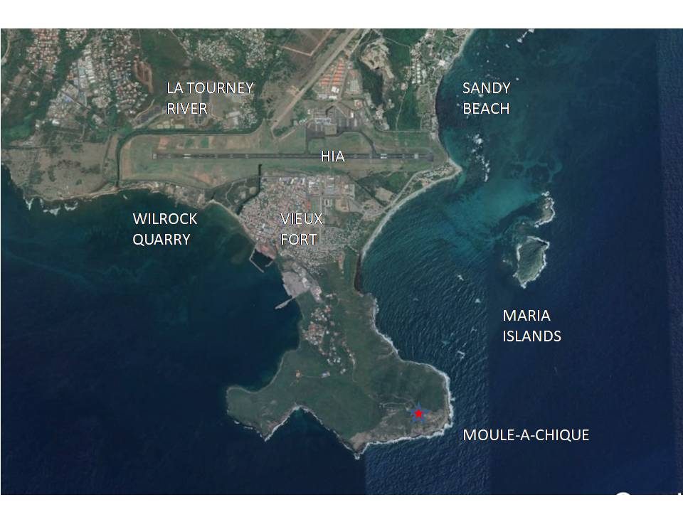
Figure 2.1c Hewanorra International Airport area

Passenger traffic levels at UVF are steadily growing: From 2009 to 2018, annual passenger volumes at UVF grew by 63%, from 515,137 to 838,120 passengers, a compound annual growth rate of 5.6%. This passenger growth – and the associated growth in aircraft operations – places pressure on airport infrastructure requiring greater investments in facility expansion and maintenance.

    - George F. L. Charles Airport

The George F.L. Charles Airport (SLU) mainly accommodates regional travel and is situated on the northwest coast in the capitol city of Castries (Figure 2.1d). This airport is about five minutes from the downtown commercial center of Castries and its operational hours are nominally from 6:00 am to 8:00 pm daily.

Figure 2.1d George F. L. Charles Airport (SLU) area
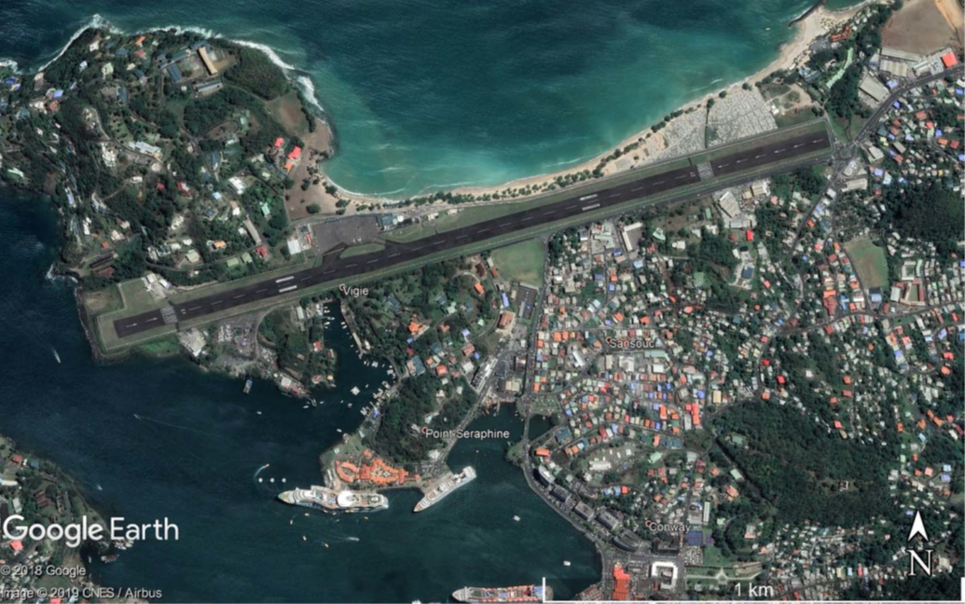

Key design features of the existing SLU airport are as follows:

- Non-precision approach runway
- Runway oriented west/east: runway 09/27 (RWY 09/27)
- Runway measures 1898m (L) x 45m (W) or 6,227 x 148 feet
- Aerodrome elevation 6.7m (22 ft.)
- Runway threshold elevation 6m ASL at west end and 3m ASL at east end
- Approach and runway lighting
- Radio navigation and landing aid available: NDB
- Eight (8) foot high fence along the entire perimeter consists of mixture of wire mesh, barbed wire and razor wire

More aeronautical information of a lasting character essential to air navigation at the SLU is available in the ECAR/AIP.

Overview of Works

The runway at the UVF, last resurfaced in 1992, has deteriorated significantly and is also without runway shoulders and runway end safety areas (RESAs). The existing drainage systems at both airports function poorly, resulting in water from rainstorms pooling close to the runway for extended periods of time before running off or infiltrating. As a result of the foregoing, the proposed CATCOP will comprise the following:

At the UVF:

- Rehabilitation of the existing runway, inclusive of runway shoulders
- Construction of code 4E turning bay on south side runway 10 (RWY 10)
- Installation of an up-to-date airfield ground lighting system
- Construction of RESAs
- Installation of an instrument landing system (ILS)
- Updating of the aeronautical charts, including procedure design for all approaches and departures
- Remodeling and renovation of the aerodrome rescue and firefighting (ARFF) facility
- Improvement of existing storm water drainage systems based on further studies

At both UVF and SLU:

- Installation of an Automatic Dependent Surveillance-Broadcast (ADS-B) system by erecting two (2) ground stations (receiver antennae) at locations outside the existing airport perimeters
- Installation of ADS-B monitor at the air traffic control (ATC) tower within the airport perimeter
- Provision of the requisite training to all air traffic controllers (ATCOs) and other personnel relevant to new equipment installations and procedures

All of the above activities have physical footprints (except the training related new equipment) that are within the existing airport boundaries, except for the ADS-B towers/antennas. The final location of both towers/antennae will be decided after a detailed design study conducted once the project begins implementation, but two tentative locations have been selected on existing towers at Cape Moule-a-Chique (the promontory south of UVF) and Vigie Hill (the hilltop north of SLU). These locations already have towers in place as well as access roads, which will minimize or avoid any environmental or social impact.

Figure 2.2a shows a standard ADS-B ground station. The size and installation are similar to that of a cell phone tower. The site locations of the proposed ADS-B facilities are considered civil aviation security restricted areas and measures, such as fencing, will be taken to mitigate against unauthorized entry. Figures 2.2b and 2.2c illustrate the common ILS ground equipment used in aviation. The ILS will be located inside the UVF.

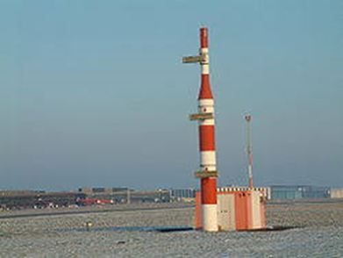
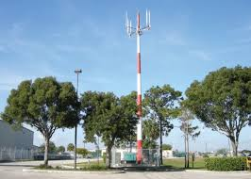

Figure 2.2a ADS-B Ground Station Figure 2.2b ILS Glide Slope Station

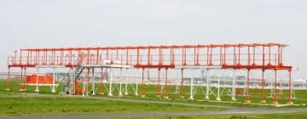

Figure 2.2c ILS Localizer Antenna Array

The above installations have small physical footprints and will be undertaken within the existing airport boundaries or on existing tower structures, and so will have minimal environmental and social risks and impacts. Specifically, ILS and ATC will be installed entirely within the airport boundaries, as well as any works or improvements to firefighting equipment and facilities. The off-site ADS-B towers/antennae would need to be installed at a location with line-of-sight to the airport, such as the hilltops at Cape Moule-a-Chique (near UVF) and Vigie Hill (near SLU). If another location is selected the preference will be for hilltops already fitted with secure tower installations for cell phones or weather monitoring stations, for which the ADS-B may share the grounds and/or the tower itself.

There are also proposed works for improvement of the existing storm water drainage systems at UVF. The proposed project interventions will mainly be limited to the existing facilities of the airport and will be designed to minimize any additional runoff due to the project interventions. The UVF will be the focus of all of the civil works being undertaken during the project.

There will be no works carried out on the La Tourney River as part of the drainage rehabilitation. A previous flood control study recommended that the surface drainage system at UVF be modified as a necessary first step in the control of flooding at UVF, in order to protect the UVF against the 1:100 rainfall event (see section 4.5.5 of this ESA).

In case of natural disasters, the project also includes a Contingency Emergency Response Component (CERC) component. To comply with World Bank Environmental and Social Standard requirements, the ESA has included possible post-disaster related activities, list of negative activities, possible environmental and social impacts and process to be followed for a rapid environmental and social assessment.

SUMMARY OF POTENTIAL ENVIRONMENTAL AND SOCIAL RISKS, IMPACTS, AND MITIGATION MEASURES

The environmental and social risk classification is Moderate under the World Bank Environmental and Social Framework based on location, type, sensitivity and scale of the project intervention, nature and magnitude of potential environmental and social risks and impacts, and client capacity. The proposed project will not support expansion or major rehabilitation of the existing airports. The physical works are mainly focused on improvement of existing runway, consruction of Runway End Safety Areas (RESAs) for both UVF runway ends and drainage facilities in Hewanorra International Airport (UVF). In addition, the project includes equipment to improve traffic safety and efficiency in UVF and Georges FL Charles Airport (SLU). In addition to project interventions within the existing airports, the project will support the installation of up to two antennae for the Automatic Dependent Surveillance-Broadcast (ADS-B) system, which will be located outside of the airports most likely on existing communications tower facilities.

The project locations are largely developed areas with restricted access, thus minimizing community health and safety risks. Project activities are expected to be limited to existing sites (occurring within the current demarcations of both airports and ADS-B towers/antennas), limited in number, likely reversible in nature, and can be mitigated with measures that are readily identifiable and technically and economically feasible. The project also includes improvement of the existing drainage systems in UVF, which will be carried out based on the further studies on the current drainage patterns to ensure there will no additional impacts from erosion and sedimentation that could impact off-site coastal and marine habitat due the drainage improvement work. Overall, the project is likely to reap positive environmental benefits through enhancing the safety and resilience at the two airports. The SLASPA and the World Bank will review the Environmental and Social Risk Classification (ESRC) on a regular basis throughout the project life cycle to ensure that it continues to accurately reflect the level of risk the project presents.

A Preliminary Environmental and Social Assessment (ESA) was prepared to inform decision making and includes an initial assessment of the project induced environmental and social impacts and associated risks based on the currently available design information to ensure that the project will be environmentally and socially sound and sustainable. It confirms that the impacts are not significant for the proposed project and can be mitigated with standard mitigation practices through the different plans prepared for the project, including an Environmental and Social Management Plan (ESMP), a Labor Management Procedure (LMP), and a Stakeholder Engagement Plan (SEP) including a Grievance Redress Mechanism (GRM). The ESA and associated plans will be further updated at the detailed design stage using the information provided within this ESA. In addition, the ESMP will require preparation of other plans such as Waste Management Plan (WMP); Hazardous Materials Control Plan (HMCP); Resource Efficiency and Pollution Management Plan (REPMP); Emergency Response Plan (ERP); Traffic and Road Safety Plan (TRSP); Community Health and Safety Plan (CHSP); and a Storm water, sediment and erosion control plan (SWSECP) at the detailed engineering phase. The contractor(s) will be required to prepare a Contractor’s Environmental and Social Management Plan (C-ESMP) before execution of physical works.

SUMMARY OF PREVIOUS STAKEHOLDER ENGAGEMENTS

There has been consultation relating to the Project between government agencies. Those include the following:

- April 29-30, 2019:
- discuss the scope of potential CATCOP

- July 10-12, 2019:
- discuss and finalize the scope of project components
- confirm project preparation and implementation arrangements
- discuss safeguards and fiduciary requirements and
- agree on a timeline for project preparation and implementation

- September 16-18, 2019:
- confirm implementation arrangements and assessment of capacity
- finalize safeguard documents (ESA)
- further discuss and finalize the scope of the project components
- finalize terms of reference (ToRs) for technical assistance and feasibility studies and
- finalize the cost estimates of the investments

Table 2 provides a brief summary of the stakeholders who were engaged as part of those consultations/meetings.

Table 2a Stakeholders Engaged During WB Meetings
Stakeholder | Point of Contact | Previous Consultation Efforts
MINISTERS
Prime Minister | Cabinet Secretary, Office of the Prime Minister | September 5, 2022
STATUTORY BODIES
Saint Lucia Air and Sea Ports Authority (SLASPA) | General Manager | April 29, 2019; September 16, 2019, February 17-19, 2021; September 29 to October 1, 2021; May 31 to June 2, 2022; and October 4 - 6 2022
GoSL AGENCIES
Ministry of Finance, Economic Growth, Job Creation, External Affairs and the Public Service | Permanent Secretary, Department of Finance | April 29, 2019; February 17-19, 2021; September 29 to October 1, 2021; March 30, 2022; May 31 to June 2, 2022; and October 4 - 6 2022
Ministry of Infrastructure, Ports, Energy and Labour | Permanent Secretary, Department of Infrastructure, Ports and Energy | April 29. 2019 February 17-19, 2021; September 29 to October 1, 2021; May 4, 2022; May 31 to June 2, 2022; and October 4 - 6 2022; September 27, 2022

Stakeholder | Point of Contact | Previous Consultation Efforts
GoSL AGENCIES
Ministry of Economic Development, Urban Renewal, Housing, Transport and Civil Aviation | Permanent Secretary, Department of Economic Development, Transport and Civil Aviation | September 17, 2019; March 30, 2022
Project Coordination Unit | Project Coordinator | September 18, 2019;
Ministry of Agriculture, Fisheries, Physical Planning, Natural Resources and Co-operatives | Permanent Secretary, Department of Planning | September 17, 2019, August 30, 2022
Development Control Authority (DCA) | Executive Secretary, DCA | September 17, 2019, March 30, 2022; September 13 and 15, 2022
REGIONAL AGENCIES
Eastern Caribbean Civil Aviation Authority (ECCAA) | Director General, ECCAA | April 29, 2019; March 30, 2022; January 6, 2023
INTERNATIONAL INTER-GOVERNMENTAL ORGANIZATION
Organization of Eastern Caribbean States (OECS) Commission |  | April 29, 2019

Table 2b shows other consultation meetings held.

Table 2b Other Stakeholder Consultation Meetings
Stakeholder | Venue | Date | Attendees | Chairperson
HIA Workers | HIA VIP Lounge | 10.27.2019 | 31  22 - Females  9 - Males | Amy Charles, SLASPA
GFLCA | GFLCA VIP Lounge | 11.11.2019 | 17  8 – Females  9 - Males | Amy Charles, SLASPA
Key Government Ministries, Department and Agencies | Ministry of Finance | 30.03.2022 | 7 (2F; 5M) | Shirlene Simmons-James, CATCOP-PIU
Government Departments, Agencies and NGOs | SLASPA HQ Conference Room | 04.05.2022 | 7 (3 F; 4 M) | O. Paul Mondesir – CATOP-PIU
Airline Operating Committee (AOC) | IAM Jet Centre, Vieux Fort | 09.08.2022 | 11  3 Female  8 Male [+ PIU and SLASPA SM]) | O. Paul Mondesir – CATCOP-PIU
Government Departments, Agencies and NGOs | SLASPA HQ Conference Room | 30.08.2022 | 10  6 Females  4 Males | O. Paul Mondesir – CATCOP-PIU
Saint Lucia Fire Service | Headquarters of the SLFS | 12.09.2022 | 3 Males | Shirlene Simmons-James- CATCOP-PIU
Referral Agencies of the Development Control Authority | SLASPA HQ Conference Room | 15.09.2022 | 9  2 Female  7 Male | O. Paul Mondesir – CATCOP-PIU
Air Rescue Fire Fighting Officers and Vieux Fort Fire Operations | Air Rescue Fire Facility | 21.09.2022 | 26  5 Females  21 Males | Johannes Ruof- CATCOP-PIU
HIA Quarterly Facilitation Meeting | SLASPA HQ Conference Room | 27.09.2022 | 17 (8 F; 9 M) | O. Paul Mondesir – CATCOPPIU

The Report for each of the meetings convened at HIA and GFLCA are Annexed to this document. (See Appendix 1 and 2 respectively)

STAKEHOLDER ENGAGEMENT PLAN (SEP)

STAKEHOLDER ENGAGEMENT

Stakeholder engagement is an inclusive process, conducted throughout the project life cycle, and involves interactions between identified groups of people. It provides stakeholders with an opportunity to raise their concerns and opinions, and ensure that this information is taken into consideration when making project decisions. Stakeholder engagement is most effective when initiated at an early stage of the project development process, and is an integral part of early project decisions and the assessment, management and monitoring of the project’s environmental and social risks and impacts.

WORLD BANK REQUIREMENTS

The World Bank’s Environmental and Social Framework (ESF)’s Environmental and Social Standard (ESS) 10, “Stakeholder Engagement and Information Disclosure”, recognizes “the importance of open and transparent engagement between the Borrower and project stakeholders as an essential element of good international practice. Effective stakeholder engagement can improve the environmental and social sustainability of projects, enhance project acceptance, and make a significant contribution to successful project design and implementation (World Bank ESF, 2017: Page 97).”

Specifically, the requirements set out by ESS10 are the following:

- “Borrowers will engage with stakeholders throughout the project life cycle, commencing such engagement as early as possible in the project development process and in a timeframe that enables meaningful consultations with stakeholders on project design. The nature, scope and frequency of stakeholder engagement will be proportionate to the nature and scale of the project and its potential risks and impacts.
- Borrowers will engage in meaningful consultations with all stakeholders. Borrowers will provide stakeholders with timely, relevant, understandable and accessible information, and consult with them in a culturally appropriate manner, which is free of manipulation, interference, coercion, discrimination and intimidation.
- The process of stakeholder engagement will involve the following, as set out in further detail in this ESS:
- stakeholder identification and analysis;
- planning how the engagement with stakeholders will take place;
- disclosure of information;
- consultation with stakeholders;
- addressing and responding to grievances; and
- reporting to stakeholders.
- The Borrower will maintain and disclose as part of the environmental and social assessment, a documented record of stakeholder engagement, including a description of the stakeholders consulted, a summary of the feedback received and a brief explanation of how the feedback was taken into account, or the reasons why it was not.” (World Bank ESF, 2017: Page 98).

SCOPE OF SEP

This Stakeholder Engagement Plan (SEP) seeks to be proportionate to the nature and scale of the project and its potential risks and impacts. This Plan will be updated as necessary.

SEP OBJECTIVES

The purpose of the present SEP is to explain how Stakeholder Engagement will be practiced throughout the course of the project and which methods will be used as part of the process; as well as to outline the responsibilities of the GoSL, SLASPA and contractors in the implementation of Stakeholder Engagement activities.

While the project is not expected to cause any physical resettlement, and only limited permanent land acquisition is possible, the involvement of the local populations has proven to be essential to the success of projects. It ensures smooth collaboration between project staff and, if necessary, local communities as well as minimizes and mitigates environmental and social risks related to projects.

The goals of stakeholder engagement for the CATCOP will be to:

- Provide ongoing information on the project to the public and GoSL agencies
- Provide timely and appropriate information prior to and during construction to enable informed participation in the project and definition of appropriate mitigation measures
- Encourage equal participation of all affected groups in the consultation process
- Disclose the impacts of the project and proposed mitigation measures
- Obtain public input on the mitigation measures
- Provide ongoing information on the implementation of the mitigation measures
- Facilitate open and continuous communication and consultation between various groups including construction contractors, stakeholders, and the general public

The stakeholder engagement process will be ongoing throughout the life of the project and will include formal scheduled consultations and meetings. Information will also be disseminated as needed to address significant changes in schedule or other important project developments. The stakeholder engagement process includes two key aspects:

- Early and ongoing outreach to key stakeholders to provide information on the project
- A grievance redress process to address public complaints, should there be any during implementation of the project

STAKEHOLDER IDENTIFICATION AND ANALYSIS

STAKEHOLDER IDENTIFICATION

The first step in the stakeholder engagement process is to identify the key stakeholders to be consulted and involved. Stakeholders are individuals or groups who are affected or are likely to be affected by the project and who may have an interest in the project.

The stakeholder groups to be engaged may be expanded during project implementation.

Potential Stakeholders

A preliminary list (Table 4.1.1) of potential stakeholders for the CATCOP was compiled based on discussions already held between local and regional agencies and activities that are related to the proposed project.

Table 4.1.1 Potential Stakeholders
Stakeholder | Point of Contact | Previous Consultation Efforts
STATUTORY BODIES
SLASPA | General Manager | See Chapter 2
National Conservation Authority | Chairman | None
GoSL AGENCIES
Department of Finance | Permanent Secretary | See Chapter 2
Department of Infrastructure, Ports and Energy | Permanent Secretary | See Chapter 2
Department of Economic Development, Transport and Civil Aviation | Permanent Secretary | See Chapter 2
Project Coordination Unit (PCU) | Project Coordinator | See Chapter 2
Department of Physical Planning | Permanent Secretary | See Chapter 2
Development Control Authority (DCA) | Executive Secretary | See Chapter 2
REGIONAL AGENCIES
ECCAA | Director General, ECCAA | See Chapter 2

Affected Parties

Due to the nature of the project and its location, other stakeholders who may be affected include individuals living near the project areas in Vieux Fort (Figure 1.3a, and 1.3b) and Castries (Figure 1.3a and 1.3c).

Table 4.1.2 lists the stakeholder groups that will require engagement during project implementation and a record of consultation efforts during ESA preparation.

Table 4.1.2 Affected Parties
Stakeholder | Point of Contact | Previous Consultation Efforts
LOCAL COMMUNITIES IN VIEUX FORT
La Tourney | Residents | None
Cedar Heights | Residents | None
Town of Vieux Fort | Residents | None
LOCAL COMMUNITIES IN CASTRIES
Vigie | Residents | None
AIRPORT INTERNAL STAKEHOLDERS
HIA Airport Workers (includes Airport Security, Air Traffic Services) | Airport Manager | 10.27.2019, July 28, 2022
GFLCA Airport Workers (includes Airport Security, Air Traffic Services) | Airport Manager | 11.11.2019; July 29, 2022

Other Interested Parties

Taking into consideration the activities of the proposed project and social infrastructure near the project locations, a list of other interested parties is shown in Table 4.1.3.

Table 4.1.3 Other Interested Parties
Stakeholder | Point of Contact | Previous Consultation Efforts
STATUTORY BODIES
Saint Lucia Solid Waste Management Authority (SLSWMA) | General Manager | May 4, 2022
Invest Saint Lucia | Chief Executive Officer | May 4, 2022
GoSL AGENCIES
Department of Agriculture, Fisheries, Natural Resources and Co-operatives | Permanent Secretary | August 30, 2022
Department of Labor | Permanent Secretary | August 30, 2022
Department of Health and Wellness | Permanent Secretary | August 30, 2022
Department of Sustainable Development | Permanent Secretary | August 30, 2022
Department of Tourism, Information and Broadcasting | Permanent Secretary | None

Stakeholder | Point of Contact | Previous Consultation Efforts
GoSL AGENCIES
Department of Home Affairs and National Security | Permanent Secretary | August 30, 2022
NON-GOVERNMENTAL ORGANIZATIONS (NGOS)
Saint Lucia Archeological and Historical Society (SLAHS) | President, SLAHS | May 4, 2022
Saint Lucia National Trust (SLNT) | Director, SLNT | August 30, 2022
OTHER PRIVATE INTERESTS
St. Mary’s College (SMC) | Principal, SMC | None
Airline Operators Committee (AOC) | Chairman, AOC | August 9, 2022
St. Lucia Chamber of Commerce, Industry and Agriculture (SLCCIA) | Executive Director, SLCCIA | None
Coconut Bay Resort and Spa | General Manager | None
Rendezvous Malabar Beach | General Manager | None
Auberge Seraphine (hotel) | General Manager | None
SOL EC Limited | General Manager | None
Jn Marie & Sons Ltd. | General Manager | None
Northwest Limited | General Manager | None
Water and Sewerage Company Inc. (WASCO) | General Manager | May 4, 2022; March 30, 2023
St. Lucia Electricity Services Limited (LUCELEC) | General Manager | September 27, 2022; March 30, 2023
Media | President, Media Association | None

Disadvantaged/Vulnerable Individuals or Groups

Due to the nature and scope of the project, the only persons identified under this category at this time are those who may speak Kweyol (French dialect) as their first or only language. The elderly, disabled, deaf and visually impaired, and including the LGBTQ community may also make up part of this group.

STAKEHOLDER ANALYSIS

Stakeholder Analysis Process

Stakeholder analysis is the process of identifying the stakeholder groups that are likely to affect or be affected by a proposed action, and sorting them according to their impact on the action and the impact the action will have on them. Stakeholder analysis is an ongoing process, which may evolve as new stakeholders are introduced to the project. The preliminary stakeholder analysis has identified the various interests of stakeholder groups and the influence these groups may have on the project. The analysis also shapes the design of stakeholder consultation events and which stakeholders to engage and when.

Interest and influence are categorized as low, moderate or high and defined below.

Table 4.2.1
Category | Definition
LOW | Those who are least likely to be affected by the project and the benefit to them can be considered as minimal.
MEDIUM | Those who are likely to be affected by the project and may potentially benefit, directly or indirectly.
HIGH | Those who are most affected by the project and may potentially benefit the most, directly or indirectly.

Government of Saint Lucia (GoSL)

The GoSL agencies are key stakeholders for the project. Engagement with the GoSL will serve two main purposes:

- Involve ministries and departments in each phase of the Project to build consensus and ownership of the findings; and
- Identify the governance framework for this project’s development.

Table 4.2.2 lists the potential role, interest, and influence on the project for each of the GoSL stakeholders.

Table 4.2.2 Government Agencies Stakeholder Analysis
Stakeholder | Potential Role in Project | Interest | Influence
Department of Finance | Provide oversight and guidance with respect to the financial aspect of the Project. | High | High
Department of Infrastructure, Ports, Energy | Primarily responsible for the provision and maintenance of major infrastructure, including drains, and the provision and management of technical services in the areas such as transport and building infrastructure | High | High
Department of Economic Development, Transport and Civil Aviation | Provide oversight to ensure ICAO standards are met in runways works, installation of navigational facilities and aviation personnel training | Moderate | Moderate
Project Coordination Unit (PCU) | Support and guide SLASPA’s coordination and implementation processes | Low | Moderate
Department of Physical Planning | Evaluate consistency with physical planning requirements | High | High
Development Control Authority (DCA) | Among others, regulates the use of land, assesses the environmental impacts of development and grants permission for land development. | High | High
Department of Agriculture, Fisheries, Natural Resources and Co-operatives | Address compensation requirements for temporary loss of agricultural production | Low | Low
Department of Labor | Address occupational health and safety (OHS) standards | Moderate | Moderate
Department of Health and Wellness | Address environmental and health standards through their Environmental and Health Safety Units | High | High
Department of Sustainable Development | Identify issues and opportunities relating to sustainable energy development | Low | Low
Department of Tourism, Information and Broadcasting | Support public relations drive for the project | Low | Moderate
Department of Home Affairs and National Security | Identify issues and opportunities for road safety and traffic management | Low | Low

Statutory Bodies

Table 4.2.3 provides the stakeholder analysis for statutory bodies.

Table 4.2.3 Statutory Bodies Stakeholder Analysis
Stakeholder | Potential Role in Project | Interest | Influence
SLASPA | The SLASPA is the airport operator and air traffic services provider as well as the Project Implementing Unit (PIU) for this Project. | High | High
National Conservation Authority | Responsible for maintenance of parks and beaches in Saint Lucia. Drainage works at airports would be of concern as airports are located next to beach property under their purview. | Moderate | Moderate
Castries City Council (CCC) | Caretakers of the Choc Cemetery at Vigie near GFLCA. | High | Moderate
Saint Lucia Solid Waste Management Authority | Responsible for providing a coordinated and integrated systematic approach to collection, treatment, disposal, and recycling of wastes including hazardous wastes as well as management of two sanitary disposal sites. | Low | Moderate
Invest St. Lucia | Responsible for lands around the airport. To serve as a partner in facilitating and supporting access for material and equipment and use of land where necessary e.g. ILS and ADS-B installation. | Moderate | High

Regional Agencies

Table 4.2.4 provides the stakeholder analysis for regional agencies.

Table 4.2.4 Regional Agencies Stakeholder Analysis
Stakeholder | Potential Role in Project | Interest | Influence
ECCAA | Regulate civil aviation activities consistent with ICAO SARPS. Also provide technical and specialized assistance with Communication, Navigation and Surveillance (CNS). | High | High

Non-Governmental Organizations (NGOs)

Table 4.2.5 provides the stakeholder analysis for NGOs.

Table 4.2.5 NGOs Stakeholder Analysis
Stakeholder | Potential Role in Project | Interest | Influence
Saint Lucia Archeological and Historical Society | Provide archaeological and historical information about the project site. | Low | Low
Saint Lucia National Trust | Provide information about the project area of significant natural, cultural and historical value. | Low | Low

Airport Internal Stakeholders

Table 4.2.6 provides the stakeholder analysis for airport internal stakeholders. Those include all entities involved in the day-to-day airport operations, example immigration, customs, airlines, aircraft ground handlers, aviation fuel providers, caterers, and concessionaires like rental car operators.

Table 4.2.6 Airport Internal Stakeholder Analysis
Stakeholder | Potential Role in Project | Interest | Influence
Airport Internal Stakeholders | Support system | Moderate | Low

Local Community

Local communities (Table 4.1.2), near the potential runway rehabilitation and drainage upgrading areas, are likely to have interest in the project. There are few Individuals, landowners or agricultural producers in the project areas in Vieux Fort and Castries, and their interest in the project, if any, will be minimal. Based on the Project activities, it is anticipated that air, noise and dust emissions, generation of waste and debris, and workers’ and community health and safety, will be among the possible concerns during implementation.

Stakeholder concerns from initial scoping and consultation meetings with community members, when held, will be summarized in Table 4.2.7 below and addressed in the ESA.

Table 4.2.7 Summary of Scoping Comments
Resource Topic | Stakeholder Concerns Addressed in the ESA
NB: Table 4.2.7 will be populated once the project sensitization and awarenes sessions with stakeholders have been completed.

Other Private Interests

Table 4.2.8 provides the stakeholder analysis for other private interests.

Table 4.2.8 Other Private Interests Stakeholder Analysis
Stakeholder | Potential Role in Project | Interest
St. Mary’s College (SMC) | Minimal | Low
Airline Operators Committee (AOC) | Support System for project and provider of guidance and advice on airlines requirements and future projections in aviation in Saint Lucia | Moderate
St. Lucia Chamber of Commerce, Industry and Agriculture (SLCCIA) | Business interest. Members may serve as conduits for importation of equipment and material | Moderate
Coconut Bay Resort and Spa | Business interest. Accommodation of international or regional Contractors/ consultants on project | Low
Rendezvous Malabar Beach | Business interest. Accommodation of international or regional Contractors/ consultants on project | Low
Auberge Seraphine (hotel) | Business interest. Accommodation of international or regional Contractors/ consultants on project | Low
SOL EC Limited | Provider of aircraft jet fuel service at airport and affected by any additional business, delays or disruptions. | High
Water and Sewerage Company Inc. | Provider of water/ sewerage services nationally and access to such supplies on this project | Moderate
St. Lucia Electricity Services Limited (LUCELEC) | Provider of electricity services nationally and on this project. Neighbour of airport in terms of solar panel facility to the north west of airport. | Low

Funding Entities

The CATCOP will be funded by the International Development Association (IDA). These funds will be used to provide the support needed to realize the Project Development Objective. The project funder has a high interest and high influence over the project outcome and will receive frequent updates on the project progress during the pre-feasibility stage.

Summary of Project Stakeholder Needs

Table 4.2.10 summarizes project stakeholder needs

Table 4.2.10 Summary of Project Stakeholder Needs
Community | Stakeholder Group | Key Characteristics | Language Needs | Preferred Means of Notification (email, phone, radio, letter) | Specific Needs (accessibility, daytime meetings)
La Tourney/Cedar Heights | Residents | 495 households | English and kweyol | Television | Sign language
Vigie | Residents | 117 households | English | Television | Sign language

STAKEHOLDER ENGAGEMENT PROGRAM

PUBLIC SCOPING MEETINGS

A community meeting will be conducted with the residents of communities near HIA and GFLCA. Those persons will be presented with details of the proposed CATCOP project to be undertaken. Comments from community members will be obtained during this meeting and recorded in Table 4.2.7-1 (Summary of Scoping Comments). Subsequent surveys will be conducted with community members.

INFORMATION DISCLOSURE

There are a variety of engagement methods used to build relationships, gather information, consult, and disseminate project information to stakeholders. Table 5.2-1 provides a list of different methods to disseminate information on the project, and describes the application of these methods. Not all of these may be applicable to this project.

Table 5.2-1 Information Dissemination Methods
Information Dissemination Method | Application
Correspondence by phone/email/text/instant message | - Distribute project information to GoSL officials, organizations, agencies and companies  - Inform stakeholders about consultation meeting
Print media (brochures and leaflets) | - Disseminate project information to public and illiterate stakeholders  - Inform the stakeholders about consultation meetings
Radio and television (e.g. SLASPA Port Call) | - Prepare pubic information material including Q&A in both English and Kweyol for radio and television public service announcements  - Prepare bimonthly advertisements to facilitate the dissemination of information on the Project
Website and social media | - Develop a CATCOP website to disseminate project information to large audiences and stakeholders  - Create a project Facebook and Instagram pages with information similar to the website
Formal meetings (virtual and in-person, where allowed) | - Present project information using PowerPoint presentations  - Build impersonal relations with high level stakeholders  - Distribute technical documents  - Record discussion, comments/questions raised and responses
Public meetings (virtual and in-person, where allowed) | - Present project information to a large audience of stakeholders or to a particular community using PowerPoint presentations, posters, video or project information documents  - Build relationships with local communities  - Distribute non-technical project information  - Record discussion, comment/questions raised and responses

Information Dissemination Method | Application
Focus group meetings | - Facilitate meeting in smaller group of between 8 and 15 people to provide their views and opinions of the Project  - Record discussion, comment/questions raised and responses
Workshops | - Present project information to a group of stakeholders  - Use participatory exercises to facilitate group discussions, brainstorm issues, analyses information, and develop recommendations and strategies  - Record responses
Roundtable discussions | - Use prepared questions or gather preliminary questions to facilitate group discussions  - Each person is given equal right to participate  - Record responses
Surveys | - Gather opinions and views from individual stakeholders  - Gather baseline data  - Record data  - Develop a baseline database for monitoring impacts
Site visit | - Gather opinions and views from individual stakeholders through visiting project site

STAKEHOLDER CONSULTATION PROCESS

It is critical to plan each consultation process, consult inclusively, document the process, and communicate follow-up. The timing of stakeholder engagement is broken down by stakeholder and project phase. The timing and methods of engagement with stakeholders are provided below in Table 5.3. Engagement and consultation will be carried out on an ongoing basis as the nature of issues, impacts, and opportunities evolve.

Prior to implementation of the Project, stakeholder consultation activities will involve informing persons about the existence of the GM and Stakeholder Engagement Plan, and also providing them with the opportunity to:

- identify additional stakeholders and their roles;
- suggest other possible risks; and
- indicate how they would prefer to be engaged during implementation.

Table 5.3 Stakeholder Engagement and Timing
Stakeholder | Engagement Method | Timing
GoSL AGENCIES
Department of Finance | - Formal meetings | - Design Phase  - Implementation Phase  - Monitoring and Evaluation Phase
Stakeholder | Engagement Method | Timing
GoSL AGENCIES
Ministry of Infrastructure, Ports, Energy | - Correspondence by phone/email/text/instant message  - One-on-one interviews  - Formal meetings  - Roundtable discussions | - Design Phase  - Implementation Phase  - Monitoring and Evaluation Phase
Ministry of Economic Development, Transport and Civil Aviation | - Correspondence by phone/email/text/instant message  - One-on-one interviews  - Formal meetings  - Roundtable discussions | - Design Phase  - Implementation Phase  - Monitoring and Evaluation Phase
PCU | - Formal meetings  - Teleconferences | - Design Phase  - Implementation Phase  - Monitoring and Evaluation Phase
Department of Physical Planning | - Formal meetings  - Submission of plans for approval  - Correspondence by mail/ phone/email/text/instant message | - Design Phase  - Implementation Phase  - Monitoring and Evaluation Phase
Development Control Authority (DCA) | - Formal meetings  - Submission of plans for approval  - Correspondence by mail/phone/email/text/instant message | - Design Phase  - Implementation Phase  - Monitoring and Evaluation Phase
Department of Agriculture, Fisheries, Natural Resources and Co-operatives | - Formal meetings | - Design Phase  - Implementation Phase
Ministry of Health and Wellness; | - Formal meetings | - Design Phase  - Implementation Phase
Department of Sustainable Development | - Formal meetings | - Design Phase  - Implementation Phase
Ministry of Tourism, Information and Broadcasting | - Formal meetings | - Design Phase  - Implementation Phase
Department of Home Affairs and National Security | - Formal meetings | - Design Phase  - Implementation Phase  - Monitoring and Evaluation Phase
STATUTORY BODIES
SLASPA | - Correspondence by phone/email/Text/Instant message  - One-on-one interviews  - Formal meetings  - Roundtable discussions | - Design Phase  - Implementation Phase  - Monitoring and Evaluation Phase
Stakeholder | Engagement Method | Timing
STATUTORY BODIES
National Conservation Authority | - Correspondence by phone/email/text/instant message  - One-on-one interviews  - Formal meetings | - Design Phase  - Implementation Phase  - Monitoring and Evaluation Phase
Castries City Council | - Correspondence by phone/email/text/instant message  - One-on-one interviews  - Formal meetings  - Roundtable discussions | - Design Phase  - Implementation Phase
Saint Lucia Solid Waste Management Authority | - Formal meetings  - Teleconferences  - Correspondence by mail/phone/email/text/instant message | - Design Phase  - Implementation Phase
Invest Saint Lucia | - Formal meetings  - Teleconferences  - Correspondence by phone/email/text/instant message | - Design Phase  - Implementation Phase  - Monitoring and Evaluation Phase
REGIONAL AGENCIES
ECCAA | - Correspondence by phone/email/Text/Instant message  - Formal meetings  - Teleconferences | - Design Phase  - Implementation Phase  - Monitoring and Evaluation Phase
NGOs
Saint Lucia Archeological and Historical Society | - Correspondence by phone/email/Text/Instant message  - One-on-one interviews  - Formal meetings  - Roundtable discussions | - Design Phase  - Implementation Phase
Saint Lucia National Trust | - Correspondence by phone/email/Text/Instant message  - One-on-one interviews  - Formal meetings  - Roundtable discussions | - Design Phase  - Implementation Phase
AIRPORT INTERNAL STAKEHOLDERS
 | - Briefings  - Print media | - Design Phase  - Implementation Phase  - Monitoring and Evaluation Phase
Stakeholder | Engagement Method | Timing
LOCAL COMMUNITIES
La Tourney, Cedar Heights, Town of Vieux Fort, Vigie | - Correspondence by phone/email/text/instant message  - Interviews  - Print media  - Radio and television  - Website and social media  - Public meetings  - Workshops  - Survey  - Grievance Redress | - Design Phase  - Implementation Phase  - Monitoring and Evaluation Phase
OTHER PRIVATE INTERESTS
St. Mary’s College (SMC) | - Print media  - Radio and television  - Website and social media | - Implementation Phase
Airline Operators Committee (AOC) | - Correspondence by mail/phone/email/text/instant message  - One-on-one interviews  - Formal meetings  - Roundtable discussions | - Design Phase  - Implementation Phase  - Monitoring and Evaluation Phase
St. Lucia Chamber of Commerce, Industry and Agriculture | - One-on-one interviews  - Correspondence by mail/phone/email/text/instant message | - Design Phase  - Implementation Phase
Coconut Bay Resort and Spa | - Correspondence by phone/email/text/instant message | - Implementation Phase
SOL EC Limited | - Formal meetings  - Correspondence by phone/email/text/instant message | - Design Phase  - Implementation Phase  - Monitoring and Evaluation Phase
Water and Sewerage Company Inc. | - One-on-one interviews  - Correspondence by phone/email/text/instant message | - Design Phase  - Implementation Phase  - Monitoring and Evaluation Phase
St. Lucia Electricity Company Limited | - One-on-one interviews  - Correspondence by phone/email/text/instant message | - Design Phase  - Implementation Phase  - Monitoring and Evaluation Phase

NB: As a result of the ongoing COVID-19 pandemic, stakeholder engagement activities will be guided by the World Bank technical guidance on “Public Consultations and Stakeholder Engagement in WB-supported operations when there are constraints on conducting public meetings”, (March 20, 2020), as well as international best practices and National regulations to limit the spread of COVID-19.

TIMELINES

Table 5.4 shows the timelines for the various phases of the Project. It is anticipated that the project will commence in 2020 with the detailed engineering design and other technical studies to prepare the bidding documents. This preliminary ESA will be updated during the detailed engineering phase. The physical works will not commence until after completion of the technical studies, detailed engineering and completion of bidding process. The entire implementation phase of the project will run for a total of six years.

Table 5.4 Timelines

Activities | Schedule | Revised Schedule | Workforce
Runway resurfacing at UVF, inclusive of shoulders | Q1-Q2 2022 | Q4 2023/2024-Q3 2025/2026 | Contractor
Construction of code 4E turning bay on south side runway 10 | Q1-Q2 2022 | Q4 2023/2024-Q3 2025/2026 | Contractor
Construction of runway end safety areas (RESAs) at UVF | Q1-Q2 2022 | Q4 2023/2024-Q3 2025/2026 | Contractor
Installation of up-to-date airfield ground lighting system at UVF | Q3-Q4 2022 | Q4 2023/2024-Q3 2025/2026 | Contractor
Rehabilitation of storm water drainage system at UVF | Q3-Q4 2022 | Q4 2023/2024-Q3 2025/2026 | Contractor
Installation of instrument landing system (ILS) at UVF | Q3-Q4 2022 |  | Contractor
Erection of ground station (receiver antenna) for ADS-B system for UVF | Q1-Q2 2022 | Q4 2023/2024-  Q1 2024/2025 | Contractor
Erection of ground station (receiver antenna) for ADS-B system for SLU | Q1-Q2 2022 | Q4 2023/2024-  Q1 2024/2025 | Contractor
Installation of ADS-B monitor at UVF | Q1-Q2 2022 | Q4 2023/2024-  Q1 2024/2025 | Contractor
Installation of ADS-B monitor at SLU | Q1-Q2 2022 | Q4 2023/2024-  Q1 2024/2025 | Contractor
Remodeling and renovation of aerodrome rescue and firefighting (ARFF) facility at UVF | Q1-Q2 2022 | Q4 2022/2023-Q1 2023/2024 | Contractor
Updating aeronautical charts and procedure design for all approaches and departures at UVF | Q1-Q2 2022 | Q4 2022/2023-Q1 2023/2024 | Contractor
Training all air traffic control (ATC) staff and other personnel relevant to new equipment installations and procedural designs | Q1-Q2 2022 | Q2 2023/2024 | Contractor
NB- Project Years are as follows: Year 1- 2020-2021 (Oct-Mar); Year 2- 2021-2022 (April-Mar); Year 3- 2022-2023 (April-Mar); Year 4- 2023-2024 (April-Mar); Year 5-2024-2025 (April-Mar); Year 6- 2025-2026 (April-Mar); Year 7- 2026-2027 (Apr-Aug); Quarters run from April through to March, with 1st quarter starting April 1; and 4th quarter ending March 31st of the years referenced above respectively)

GRIEVANCE REDRESS MECHANISM

6.1 PURPOSE

A Grievance Redress Mechanism (GRM) is necessary for addressing the legitimate concerns of the Project Affected Persons (PAPs). It is anticipated that some of these concerns may include eligibility criteria, and compensation entitlements for loss of livelihood or use of land, and for noise associated with project activities.

6.2 OBJECTIVES OF A GRIEVANCE REDRESS MECHAMISM (GRM)

- Ensure all Government of Saint Lucia and World Bank safeguards are adhered to in all subprojects and activities;
- Resolve all grievances emanating from the project activities;
- Establish relationships of trust between project staff and local communities and stakeholders;
- Create transparency between stakeholders including affected local communities and residents through an established communication system;
- Build up a relationship of trust amongst the project staff and the affected parties;

In the interest of all parties concerned, the GRM is designed with the objective of solving disputes at the earliest possible time. The World Bank’s ESF, ESS10, emphasizes that the PAPs should be heard and, for that reason, must be fairly and fully represented. Further, the mechanism should implicitly discourage referring matters to the court system for resolution.

6.3 MECHANISM FOR GRIEVANCE REDRESS

The mechanism for grievance redress shall therefore include:
- A reporting and recording system for all grievances;
- Procedure for assessment of the grievance;
- A time frame for responding to the grievances filed;
- Provision for the establishment of a Grievance Redress Committee (GRC) that includes women; and
- The mechanisms for adjudicating grievances and appealing judgments.

The Communications and Community Liaison Officer (CCLO) from the Business Development and Corporate Communications Department of SLASPA will also provide support in the coordination and implementation the GM.

6.4 ROLES AND RESPONSIBILITIES

The Project Manager (PM) and Environmental and Social Specialist (ESS) assigned to the project are designated as the key officers in charge of GM.

The SLASPA has appointed a Communications and Community Liaison Officer (CCLO) from the Business Development and Corporate Communications Department to conduct stakeholder outreach during project implementation, and to provide support in the coordination and implementation to the GM. This will be conducted in collaboration with the project’s Environmental and Social Specialist (ESS) who is responsible for the overall monitoring and reporting to the Bank on the Grievance Mechanism.

6.4.1 Role of the Communications and Community Liaison Officer (CCLO)
The CCLO will:
- Receive complaints as a Point of Contact for the GM and record grievance in the log;
- Acknowledge and respond to the PAP in writing using the prescribed form, via email or telephone call within 5 working days of receipt of the complaint, and inform the PAP of forwarded grievance to the PM or ESS for resolution; and
- Receive resolutions and communicate decision to the PAP.

6.4.2 Role of the Environment and Social Specialist (ESS)
The ESS will:
- Coordinate the Grievance Mechanism before the commencement of project activities to resolve issues;
- Act as the Focal Point on grievance redress issues: and facilitate access at the level of the CATOP-SL;
- Create awareness of the GM amongst all the stakeholders through public awareness activities;
- Assist in resolving Grievances by coordinating with the PAP and Grievance Redress Committee (GRC) when necessary;
- Maintain information of grievances and resolutions;
- Monitor the project activities of contractors and consultants on Redressal of Grievances.
- Regularly contact all Points of Receipt of Complaints, receive the complaints made and assist in Redressal of all Grievances by coordinating with the PAP;
- Prepare monthly/quarterly progress reports on Grievances to the PM and World Bank.

6.4.3 Composition and Role of the Grievance Redress Committee (GRC)
The members of the GRC shall comprise the following:
- Assistant Airport Manager, - UVF, SLASPA;
- Assistant Airport Manager, - SLU, SLASPA;
- The Legal Officer, SLASPA;
- Chief Engineer, SLASPA;
- Human Resource Officer, SLASPA;
- Communications and Community Liaison Officer (CCLO); and
- CATCOP Representative (Project Manager or his/her designate)

The Grievances Redress Committee (GRC) will be responsible for receiving and resolving in a fair, objective, and constructive manner, all concerns or complaints raised by PAPs within the communities affected by the Project. The broad responsibilities of the GRC include:
- Provide relief and support to the affected persons;
- Receiving, reviewing, investigating and keeping track of grievances;
- Prioritize grievances and resolve them at the earliest;
- Provide information to PIU on serious cases at the earliest;
- Adjudicate the grievances;
- Hold meetings, where necessary, with complainants and relevant project personnel to find mutually acceptable resolutions to grievances;
- Monitoring and evaluating fulfillment of agreements achieved through the grievance redress mechanism; and
- Study the normally occurring grievances and advise the PM and ESS.
The contractor shall take reasonable action to address grievances using the GM that is in place.

6.5 GRIEVANCE MECHANISM STRUCTURE

A three (3) tier grievance redress structure is planned to address all complaints related to the Project, and three (3) Grievance Risk Levels – Level 1 (Low Risk), Level 2 (Substantial Risk) and Level 3 (High Risk).
More information on the Grievance Risk Levels is outlined in Section 6.11.

6.5.1 The First Tier for Redress

The stakeholders are informed of the various points for making complaints. These complaints are received at the two (2) established points. These locations are within the CATCOP Project Office and at the SLASPA Headquarters. Complaints can be made in writing, email, telephone or anonymously to the Project Office. The Points of Receipt of Complaints collect and record the complaints. See Table 6 below for Point of Receipt of Complaints.

The CCLO communicates with the PAP/Complainant acknowledging receipt of the complaint and informing the complainant that the concern is being addresses. The grievance is addressed by the PM and ESS. If the complaint cannot be resolved at this level it is taken to the next level.

Table 6: Point of Receipt of Complaints

Name | Designation | Contact Information
Shirlene Simmons-James | Environmental and Social Specialist (ESS) – CATCOP, SLASPA | T: 1 (758) 457-6168  M: 1 (758) 720-2673  E: Shirlene.simmons-james@slaspa.com
Peter Lewis | Communications and Community Liaison Officer (CCLO) - SLASPA | T: 1 (758) 457-6108  M: 1 (758) 720-6933  E: peter.lewis@slaspa.com
Curline Ince | Administrative Assistant – CATCOP, SLASPA | T: 1 (758) 457-6168  M: 1 (758) 518-8054  E: curline.ince@slaspa.com

Complaints can be made in writing, verbally, over the phone, emails or any other media. As soon as a Point of Receipt of Complaint receives a complaint, he /she will recorded the grievance in the Grievance Office Log. (See Annex A: Grievance Office Log). The person receiving the complaints should try to obtain relevant basic information regarding the grievance utilizing the Grievance Office Log and immediately inform the Project Manager or Environment and Social Specialist.

Grievances will be registered in a registry of complaint and all information related to the handling of the grievances will be recorded in the registry. (See Annex B: Grievance Register). The CCLO will contact the PAP and will issue an acknowledgment of the grievance in writing via email within 5 working days of receipt. (See Annex D: Grievance Acknowledgement Form). In the case of issues with project management staff, the Project Manager may be required to recuse himself or herself if the complaint directly involves him or her.

The PM and ESS will attempt to address grievances within an established timeframe of 15 days upon receipt. In cases of timely or urgent matters a period of a minimum of 24 hours and a maximum of 15 days will be allotted for addressing or resolving the grievance. Grievances can be made in person, telephone call or writing. Grievances can be made anonymously. For grievances made via telephone or in person, grievances will be recorded. (See Annex A: Grievance Office Log). If the complaint is received in person, then the PAP will be issued the Complainant Form to record the grievance. Grievances received verbally must be documented, verified, and signed by the PAP and the officer receiving the report (See Annex C: Complainant Form).

Meetings with the PAP will be held and an attempt to find a solution to the complaint received. The deliberations of the meetings and decisions taken are recorded in the format as in Annex F (Meeting Record Format).

The Grievance Mechanism will be disseminated through brochures and training sessions and will be made known to all stakeholders through public awareness and information sessions.

The CCLO will be notified by the Environmental and Social Specialist through a report of the resolution of any grievance. The CCLO will inform the PAP in writing of the measures taken to address the grievance, and the Complainant will be expected to sign the letter of acceptance or rejection of said redress action. (See Annex E: Disclosure Form). If the complaint cannot be resolved at this level, it is taken to the next level.

6.5.2 The Second Tier for Redress
The ESS notifies the Chairperson the GRC that a complaint has been filed and the PAP did not accept the resolution from the first tier of redress. The Chairperson of the GRC receives a report of the complaint and decision, and convenes a meeting. The CCLO informs the PAP of the meeting of the GRC. The GRC will hold the necessary meetings with the PAP / complainant and the concerned officers and attempt to find a solution acceptable at all levels. GRC would record the minutes of the meeting in the Meeting Record Format. (See Annex F: Meeting Record Format).
The nature of the grievance would determine the period (not exceeding 14 working days) necessary for the GRC to address the grievance. The deliberations of the meetings and decisions taken are recorded in the format as in Meeting Record Format. The 14-working day timeframe shall not apply in the case of complaints and grievances that specifically pertain to the valuation of affected assets, since these may be determined by a Board of Assessment or the courts. The decisions of the GRC are communicated to the PAP formally and if she/he accepts the resolutions, the complainant’s acceptance is obtained on the Disclosure Form. (See Annex E: Disclosure Form).
Where the PAP does not accept the solution offered by the GRC, or if he/she does not receive a response or is not satisfied with the outcome within the agreed time, he/she can appeal to the General Manager of the SLASPA. If the PAP is not satisfied with the decision of the GRC or the response to the appeal by the General Manager of the SLASPA, he/she can activate the next level. It is expected that the complaint will be resolved at this level in 30 working days.

6.5.3 The Third Tier for Redress
If the PAP does not agree for the resolution at the 2nd Tier, or there is a time delay of more than 30 working days in solving the issue, the PAP can opt to consider taking it to the third level. The Complainant may decide to take a legal or any other recourse if he /she is not satisfied with the resolutions due to the deliberations of the tiers of GM.

6.6 ADDRESSING SEXUAL EXPLOITATION AND ABUSE AND SEXUAL HARASSMENT (SEA/SH)

The specific nature of sexual exploitation and abuse and of sexual harassment (SEA/SH) requires tailored measures for the reporting, and safe and ethical handling of such allegations. A survivor-centered approach aims to ensure that anyone who has been the target of SEA/SH is treated with dignity, and that the person’s rights, privacy, needs and wishes are respected and prioritized in any and all interactions.

The project’s E&S Specialist will be responsible for dealing with any SEA/SH issues, should they arise. A list of SEA/SH service providers will be kept available by the project. The GM should assist SEA/SH survivors by referring them to Services Provider(s) for support immediately after receiving a complaint directly from a survivor.

To address SEA/SH, the project will follow the guidance provided on the World Bank Technical Note “Addressing Sexual Exploitation and Abuse and Sexual Harassment (SEA/SH) in Investment Project Financing Involving Civil Works”. This GM will follow the official WB definitions described on the Technical Note as shown below:

Sexual Abuse (SEA) is an actual or threatened physical intrusion of a sexual nature, whether by force or under unequal or coercive conditions

Sexual Exploitation (SE) refers to any actual or attempted abuse of a position of vulnerability, differential power, or trust, for sexual purposes, including, but not limited to, profiting monetarily, socially or politically from the sexual exploitation of another.

Sexual harassment (SH)
Sexual Harassment (SH) is any unwelcome sexual advance, request for sexual favour, verbal or physical conduct or gesture of a sexual nature, or any other behaviour of a sexual nature that might reasonably be expected or be perceived to cause offense or humiliation to another, when such conduct interferes with work, is made a condition of employment or creates an intimidating, hostile or offensive work environment.

Sexual Exploitation and Abuse and Sexual Harassment (SEA/SH) service provider
An organization offering specific services for SEA/SH survivors, such as health services, psychosocial support, shelter, legal aid, safety/security services, etc.

Survivor-centered approach
The survivor-centered approach is based on a set of principles and skills designed to guide professionals—regardless of their role—in their engagement with survivors (predominantly women and girls but also men and boys) who have experienced sexual or other forms of violence. The survivor-centered approach aims to create a supportive environment in which the survivor´s interests are respected and prioritized, and in which the survivor is treated with dignity and respect. The approach helps to promote the survivor´s recovery and ability to identify and express needs and wishes, as well as to reinforce the survivor´s capacity to make decisions about possible interventions.
The E&S Specialist and PIU will receive sensitization training on the survivor-centred approach.

SEA/SH grievances can be received through any of the available channels and will be considered level 3 grievances investigated and addressed by the GRC. A list of SEA/SH service providers will be kept available by the Project. Additionally, if an incident occurs, it will be reported as appropriate, keeping the anonymity and confidentiality of the complainant and applying the survivor-centered approach. Any cases of SEA/SH brought through the GM will be documented but remain closed/sealed to maintain the confidentiality of the survivor. The WB will be notified as soon as the Project Manager and the E&S specialist learn about the complaint.

If a SEA/SH related incident occurs, it will be reported through the GM, as appropriate and keeping the survivor information confidential. Specifically, following steps will be taken once an incident occurs:

ACTION 1: complaint intake and REFERRAL

If the survivor gives consent, the E&S specialist fills in a complaints form excluding any information that can identify the survivor:
- The nature of the allegation (what the complainant says in her/his own words without direct questioning)
- If the alleged perpetrator was/is, to the survivor’s best knowledge, associated with the project (yes/no)
- The survivor’s age and/or sex (if disclosed); and,
- If the survivor was referred to services

If the survivor does not want to provide written consent, her consent can be verbally received. If needed or desired by the survivor, the PIU E&S Specialist refers her/him to relevant SEA/SH service providers, identified in the mapping of SEA/SH service providers and according to preestablished and confidential referral procedures (See Appendix 4 for Referral Pathway). The survivor’s consent must be documented even if it is received verbally. The service providers will be able to direct survivors to other service providers in case the survivor wishes to access other services. The PIU safeguards specialist will keep the survivor informed about any actions taken by the perpetrator employer. If the survivor has been referred to the relevant SEA/SH service providers, received adequate assistance, and no longer requires support; and if appropriate actions have been taken against the perpetrator or if the survivor does not wish to submit an official grievance with the employer, the PIU Safeguards Specialist can close the case.

ACTION 2: INCIDENT REPORTING

The PIU E&S Specialist needs to report the anonymized SEA/SH incident as soon as it becomes known, to the Project Manager who will in turn inform the World Bank Task Team Leader (TTL) or directly to the TTL.

Complaint Forms and other detailed information should be filed in a safe location by the PIU Safeguards Specialist. Neither the PIU E&S specialist nor the Project Manager should seek additional information from the survivor.

SEA/SH incident reporting is not subject to survivors’ consent but the PIU E&S Specialist needs to provide ongoing feedback to the survivor at several points in time: (1) when the grievance is received; (2) when the case is reported to PIU and WB; (3) when the verification commences or when a determination is made that there is an insufficient basis to proceed; and (4) when the verification concludes or when any outcomes are achieved or disciplinary action taken.

As long as the SEA/SH remains open the PIU Safeguards Specialist and/or Project Manager should update the World Bank TTL on the measures taken to close the incident.

ACTION 3: GRIEVANCE VERIFICATION AND INVESTIGATION

Each SEA/SH incident should be verified to determine if it was related to the WB financed project. The PIU E&S specialist should form a SEA/SH verification committee comprised by her/him, one member of the PIU, one member of a local service provider and a representative of the contractor (if relevant). The PIU E&S Specialist should notify the SEA/SH Committee of the incident within 24 hours of its creation. The SEA/SH verification committee will consider the SEA/SH allegation to determine the likelihood that the grievance is related to the project.

If after the committee review, SEA/SH allegation is confirmed and it is determined that it is linked to a project, the verification committee discusses appropriate actions to be recommended to the appropriate party—i.e., the employer of the perpetrator, which could be the PIU or a contractor. The PIU will ask contractors to take appropriate action. The committee reports the incident to the perpetrator’s employers to implement the remedy/disciplinary action in accordance with local labor legislation, the employment contract of the perpetrator, and their codes of conduct as per the standard procurement documents.

For SEA/SH incidents where the survivor did not consent to an investigation, the appropriate steps should be taken to ensure the survivor is referred to/made aware of available services and that the project mitigation measures are reviewed to determine if they remain adequate and appropriate or if they require strengthening.

If the survivor is interested in seeking redress and wishes to submit an official complaint with the employer, or with entities in the St. Lucian legal system, the PIU Safeguards Specialist should provide linkages to the relevant institutions. Ensuring due legal process is up to the police and the courts, not the SEA/SH verification committee. Unlike other types of issues, the PIU E&S Specialist does not conduct investigations, make any announcements, or judge the veracity of an allegation.

Any cases of SEA/SH brought through the GM will be documented but remain closed/sealed to maintain the confidentiality of the survivor. Here, the GM will primarily serve to:
- Refer complainants to the SEA/SH Services Provider; and
- Record the resolution of the complaint

The GM will also immediately notify both the Implementing Agency and the World Bank of any SEA/SH complaints WITH THE CONSENT OF THE SURVIVOR.

6.7 Creating Awareness
The ESS will initially brief all the staff of project office, the GRC, the sub-projects including consultants and contractors, and the staff of the SLASPA, on the Grievance Redress Mechanism of the Project, and explain to them the procedures and formats to be used including the reporting procedures.

The Business Development and Corporate Communications Department of SLASPA in collaboration with The PIU will develop information, education and communication material of the project communities on the Grievance Mechanism of the Project and explain the procedures and formats to be used including the reporting procedures.
Awareness campaigns would be conducted targeting the project staff, SLASPA staff, project stakeholders, communities of project’s locations, to educate the people on the availability of the GM. Various mediums will be used. The GM will also be published on the Government of Saint Lucia, SLASPA and the project website, and social media platforms. A project site board will be erected on the sites of sub-projects indicating the existence of the mechanism and a phone number, email and address for further information. The GM will be translated into local and colloquial expressions if determined to be needed.

6.8 Reporting
The Environment and Social Specialist would prepare the Quarterly Report on the Grievance Redress issues of the Project for addition into reports various project reports. See Annex G: Tracer Matrix for Grievances.

6.9 Periodic Review by the GRC
The Grievance Redress Committee may review the nature of grievances that have been represented and if grievances are repeated, recommend suitable changes in implementation procedures and recommended these to the Director of Airports for consideration.

6.10 GRM Jurisdiction

This is a project specific GM and applicable to solve the concerns of the stakeholders of the Project. This is however not intended to bypass SLASPA’s own redress process; intended to address affected people’s concerns and complaints promptly, making it readily accessible to all segments of the affected people and is scaled to the risks and impacts of the Project.

6.11 Grievances Levels

Complaints or grievances for this project will be classified as Level 1 (Low Risk), Level 2 (Substantial Risk) and Level 3 (High Risk). While all complaints or grievances are considered important and critical, Levels 2 and 3 are classified as high priority, with Level 3 being the highest priority. Levels 2 and 3 require immediate intervention of the PIU Project Manager, Environment and Social Specialist, or Grievance Redress Committee.
(See Table 6.11)

Table 6.11: Grievance Level Description and Responsibilities

GRIEVANCE CATEGORY | DESCRIPTION | INTERNAL RESPONSE | RESPONSIBILITY
Level 1  (Low Risk) | When an answer can be provided immediately and/or CATCOP PIU are already working on a resolution.  Examples include Sexual Exploitation Abuse (SEA) and  Sexual Harassment (SH), issues with the communication of information regarding the project.  All attempts to report non CATCOP issues can be dismissed and treated at this level. | Respond immediately to PAP complainant. Record and report as part of overall reporting process and inform the PIU Project Manager.  Does not require internal consultation | Environment and Social Specialist
Level 2  (Substantial  Risk) | One off grievance that requires measured response and actions / commitments to resolve complaint.  Examples include: Sexual Exploitation Abuse (SEA) and  Sexual Harassment (SH), dissatisfaction with inputs received; reports of health and safety concerns, water, air and noise pollution; complaints about project timeline issues; complaints about field staff; complaints about works. | Needs input from PIU Project  Manager and Environment and Social Specialist | Project Manager
Level 3  (High Risk) | Legal violations on the part of project staff or beneficiaries;  Repeated, extensive and high profile grievances that may jeopardize the reputation of the CATCOP.  Examples include: Sexual Exploitation Abuse (SEA) and Sexual  Harassment (SH), reports on fraudulent disbursement of inputs; complaints over failure to deliver inputs promised;  Encroaching on protected areas or environmental resources (air, water, land, flora, fauna, etc.); flooding. | Needs input from PIU Project  Manager, Environment and Social Specialist; Grievance Redress  Committee | Project Manager and / or  Grievance Redress Committee

REPORTING

OBJECTIVES

In both personal and business relationships, follow-through is important. The same principle applies to stakeholder engagement. Once consultations have taken place, stakeholders will want to know which of their suggestions will be used, what risk or impact mitigation measures will be put in place to address their concerns, and how, for example, project impacts are being monitored. Often the same methods used in information disclosure are applied to reporting back to stakeholders. This follow can include large-scale forums, brochures, targeted meetings, and consultative meetings.

REPORTING TO STAKEHOLDERS

Reporting to stakeholders involves providing important details on the undertakings, routines, status, and progress of the project team and the project progress. Reporting to stakeholders may also include new or corrected information since the last report. Keeping track of the many commitments made to various stakeholder groups at various times, and communicating progress made against these commitments on a regular basis, requires planning and organization. The methods and frequency of reporting to stakeholders are provided below Table 7.2.

Table 7.2 Methods and Frequency of Reporting to Stakeholders
Reporting Party | Reporting Method | Stakeholder | Reporting Information | Frequency
Project Steering Committee | Formal meetings | SLASPA | - Project status  - Plans for next period  - Issues and changes  - Progress of the communication campaign | Quarterly meeting
SLASPA | Formal meetings | Relevant GoSL Agencies | - Project status  - Plans for next period  - Issues and changes | Quarterly meeting
SLASPA | Public meetings | NGOs  Local Community  Private Interests | - Project status  - Plans for next period  - Issues and changes | Quarterly meeting
Project Steering Committee | Correspondence by email or postal mail | SLASPA | - Project status  - Issues and changes | When changes occur
SLASPA | Print media | NGOs  Local Community  Private Interests | - Project status  - Issues and changes | When changes occur
SLASPA | Radio and television (English and Kweyol) | NGOs  Local Community  Private Interests | - Project status  - Issues and changes | When changes occur
SLASPA | Website and social media | NGOs  Local Community  Private Interests | - Project status  - Issues and changes | When changes occur

ANNEXES

Annex A: Grievance Office Log

Grievance Office Log

Office: | Name of Grievance log officer:

No. | Name | Alias | Date of Complaint | Staff Signature | Complainant’s Signature | Complainant’s contact information
1.
2.
3.
4.
5.
6.

Annex B: Grievance Register
Grievance Register- Safeguards Report Log
Location: | Safeguards Officer:
No. | Type | Format | Date | Time | Complainant Details | Action Taken | Signatures
1. | Internal Stakeholder- Applicant [ ]  Internal Stakeholder:  Staff [ ]  External Stakeholder [ ] | In person- SLASPA Office [ ]  In person- field [ ]  Telephone [ ]  PIU Office [ ]  Other [ ]  Specify |  |  | Name:  Alias:  Contact Information: | Applicant reassured- NGF [ ]  Formal grievance filed [ ]  Other (specify) | Officer:  Complainant:
2. | Internal Stakeholder- Applicant [ ]  Internal Stakeholder: Staff [ ]  External Stakeholder [ ] | In person- SLASPA Office [ ]  In person- field [ ]  Telephone [ ]  PIU Office [ ]  Other [ ]  Specify |  |  | Name:  Alias:  Contact Information: | Applicant reassured [ ]  Formal grievance filed [ ]  Other (specify) | Officer:  Complainant:
3. | Internal Stakeholder- Applicant [ ]  Internal Stakeholder: Staff [ ]  External Stakeholder [ ] | In person- SLASPA Office [ ]  In person- field [ ]  Telephone [ ]  PIU Office [ ]  Other [ ]  Specify |  |  | Name:  Alias:  Contact Information: | Applicant reassured [ ]  Formal grievance filed [ ]  Other (specify) | Officer:  Complainant:
4. | Internal Stakeholder- Applicant [ ]  Internal Stakeholder: Staff [ ]  External Stakeholder [ ] | In person- SLASPA Office [ ]  In person- field [ ]  Telephone [ ]  PIU Office [ ]  Other [ ]  Specify |  |  | Name:  Alias:  Contact Information: | Applicant reassured [ ]  Formal grievance filed [ ]  Other (specify) | Officer:  Complainant:

Annex C: Complainant / Project Affected Person Form

COMPLAINT FORM
To be completed by Complainant
COMPLAINANT INFORMATION
Name:
Address:
Phone:
Email:
COMPLAINT INFORMATION
Complaint Date:
Complaint Location:
Complaint Details:

Suspected cause of the problem:

What should be considered to avoid a repeat of the problem?

Name of person completing this form:
Signature:
Date:

Annex D: Grievance Acknowledgement Form

Dear (NAME):

The Project Implementing Unit (PIU) of the Caribbean Regional Air Transport Connectivity Project (CATCOP) is responding with respect your complaint received on (dd/mm/yyyy). The PIU will begin/not be [delete as appropriate] investigating this grievance, as the PIU is of the view that it may be/that it is not in this case responsible for the grievance.

[If the PIU is going to investigate the case further, please give summary details of the next steps that will be taken to conduct the investigation]

Please do not hesitate to contact the Environmental and Social Specialist should you have any questions or need clarification.

Best regards,

NAME

DATE

Annex E: Disclosure Form

Disclosure Form
1. Complaint No.:
2. Name of Complainant:
3. Date of Complaint:
4. Summary of the Complaint:
…………………………………………………………………………………………………………………………………………
…………………………………………………………………………………………………………………………………………
…………………………………………………………………………………………………………………………………………
…………………………………………………………………………………………………………………………………………
…………………………………………………………………………………………………………………………………………
5. Summary of Resolution:
…………………………………………………………………………………………………………………………………………
…………………………………………………………………………………………………………………………………………
…………………………………………………………………………………………………………………………………………
…………………………………………………………………………………………………………………………………………
…………………………………………………………………………………………………………………………………………
6. Level of Redress (please tick where applicable)
First Second Third
7. Date of grievance redress (dd/mm/yyyy): ______________________
Name of Complainant: ____________________________
Signature of the Complainant, indicating acceptance/rejection [of the solution] to his/her grievance:
__________________________
Name of Grievance Handling Officer: ____________________________
Signature of Grievance Handling Officer: _________________________
Date (dd/mm/yyyy): ____________________

Annex F: Meeting Record Format

GRIEVANCE COMMITTEE FOLLOW-UP REPORT
To be completed by ESS Only
Date Complaint Received | Day____/ Month ____/Year _________
Time Complaint Received
Name of Complainant
Type of Complainant | ☐ Internal Stakeholder (staff)  ☐ Internal Stakeholder (beneficiary) Social Protection ☐ /TVET ☐  ☐ External Stakeholder
Complainant Contact Information | Address:  Telephone:  Email:
Type of Complaint | ☐ Communication (e.g., information on the project or consultation related issues)  ☐ Project Process- Implementation (e.g., beneficiary agreement, training, etc.)  ☐ Project Performance (e.g., failure to implement as promised or commitments)  ☐ Legal (e.g., non-compliance with Laws & Regulations)  ☐ Environment, Health, Safety, Social or Community  ☐ Construction (Noise, dust; access and transportation)  ☐ Other (specify)  ………………………………………………………………………………………………..
Grievance Level | ☐ Level 1 (Low Risk) ☐ Level 2 (Substantial Risk) ☐ Level 3 (High Risk)
GC Action or measure to be taken
Requires input of external personnel | ☐ YES  ☐ NO | If yes, explain why:
Requires investigation/documentation | ☐ YES  ☐ NO | If yes, explain why:
Grievance Resolution Offered | ☐ Accepted  ☐ Not Accepted:

Environment and Social Specialist: ………………………………………..

Date: ………………………………

Annex G: Tracer Matrix For Grievances
Tracer Matrix for Grievances
Project Area | Site visit | Concern | Indicators or Evidence of concern | Composition query | Query submission | Person in charge response (relevant state rep) | Critical intervention routes | Feedback from engagement | Results or Actions following engagement | Duty bearer for follow up

APPENDICIES

Appendix 1: Stakeholder Contact Meeting for Hewanorra International Airport on October 27, 2019

AIRPORT FACILITATION MEETING
Date | :27/10/2019 |  |  | time: 10:00 A.m. | Venue: vip lOunge

Meeting called by

PURPOSE OF MEETING
CHAIRPERSON |  |  | Ms. Amy Charles
Attendees |  |  | Chrishma Degazon Par Avion  Veronica Williams Quality Foods  Martina Dornelly Bank of St. Lucia  Julie Camille Lewis Industries  Alice Bagshaw Best of St Lucia  Karen Cave Tropical Soap Box  Caroline Frederick Shirls Variety  Pearlie Serville Shirls Varierty  Vandora Harrow Tourism Authority  Urbalda Jules Drive-A_Matic  Kerve Simon St James Club Morgan Bay  David Nelson St Lucia Fire Services  Venantius Descartes Met Services  Alice Bagshaw Best of St Lucia  Servanah Bretney Harry Edwards Jewelers  Alina John Falcon Holdings  Sharlene Nicolas Tangees  Joni Meluce Spice Travel  Yvonne Vitalis Body Holiday  Trevor Bristol Mano’s Liquor  Jonathan Boodho Delta  Aaron Grant CDSL  Diane Palton Jet Blue  Christina Amos St Lucia Reps  Valencha Charles Sixt Rent a Car  John William SOL Aviation  Ken Charlery Immigration  Rosemary Khadou Columbian Emeralds  Mike Leonce St Lucia Helicopters  Nancy Daher Duty Free Shoppers  Shenella Samuel Tarmac Lounge

ABSENT

Ms. Amy Charles gave a presentation of world bank project specific to runway and Air navigation at the Airports which is not linked to HIA redevelopment. Works which will be undertaken during the world bank project which includes:

- Resurfacing of runway
- Installation of Up to date Ground Lighting System
- Drainage Improvement at HIA
- Installation of Shoulder for Runway
- Installation of RESAs (Runway Edge Safety Area)
- Code E Taxiway
- Modernization of Air Traffic Systems with the installation of Instrument Landing System
- Installation of ADSB (Automatic Dependence Surveillance Broadcast)
- Build 360 watch tower for Fire Service so they can have complete view of facility.

Issue
Based on the given timeline world bank project will run concurrently with the Airport Redevelopment, will SLASPA be able to manage both projects?
Conclusion
Ms. Charles informed that the HIA redevelopment already has a project team and SLASPA will be getting a project team specifically for the World Bank Project.

Issue
Is there a cost to the project and how is it financed?
Conclusion
The project cost 45 million US dollars and will be financed with a loan which has some very good terms.

Issue
What is the duration of the project?
Conclusion
The HIA component is expected to last six years.

Issue
If there is an HIA redevelopment project why is there a need to invest such money in this project?
Conclusion
Last major works on the runway was in 1992 and at present the said runway works is needed.

Issue
When is construction expected to begin?
Conclusion
Construction is expected to begin in a couple of years due to the world bank process, however, some items such as navigation will commence before others.

Issue

Shouldn’t world bank project be included in the HIA redevelopment project. Since HIA redevelopment commences first will the world bank project be affected
Conclusion
World bank project is a separate project and will not hinder HIA redevelopment

Issue
Will a new runway be constructed in the HIA redevelopment?
Conclusion
Same runway and taxiways are being used in the HIA redevelopment.

Issue
Fire extinguishers are being shared by parking positions at present which is a concern for airline managers. Will this situation be remedied in the World Bank Project?
Conclusion
Information will be recorded and looked at to remedy this situation

Minutes prepared by: Curline Ince

Appendix 2: Stakeholder Contact Meeting for George FL Charles Airport on November 11, 2019

Minutes of Presentation on World Bank Project
11 November, 2019
In attendance were:

Cyprian Philogene Customs & Excise
Lesa Placide Aviation Services Ltd. (Saint Lucia)
Kevin Alexander LIAT (1974)
Edgitha Alexander Sentinel Security
Manic Bicette General Security
Paulina John Sentinel Security
Windy Charles Immigration
Jemma Baptiste SLASPA
Jermyal Paul SLASPA
Francis Charlery SLASPA - Ports Police
Agnes Felicien SLASPA
Claudina Maxius Port Health
Clifford Jeanbart SLASPA - Air Traffic Services
Mervin Roberts Saint Lucia Helicopters
Hayden Dujon Vigie Taxi Association
Joan Alphonse SLASPA
Hilarie Henry SLASPA

Presenting were:
Amy Charles - Manager Air Traffic Services (MATS) - SLASPA
Peter Lewis - Business Development and Corporate Communications - SLASPA
Susanna Isaac – Business Development and Corporate Communication - SLASPA

The meeting commenced at approximately 11:19 am

Mr. Peter Lewis commenced the meeting by welcoming everyone to the George F. L. Charles Airport VIP Lounge and briefly described the meeting agenda, which was a presentation on an upcoming airport development project being conducted by the World Bank. He hinted that the project was part of an effort to become more compliant of ECCAA and ICAO standards, then invited the main presenter, Ms. Amy Charles to speak more on the matter.

Ms. Charles began by explaining how the Saint Lucia Air and Sea Ports Authority was approached by the International Development Association, a contingent of the World Bank, with a proposal to partake in the Caribbean Regional Air Transport Connectivity Project (CATCOP). She then went on to explain its objective - an initiative geared at improving air transport safety and connectivity in compliance with regional and international standards, as well as modernizing and increasing resiliency of airport infrastructure to natural disasters.

Ms. Charles also mentioned a pre-existing redevelopment project of Hewanorra International Airport and stressed that CATCOP was separate and distinct to it. The project was said to have particular focus on airside operations because of 1) its importance, and 2) its distinction from the HIA redevelopment project which targets landside improvements.

MATS recalled conducting a site visit with the International Development Association at both airports in order to assess the scope of works to be done. Several areas of development were observed, including:
- Runway renovation / resurfacing
- Creation of Runway shoulders
- Runway End Safety Area (RECAs)
- Creation of a turning bay at HIA
- A more efficient drainage system especially at GFLCA
- Implementation of a precision approach system (Instrument Landing System)
- Installation of Automatic Dependence Surveillance Broadcast
- Training and capacity building of personnel

The presenter went on to explain the intricacies of designing & constructing airport infrastructure, the constraints of both airports, the rationale behind the intended scope of work, its cost ($45M USD) and expected duration (6 years).
She then opened the floor to questions and comments.

The questions asked were as follows:

Q: How are contractors going to be selected?
A: The project is expected to go through a bidding process both locally and internationally.

Q: How resilient is the project to political shifts within the country and how will it be affected if there is a new ruling government after the next general elections?
A: Ms. Charles assured that despite a change in government, all contractual agreements must still be honored.
Mr. Peter Lewis added that SLASPA was the main entity through which the project would be executed and is separate from political affairs.
MATS highlighted several major considerations throughout the project including the social and environmental impact in terms of air quality, noise pollution, traffic disturbances, erosion, etc. , all of which she assured were contained and not foreseen to be high risk. The generation of local employment was also expected despite the need to import specialists from abroad.

Q: When will works be conducted?
A: The majority of works will be done at night, outside of airport operational hours.
Q: What is the expected timeline for the finalization of paperwork and commencement of the actual project?
A: June 2020, however timeline can shift and delays may occur if guidelines provided by the World Bank are not followed. To avoid this, SLASPA intends to establish a Project Implementation Unit with full-time commitment to CATCOP and its related matters including stakeholder engagement.

Q: What would happen in the event of a natural disaster during the project?
A: There is a contingency plan in place for such an occurrence.

Q: What are the terms of repayment for the project funding? (Interest, length of time etc.)
A: Ms. Charles explained that she was not at liberty to disclose that information but she assured that the terms were exceptional and worthwhile.

Q: Who would be liable for the costs incurred by an airline due to diversions and delays if project works overlap into operational hours?
A: The airline would more than likely be responsible as advanced notice is usually given to an airline under such circumstances.

The presenter briefly highlighted the key collaborative agencies in the project and their respective roles:
- Government of Saint Lucia
- Ministry of Finance
- Ministry of Economic Development
- Ministry of Infrastructure
- International Development Association, a subsidiary of World Bank
- St. Lucia Air & Sea Ports Authority

With no further comments, the meeting adjourned at approximately 12:25 pm.

Appendix 3: Sample Stakeholder Consultation Notes Template

Sample Stakeholder Consultation Notes Template

Stakeholder Consultation Notes
Date/Time:
Location:
Attendees:
Reported by:
Subject:
Notes:

Appendix 4: Grievance Mechanism - ADDRESSING SEXUAL EXPLOITATION AND ABUSE AND SEXUAL HARASSMENT (SEA/SH) INCLUDING GENDER BASED VIOLENCE (GBV)

Should any incidence of gender-based violence be reported through the GM, the PIU will immediately seek out the assistance of the Department of Gender Relations for appropriate guidance and action. The Department of Gender Relations is the nationally recognized institution for the coordination of GBV incidences as well as training of individuals in handling GBV incidence. The Department of Gender Relations have developed a Gender Based Violence (GBV) Referral Pathway to guide institutions and affected person on the process for reporting and address issues as well as linking survivors to resources.
In the event that a GBV matter is registered with PIU or through the GM, the ESS will refer the survivor in accordance with the GBV Referral Pathway to connect the survivor with GBV services, resources and support immediately after receiving the complaint. It must be noted that while the GBV Pathway exists all actions must be done with accordance and consent from the survivor.
All GBV-related incidences reported through the GM, will be handled appropriately ensuring that the survivor’s information is kept confidential. Specifically, the GM will only record the following information related to the GBV complaint:
- The nature of the complaint (what the complainant says in her/his own words without direct questioning);
- If, to the best of their knowledge, the perpetrator was associated with the project; and,
- If possible, the age and sex of the survivor.

Any cases of GBV brought through the GM will be documented but remain closed/sealed to maintain the confidentiality of the survivor. Here, the GM will primarily serve to:
- Refer complainants to the GBV Services Provider; and
- Record the resolution of the complaint

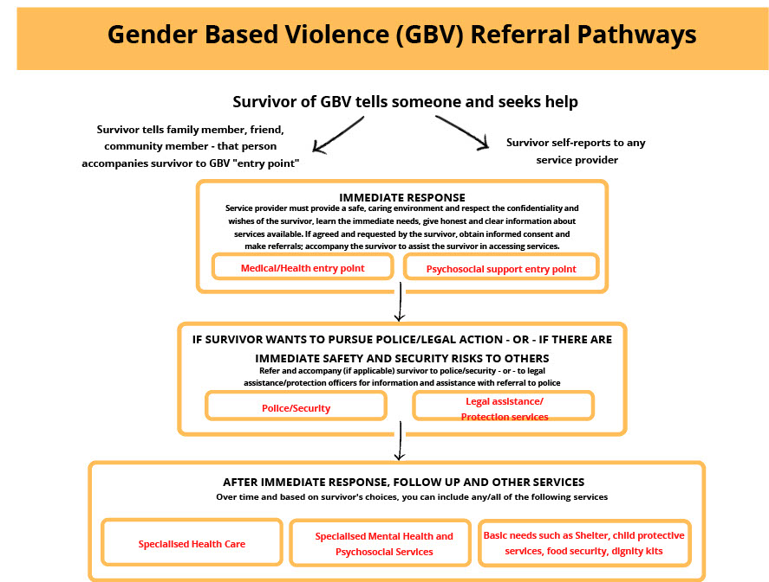

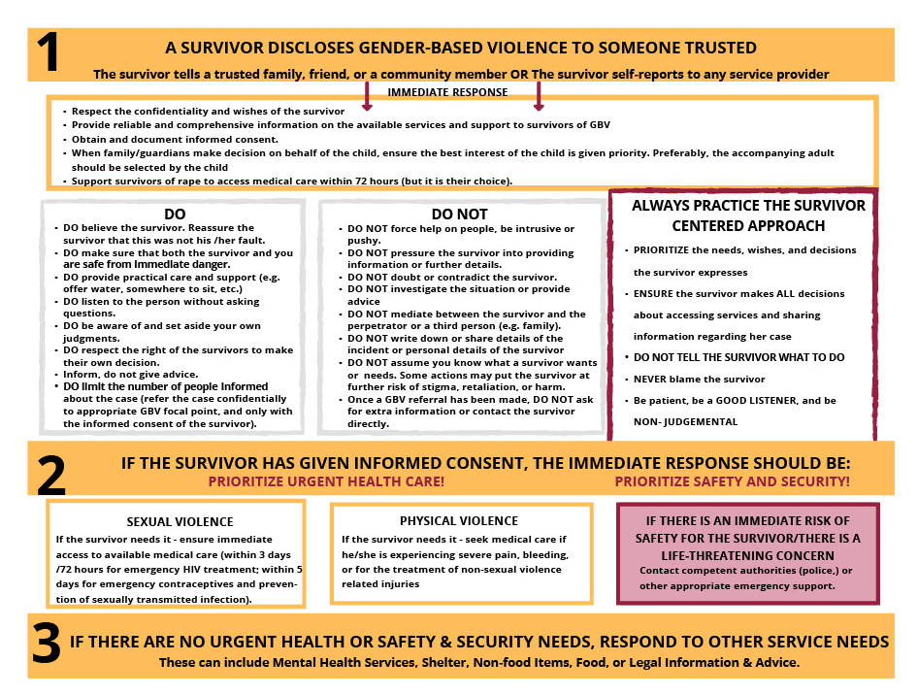

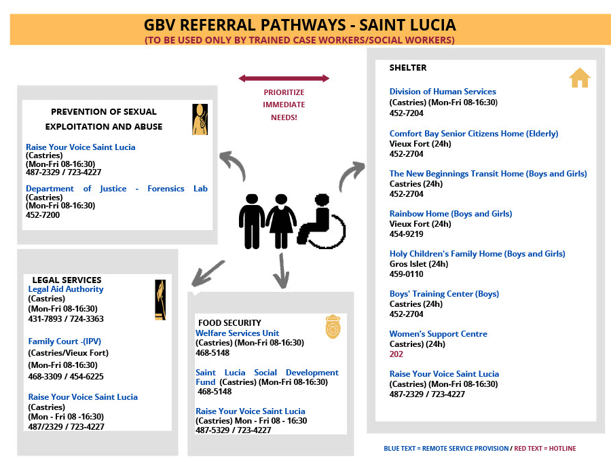
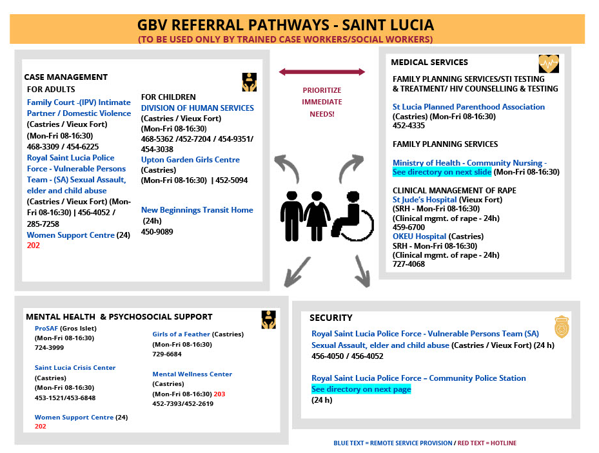

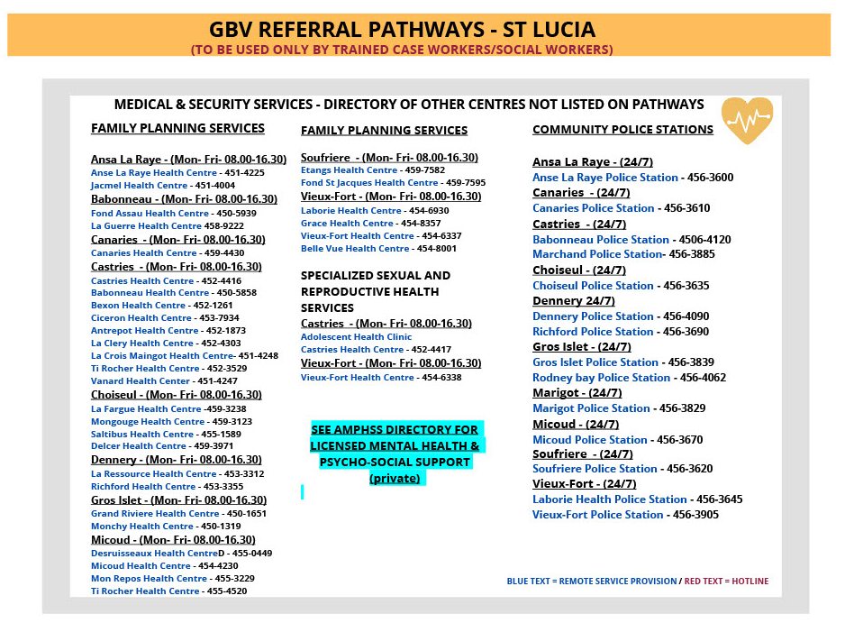

Area navigation (RNAV), Very high-frequency Omnidirectional Range (VOR), and Non-directional beacon (NDB),
The agreed goal in the POS Declaration is 48% of international aerodromes in the Caribbean region certified by December 2016.
ADS-B provides air traffic control system at a fraction of the cost of traditional radar-based surveillance system. It requires that aircraft are equipped with an ADS-B transmitter, and a ground station that receives the signal. Since well over a decade, all jet liner aircraft are equipped with ADS-B, as this technology becomes compulsory in the US and Europe by 2020. However, smaller aircraft still need to be equipped with ABS-B, thus the inclusion of budget for equipping a few St. Lucia-based commercial aircraft.
https://www.skybrary.aero/index.php/ICAO_Aerodrome_Reference_Code
http://www.horizoncaraibes.fr/charts/tlpl.pdf
http://www.horizoncaraibes.fr/charts/tlpc.pdf
The survivor-centered approach is based on a set of principles and skills designed to guide professionals—regardless of their role—in their engagement with survivors (predominantly women and girls but also men and boys) who have experienced sexual or other forms of violence. The survivor centered approach aims to create a supportive environment in which the survivor’s interests are respected and prioritized, and in which the survivor is treated with dignity and respect. The approach helps to promote the survivor’s recovery and ability to identify and express needs and wishes, as well as to reinforce the survivor’s capacity to make decisions about possible interventions.
Project actors are: (a) people employed or engaged directly by the Borrower (including the project proponent and the project implementing agencies) to work specifically in relation to the project (direct workers); (b) people employed or engaged through third parties (Project staff, subcontractors, brokers, agents or intermediaries) to perform work related to core functions of the project, regardless of location (contracted workers); (c) people employed or engaged by the Borrower’s primary suppliers (primary supply workers); and (d) people employed or engaged in providing community labor such as voluntary services or participation in project activities and processes (community workers).

